**Gina L. Gullo**

**Lesson Plan**

**1.** **Lesson:** WD Reading S**ubject:** Reading **Date:** March 19-20, 2014

**2. Target Grade Level:** 4th grade

**3. PDE Standards:**

1.4 Reading Independently.

1.1.4.D. Demonstrate comprehension / understanding before reading, during reading, and after reading on grade level texts through strategies such as retelling, summarizing, note taking, connecting to prior knowledge, extending ideas from text, and non-linguistic representations.

1.1.4.E. Demonstrate fluency in oral reading of grade level texts; demonstrate an appropriate rate of silent reading based upon grade level texts.

**PA Common Core Standards:**

CC.1.1.4.E

Read with accuracy and fluency to support comprehension.

• Read on‐level text with purpose and understanding.

• Read on‐level text orally with accuracy, appropriate rate, and expression on successive readings.

• Use context to confirm or self‐correct word recognition and understanding, rereading as necessary.

CC.1.3.4.A

Determine a theme of a text from details in the text; summarize the text.

**4. Learning Objectives and Aligned Summative Assessments:**

| **Learning Objectives** | **Aligned Summative Assessments** |
| --- | --- |
| Given a realistic fiction passage and a selection of related multiple choice and short answer questions, the student will correctly answer the questions with at least 90% accuracy.  Given a chapter from Because of Winn-Dixie and a graphic organizer, the student will summarize the chapter using a main idea and 1-2 details with 100% accuracy based on the grading checklist. | Reading Comprehension Assessment  Summarization Center Activity |

**5. Materials Needed:**

|  |  |
| --- | --- |
| Text with Winn-Dixie excerpt for each student |  |
| Summarization Graphic Organizer for each student |  |

**6. Expectations for Behavior and Class Activities:**

* The student will follow teacher directions.
* The student will actively engage in all activities to her best ability.
* The student will use respectful language towards others.
* The student will keep hands and feet to him or herself.
* The student will remain quiet and seated during the lesson.
* The student will use a quiet raised hand to respond to or ask questions.

**7. General or Specific Accommodations for Special Needs Learners:**

* Students with attention challenges will be allowed to stand at their desks rather than sit. They will also be given extra attention to help redirect them during the lesson and allowed to take verbally requested breaks as needed throughout the lesson.
* Students with learning challenges will be conference with during independent work to double check for thorough understanding of all concepts introduced or revisited in this lesson.

**8. Description of Learning Activities**

|  |
| --- |
| **Lesson Implementation** |
| Introductory Activity:  Review the summary from yesterday’s story about how Opal got Winn-Dixie. Go over how the students summarized the material and what happened in the story. Finally have the students open their books to the Winn-Dixie selection to hear about one of Opal’s adventures with Winn-Dixie.  Modeling/Demonstration:  Handout the summarization graphic organizers for today and review how to use them. Next, quickly review the vocabulary words for the story by showing the pictures from Monday’s sort activity as flash cards. Finally, begin the story.  The teacher should read the first paragraph of the story to model fluent reading and then choose student readers.  Guided Practice and Feedback:  Have students take turns reading the story. As they read help them to use comprehension questions by asking questions about what they read, and asking them to make predictions. You may also have students summarize what they are reading orally. When the students get to the part of the story where Miss Franny tells her story, tell them to jot down notes on the back of their graphic organizer to help them remember information they will use to summarize. The students may also use post-it notes as place holders for this activity if that is a better tool for them. Continue reading the story with student readers until the end (this will likely take two class periods).  Independent Practice/Exploring:  Once the story is over, allow students to break into groups of 2-3 students each. Have them use their graphic organizers to summarize Miss Franny’s story. When they are finished bring the group back together. Allow the students to share how they summarized with the class.  Review and Preview:  Review the entire story with the class allowing them to summarize it without realizing they are doing so. After they are finished, review with them how they summarized the story and give specific examples of how they took a large amount of information and made is shorter. Preview that they will have a comprehension test on Monday and begin work in centers the following day.    Formative Assessment:  The students will be formatively assessed for reading comprehension of a realistic fiction story through question and answering throughout the two-day reading. They will be formatively assessed in summarization during both the activity for independent work and in the review activity.  Accommodations:  Students with learning support needs with be paired with stronger students during the summarization groups.  Students will all have the option to pass on oral reading in order to encourage their silent reading skills without worry of being next to read. |

**9. Potential Areas of Difficulty with the Content and Correction Procedures:**

Some students may struggle with summarization by providing too many details. These students will be given more guided feedback in order to assist in their discretionary development.

**10. Summative Assessments:**

See reading comprehension assessment attached.

Summarization will be assessed during a center activity.

**11. Reflections**: This lesson went well. The students are good readers; however, the heater in this room is so loud that I need to repeat the students quite often. Some students need more help on summarization. In the future I’d use an accommodated one for those students. I am creating this for the centers lesson for students in the bottom third of the class based on grades. This should help scaffold better learning and comprehension strategies for reading.

**12. Sources:**

Bear, D., Dole, J., Echevarria, J., Hasbrouck, J., Paris, S., Shanahan, T., & Tinajero, J. (2007). *Treasures: A Reading/Language Arts Program.* New York, NY: The Macmilliam/McGraw-Hill Companies.

DiCamillo, K. (2000). *Because of Winn-Dixie.* New York, NY: Scholastic Inc.

Have Fun Teaching. (2013, Mar 14). You got me sick: Fourth grade reading comprehension worksheet. Retrieved from http://www.havefunteaching.com/wp-content/plugins/ download-monitor/download.php?id=you-got-me-sick-fourth-grade-reading-comprehension-worksheet.pdf

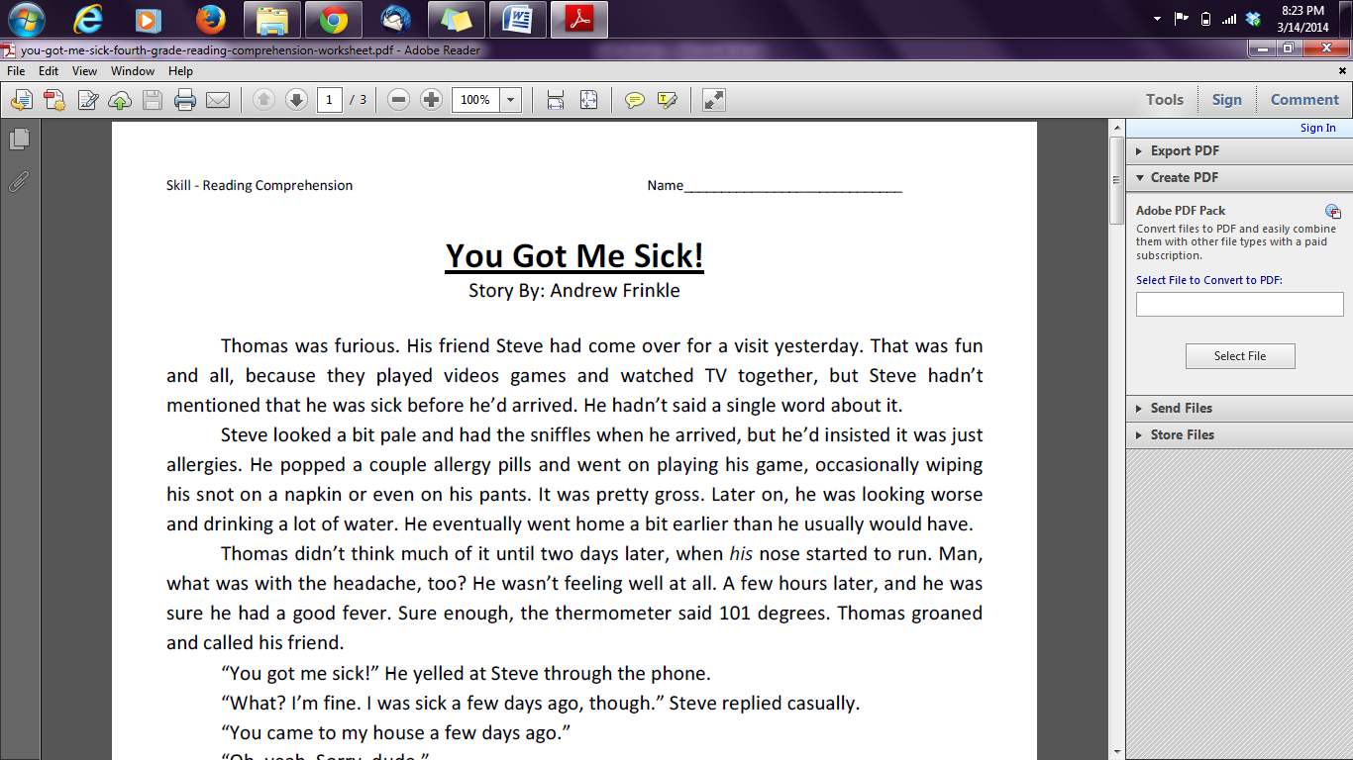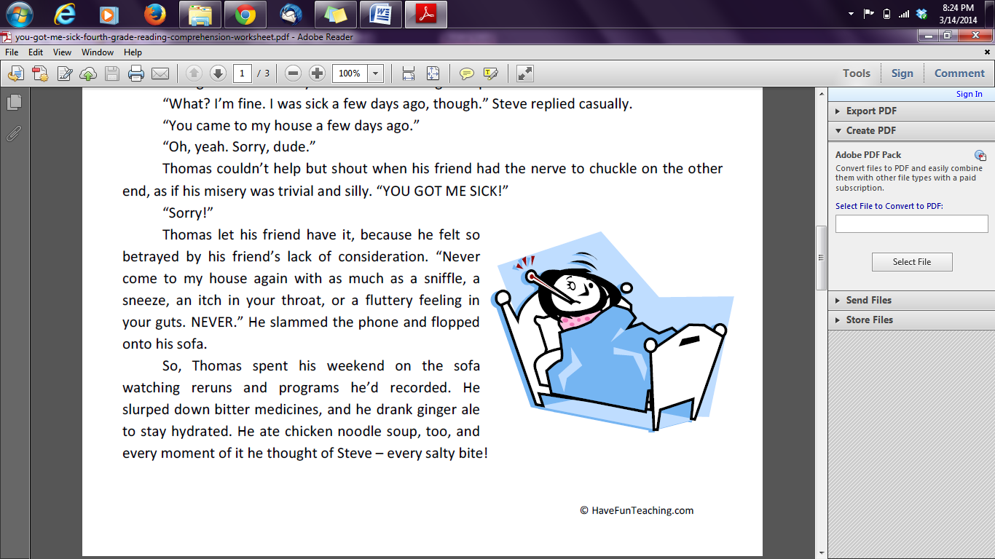

Use the information in the story to answer the questions below. Circle the correct answer for the multiple choice questions. Write in complete sentences for the short answer questions.

1. Why is Steve coming to visit Thomas?

A. to do homework

B. to eat pizza

C. to watch the football game

D. to play games

2. How does Steve look when he arrives?

A. a little sick

B. perfectly fine

C. terribly ill

D. tired

3. TRUE OR FALSE: Steve warned Thomas that he was feeling out of sorts before arriving.

A. True

B. False

4. Which of these does **NOT** describe how Thomas was feeling after he got sick?

A. ill

B. upset

C. confused

D. betrayed

5. Which of these does Thomas **NOT** do to get better?

A. lay around and rest

B. yell at Steve on the phone

C. eat soup

D. drink ginger ale

6. Describe how Thomas felt as he was getting sick. Provide at least 3 details from the story.

_______________________________________________________________________________________________________________________________________________________________________________________________________________________________________________________________________________________________________________________________________________

7. Why was Thomas mad at Steve for getting him sick? Provide at least one piece of evidence to support your answer.

_______________________________________________________________________________________________________________________________________________________________________________________________________________________________________________________________________________________________________________________________________________

**KEY:** Use the information in the story to answer the questions below. Circle the correct answer for the multiple choice questions. Write in complete sentences foR the short answer questions. 10 points per question

1. Why is Steve coming to visit Thomas?

A. to do homework

B. to eat pizza

C. to watch the football game

D. to play games

2. How does Steve look when he arrives?

A. a little sick

B. perfectly fine

C. terribly ill

D. tired

3. TRUE OR FALSE: Steve warned Thomas that he was feeling out of sorts before arriving.

A. True

B. False

4. Which of these does **NOT** describe how Thomas was feeling after he got sick?

A. ill

B. upset

C. confused

D. betrayed

5. Which of these does Thomas **NOT** do to get better?

A. lay around and rest

B. yell at Steve on the phone

C. eat soup

D. drink ginger ale

6. Describe how Thomas felt as he was getting sick. Provide at least 3 details from the story. 10 points for each correct detail; 3 points for incorrect details if less than 3 correct details are provided.

Possible answer: Thomas had a runny nose (1). Then, he had a headache (2). Finally, Thomas got a fever (3). It was 101 degrees (4).

7. Why was Thomas mad at Steve for getting him sick? Provide at least one piece of evidence to support your answer. 10 points for a correct answer, 10 points for any related piece of evidence given from the story.

Thomas was made at Steve because he didn’t tell him he felt sick when he first came over. You can tell this because the story said that Steve told Thomas it was only allergies.

Name: _____________________________________________

Summarize the Miss Franny’s story using the graphic organizer.

Miss Franny asked for a library for her birthday.

Event

/\]

Miss Franny is still scared of bears.

*Something about that bear in that library.*

About the book and running away.

She got the library!!!!!!

Name: KEY

Summarize the Miss Franny’s story using the graphic organizer.

Miss Franny is still scared of bears.

Miss Franny threw a book at the bear to make it leave, and the bear took it with him.

One day a bear came into the library.

She got the library and became the librarian.

Miss Franny asked her dad for a library for her birthday.

Event