Interview student using the following items in a one-on-one setting. (completed on 2/27/2014)

Student Name:

Date:

Grade Level:

Can you keep a snowball in your pocket overnight? Answer: no

Student answer:______________________________

What happens when snow is brought inside? Answer: it melts

Student answer:______________________________

K: Is inside snow (show example) really snow? (no)

1st and 2nd grade: How are inside snow and outside snow different? (give at least one difference, i.e. inside snow isn’t cold/doesn’t melt/isn’t made of water)

Student answer:______________________________

K: Can you count out three items (with me for Yellow)? (one, two, three)

1 & 2: If 3 students have blue snow treats and 1 has an orange snow treat, then which color did most students pick? (show pictograph to help)

Student answer:______________________________

Can water be a gas like air? yes

Student answer:______________________________

Give student picture cards of ice, water, and cloud from below. Say: Give me a solid/liquid/gas. (student should hand appropriate picture card)

 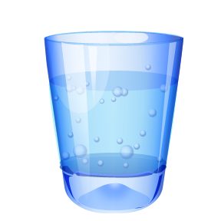 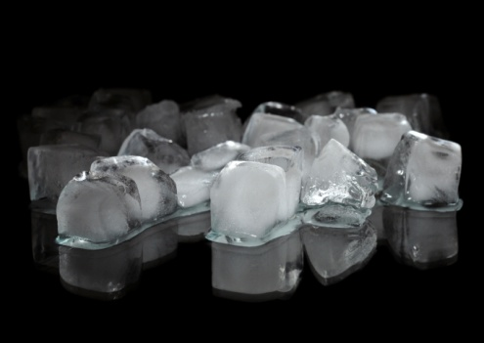

Student answer for solid:______________________________

Student answer for liquid:______________________________

Student answer for gas:______________________________

How does the inside of a solid move, a gas? (slow, fast or show me…)

Student answer for solid:______________________________

Student answer for liquid:______________________________

Student answer for gas:______________________________