**Instructional Unit or Lesson**: 1918 Influenza Pandemic

**1. Target Grade or Age Level and Subject:** 9th grade; cross-curricular unit on diseases

**2. Pennsylvania Content Standards**

Reading, Writing, Speaking, Listening

1.4 Types of Writing

1.4.9 B. Write complex informational pieces (e.g. reviews, research papers, instructions, essays, and articles)

1.5. Quality of Writing

1.5.9 A. Write with a clear focus, identifying topic, task, and audience

Language Arts:

L.N.1.3: Use appropriate strategies to comprehend literature during the reading process.  
L.N.1.3.1: Identify and/or explain stated or implied main ideas and relevant supporting details from a text.

Social Studies:

8.1.W.A: Evaluate patterns of continuity and change over time, applying context of events.  
8.1.W.B: Evaluate the interpretation of historical events and sources, considering the use of fact versus opinion, multiple perspectives, and cause and effect relationships.

Mathematics:

2.6.7.E: Interpret trends and make predictions based on data displayed in a graph.

National Core Standard:

Reading Standards for Literacy in History/Social Studies 6–12:

2. Determine the central ideas or information of a primary or secondary source; provide an accurate summary of how key events or ideas develop over the course of the text.

**3. Learning Objectives:** The student will demonstrate their knowledge of the 1918 influenza pandemic though a variety of class activities and discussion cumulating in researching and writing an essay on the pandemic.

**4. Formative Assessments:** The student will compose a two-page essay explaining the causes of 1918 influenza pandemic, reconstructing how it spread across the Americas and Europe, and evaluate how the influenza pandemic could have been prevented in 1918 and what we currently can do to prevent flu pandemic.

**5. Summative Assessments:** There will be a test at the end of the unit.

**6. Materials Needed**

Nova video worksheet

Graph Analysis Worksheets

KWL chart

No Ordinary Flu comic

Photo Analysis Worksheet

Photographs from 1918

Written Document Analysis Worksheet

Documents from 1918

Computers

Research worksheet

Rubric handout

**7. Expectations for Behavior and Class Activities:** The students' are expected to work together as a team when viewing documents and working together on the Internet.

**8. Description of Learning Activities:**

Description of Introductory Activity (Anticipatory Set)

Tell the students that we are going to be learning about the 1918 Influenza pandemic. This flu killed more people worldwide than World War I. We are going to watch a video about the flu but the video will also make references to the Avian flu. The video is only 12 minutes long.

http://www.pbs.org/wgbh/nova/body/1918-flu.html

The students will be expected to follow along with the Nova Video worksheet and answer questions on the video.

After the video, go through the questions on the worksheet.

To accommodate diverse learners: The teacher will provide a written transcript of the video and translated the transcript if necessary.

Modeling/Demonstration (also elaborations/connections to content)

Start the next part of the lesson by displaying the KWL chart. Ask the students, what do we already know about the 1918 flu? Record the answers on the chart. Then ask the students, what do we want to know about the 1918 flu? Write the answers on the chart?

Pass out the graph analysis worksheet. Explain to the students that the graphs show how the 1918 influenza affected the population. Have them take a few minutes to answer the questions, then briefly go over the worksheet.

Pass out the comic *No Ordinary Flu*. Tell the students that we are going to read about the 1918 Flu and how it affected a certain family. The teacher will start reading and after a page or two ask if any students would like to read.

After reading ask, Who was the key character in the story? Why did the story talk about soldiers? Can you explain why the store was not getting deliveries? What happened to the father in the subway car?

To accommodate diverse learners the teacher will pair the student with another student.

Guided Practice and Feedback (also probing questions/student responses)

(assume there is 25 students in the class so there will be at lease six groups of 4 students per grouping)

Tell the students we are now going to look at some photographs and read documents from the years of the Influenza pandemic. Each group will receive one document and one photograph and worksheets to help the group analyze the documents. The groups will have 10-15 minutes to work with the primary resources and then they will share with the class what they learned from the documents they had.

Pass out the Photo Analysis Worksheet and Document Worksheet, and tell the class we will now look at a photograph and a document together. The teacher should show the photograph of the group of children (first photograph attached-do not show the caption until after the discussion. The teacher should go through each worksheet with the students prompting them to ask questions and look closely at each image to learn how the flu affected people.

Possible questions to ask include: So what do you think it was like for people who experienced the 1918 flu? oHow do you think the flu affected the way people interacted?

To accommodate diverse learners: The diverse learners will be paired with other students in the class.

Independent Practice/Exploring

The teacher will now explain to the students that they are now going to do research on the Internet on the 1918 flu pandemic. The students can either work together or alone while conducting the research. However, every student turns in a two-page essay. The essay cannot be written together. The teacher should pass out the rubric and go over it with the students. Then, the teacher will pass out the research worksheet and have the student start working on the computers.

To accommodate diverse learners: ELL students will be allowed to write the essay in their native language. Other accommodations will include students verbally restating what they found on the Internet to the teacher

Discussion Questions (and student responses):

What are some of the theories on how the 1918 flu spread? The flu spread because soldiers were in camps.

Who was the key character in the story? The story is about uncle Arturo.

Why did the story talk about soldiers? The flu pandemic took place during World War I.

Can you explain why the store was not getting deliveries? There wer so many people sick that few people were working and available to make deliveries.

What happened to the father in the subway car? Arturo started coughing and the other passenger left the car because he did not want to get sick.

What happened in the end to Arturo? He died.

Can you explain what is going on in the photograph? Answers will vary

Why are people wearing mask? The people believe they will not get sick if they wear mask?

Why are the theaters closed? Answers will vary but basically because the government did not want people to gather together and spread disease?

What was the United States government's reaction to the flu? At first they did not believe it was a problem?

How did the flu affect the running of local governments? The various departments had to combine meetings.

How can we apply what we learned about the 1918 flu pandemic and apply it to today? Answers will vary

Review and Preview

Put the KWL chart back up on the board. Discuss with the students what they have learned about the 1918 influenza pandemic

General Accommodations for Diverse Learners

The students will be provided with transcripts of video.

Students can watch the video and listen with earplugs using a separate computer.

The students will have a reading partner when the class is reading the comic book.

The students will be paired with other students.

The students will be able to write the essay in their native language.

**Teacher Background information**

**Websites:**

<http://virus.stanford.edu/uda/>

<http://en.wikipedia.org/wiki/1918_flu_pandemic>

**Spread:**

The flu of 1918 was thought to have started in China in a rare genetic shift in the virus causing people to not have any immunity to it. This pandemic is often called the Spanish Flu because of the early and larger numbers of dead in Spain in May. However, there were early outbreaks in military camps in the late spring of 1918 across the U.S. World War I brought the virus back to the U.S. for a second wave in September. The war allowed for the spread of the disease and it to reach an pandemic status. The flu killed more people than all the causalities of the battles from WWI. The pandemic lasted from June 1918 to December 1920.

No vaccine was developed for this strain of influenza but it seemed to die down on its own. One theory says that the 1918 virus mutated rapidly to a less lethal strain of the disease which is a common thing for influenza viruses to do.

The 1919 flu is often considered the "forgotten pandemic" because public awareness of this pandemic since it happened is relatively low. This is attributed to the rate at which the pandemic killed, limited media coverage, being familiar with pandemics, and the end of WWI. Deaths caused by the flu may have been overlooked due to media coverage of WWI.

**Causes and symptoms:**

The 1918 flu is from the H1N1 influenza virus. Most victims were healthy young adults, in contrast to most flu outbreaks that affect children, elderly and weak patients. Research has found that the virus kills through a cytokine storm (an overreaction of the body's immune system). This could explain why healthy young adults were more affected by the flu because they had stronger immune systems.

The flu virus infected lung cells leading to an overstimulation of the immune system. The immune system attacked and destroyed lung tissue and secreted liquid into the lungs causing suffocation.

Symptoms of this flu included: difficulty breathing, pain or pressure in the chest, dizziness, fever, cough, sneezing nasal congestion, and fatigue.

**9. Sources:**

1918 Flu. (2006). Retrieved from http://www.pbs.org/wgbh/nova/body/1918-flu.html

Billings, M. (1997, June). *The influenza pandemic of 1918*. Retrieved from <http://virus.stanford.edu/uda/>

Carter, L.S. (2006). Cold comfort. *Dartmouth Medicine*. Retrieved from <http://dartmed.dartmouth.edu/winter06/html/cold_comfort.php>

Cartoon. (1918) Retrieved from http://1918.pandemicflu.gov/the_pandemic/01.htm

Davies, E.J. (n.d.) *The Influenza epidemic and how we tried to control it*. Retrieved from <http://ublib.buffalo.edu/libraries/units/hsl/resources/guides/flu45.pdf>

Library of Congress, (n.d.). *Teachers guide: analyzing photographs and prints.* Retrieved from http://www.loc.gov/teachers/usingprimarysources/resources/Analyzing_Photographs_and_Prints.pdf

Richardson, D.A. National Archives, (1918). *Letter from visiting doctor reporting situation to superintendent, Albuquerque Day School, New Mexico* (Record Group 75). Retrieved from http://www.archives.gov/exhibits/influenza-epidemic/records/visiting-doctor-letter.pdf

Taubenberger, J.K., & Morens, D.M. (2006). 1918 Influenza: the mother of all

pandemics. *Emerging Infectious Diseases*, 12(1), Retrieved from http://www.cdc.gov/ncidod/eid/vol12no01/05-0979.htm

Photo image sources:

http://www.usd116.org/ProfDev/AHTC/lessons/jwh05/1918photo.2.jpg

http://images.google.com/images?hl=en&biw=1169&bih=683&site=images&tbm=isch&oq=1918++influenza&aq=f&aqi=g6&q=1918%20influenza

C:\Users\Kassie\AppData\Local\Microsoft\Windows\Temporary Internet Files\Content.IE5\ZP19P4J6\MC900347477[1].wmfC:\Users\Kassie\AppData\Local\Microsoft\Windows\Temporary Internet Files\Content.IE5\S8MYZPC8\MC900432423[1].wmf**Nova 1918 Flu Video Questions**

*Please read these questions before the video. Then as the video plays follow along and answer the questions.*

1. How many more people did the 1918 flu kill than all of World War I?

2. Where do all flu viruses start?

3. How did Dr. Tumpey find the genetic code of the 1918 flu virus?

4. What part of the lungs did the 1918 flu virus attack? How did this cause death?

5. How many genes does a flu virus have?

6. What gene opens the cell so the virus can enter?

7. What gene gets the virus out of the cell?

8. How many different kinds of H genes and N genes do birds have?

9. How is the flu labeled? Give an example.

10. Explain how it was determined that the H gene in the 1918 flu was partly responsible for the flu's deadliness. (use the back of the page if needed)

|  |  |  |
| --- | --- | --- |
| K  WHAT DO I KNOW? | W  WHAT DO I WANT TO LEARN? | L  WHAT DID I LEARN? |
|  |  |  |

“No Ordinary Flu” Concept Map

Fill out “K” section of chart on what you know about the 1918 flu epidemic, and then fill out “W” section. Read the provided comic book on the flu and then fill out last section, “L”.

**Photo Analysis Worksheet**

Look at the photograph for a minute. After looking at the photograph go through each of the steps and write your reactions. The questions in each step are to help you look at the photograph and help you analyze what is going on.

**Step 1: Observe the photograph:**

Describe what you see. What do you notice first? What people and objects are shown? How are they arranged? What is the physical setting? What other details can you see?

**Step 2: Reflect:**

Why do you think this image was made? What’s happening in the image?

Who do you think was the audience for this image? What can you learn from examining this image? What’s missing from this image?

**Step 3: Questions:**

What might you infer from this photograph? What questions does this photograph make you ask?

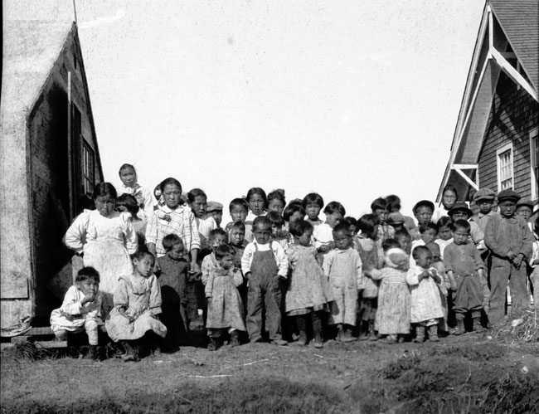

Children in the remote Alaskan village of Nushagak survived the 1918–1919 influenza pandemic. However, most of their parents and grandparents succumbed to the 1918 pandemic virus, probably because they had not been exposed to an earlier H1-like influenza virus as a result of their geographic isolation. The photograph was taken in the summer of 1919. Printed with permission from the Alaska State Library, Core: Nushagak-People-4, Alaskan Packers Association, PCA 01-2432.

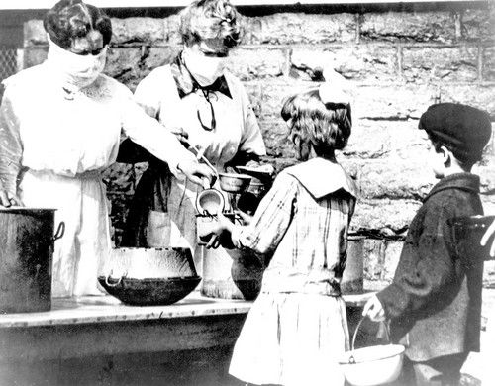

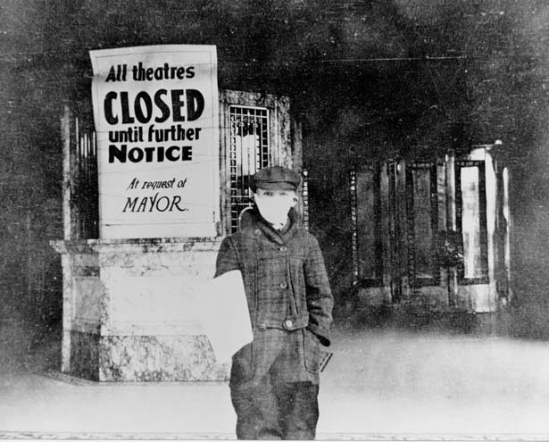

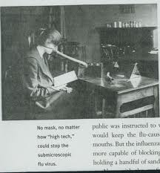

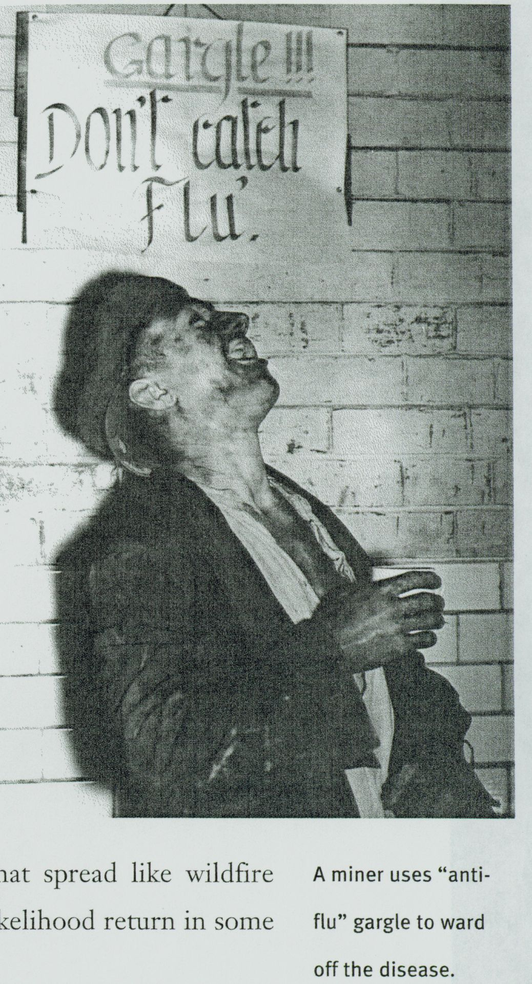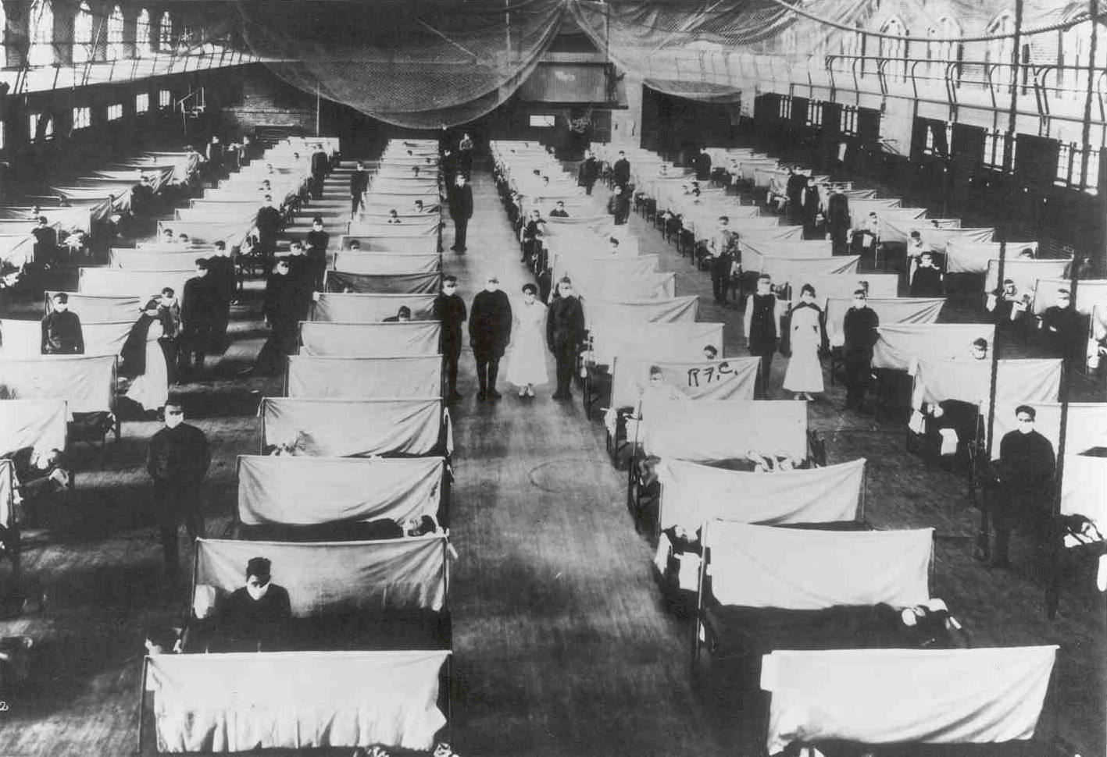

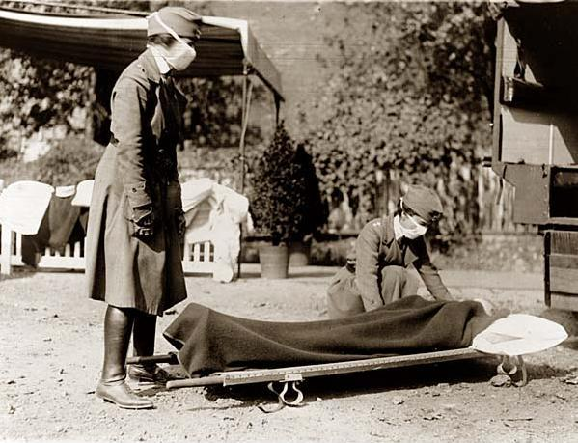



**The Evening herald. (Klamath Falls, Or.) 1906-1942, November 07, 1918**

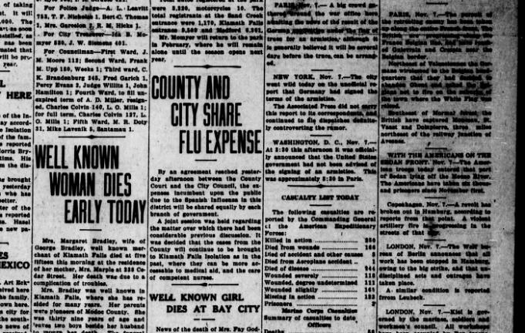

January 1919

Referring bureau wire this date indications are influenza will become epidemic here soon unless active measures taken prevent if city will adopt my recommendation relative closing theaters picture shows and other crowding places there will be no necessity for emergency hospital this demonstrated in previous outbreak at present time all places amusement excessively crowded and reports show marked daily increase in cases and deaths emergency hospital this demonstrated in previous outbreak at present time all places amusement excessively crowded and reports show marked daily increase in cases and deaths.

New Orleans Telegram from a PHS Officer to Surgeon General Rupert Blue.

taken from website:

http://1918.pandemicflu.gov/the_pandemic/02.htm

September 1918

"This epidemic started about four weeks ago, and has developed so rapidly that the camp is demoralized and all ordinary work is held up till it has passed....These men start with what appears to be an ordinary attack of LaGrippe or Influenza, and when brought to the Hosp. they very rapidly develop the most viscous type of Pneumonia that has ever been seen. Two hours after admission they have the Mahogany spots over the cheek bones, and a few hours later you can begin to see the Cyanosis extending from their ears and spreading all over the face, until it is hard to distinguish the coloured men from the white. It is only a matter of a few hours then until death comes, and it is simply a struggle for air until they suffocate. It is horrible. One can stand it to see one, two or twenty men die, but to see these poor devils dropping like flies sort of gets on your nerves. We have been averaging about 100 deaths per day, and still keeping it up. There is no doubt in my mind that there is a new mixed infection here, but what I don't know."

A physician stationed at Fort Devens outside Boston, late September, 1918

taken from website:

http://1918.pandemicflu.gov/the_pandemic/02.htm

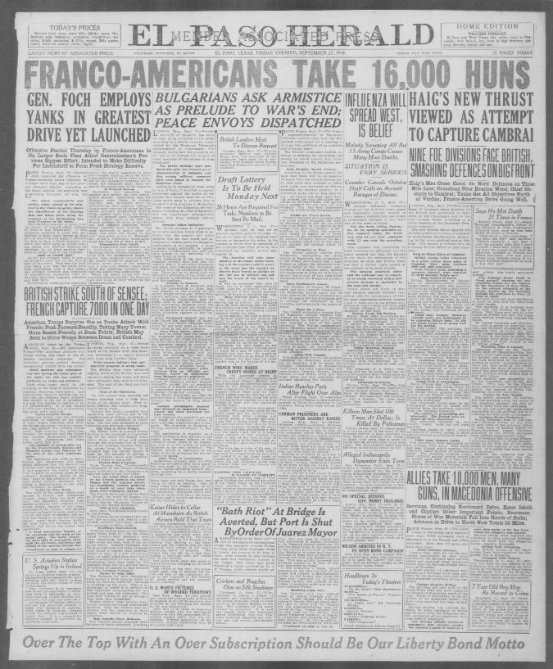

(text from El Paso Herald - image above)

INFLUENZA WILL SPREAD WEST IS BELIEF  
Malady Sweeping All But13 Amy Camps Causes Many More Deaths.  
SITUATION IS VERY SERIOUS  
Crowder Cancels October: Draft Calls on Account Ravages of Disease.  
WASHINGTON, D. O. Sept. 27.

Spanish influenza, sweeping through all but 1 of the army camps and apparently beyond control in many eastern communities, has caused a tremendous increase In the death rate of the army at home. For the week ending September 20. the surgeon general's office reported today, the death  
rate was 4.4 per cent, compared with 23 per cent the preceding week. This Increase was attributed in large measures to influenza, but the report pointed out that the figures do not show the seriousness of the situation as since last Friday there has been a farther rapid spread of the epidemic with many deaths. The surgeon general's office said the epidemic may be expected to sweep westward with a still greater Increase In mortality In the next few weeks.'  
Orders issued last night by provost marshal general Crowder can celling calls for entrapment of 142,00 draft registrants between October 7 and 11 were due to the serious conditions in many camps and were said by health officials to be absolutely necessary at this time.

Boston Needs 500 Doctors.  
Boston. Maas.. Sept. 27. Health authorities in Massachusetts, who have been battling unceasingly to check the spread of Influenza, were today hoping for the arrival of physicians and nurses from outside the state, in response to urgent appeals by the governor. Dr. Eugene R. Kelley, state health commissioner, estimated that 500 physicians and 1000 nurses were needed. Traveling expenses and salary will be paid all who respond.

Public Meetings Banned.  
Beginning today, all public meetings in this city were to be prohibited, as far as practicable bv the emergency health commission. It bas left optional with the churches as to whether services should be held next Sunday. Tbe cessation or a heavy rain, which fell for 36 hours, and the re  
turn of sunshine were looked upon as sugaring well for the fight against the epidemic.

Influenza In Denver.  
Denver. Colo, Sept. 17. The first case of Spanish Influenza reported in Denver became known today with the death of Miss Blanche Kennedy, of Chicago. She came here last Saturday  
to visit a brother. No other eases have been reported to the health authorities

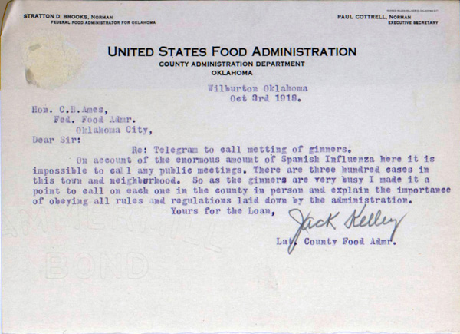

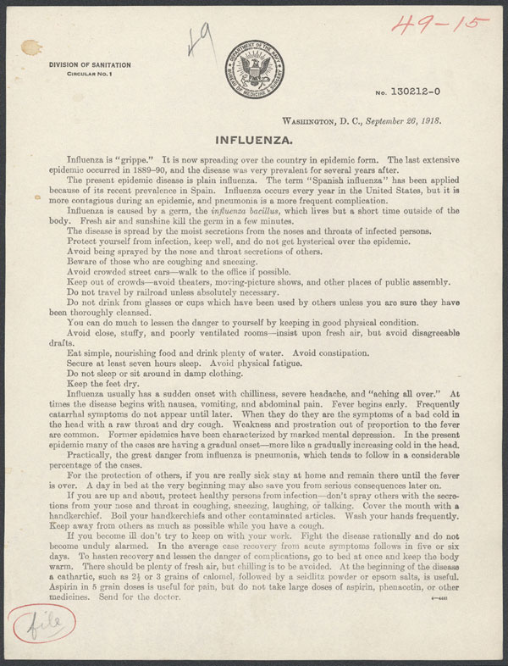

September 27, 1918; from Clifford Orr to his father:   
You needn't worry any more because I'm all right now. The doctor let me go to classes today, and I am feeling almost as well as usual. I still am pretty stuffed up but coming fine. I surely was lucky not to have been worse. Some fellows who were taken sick before I was are still in bed and liable to be for some time. I was in bed from Monday afternoon to Thursday noon, while several right in the same dorm have been there a week. One freshman has died, and I don't know how many soldiers. Chapel has been cut out, the movies closed, and Dartmouth Night, which was to be held next Monday to celebrate the College's 150th birthday, has been cancelled. . . . The epidemic has killed what little college life there

was. . . .

There are only about eight doctors in town, and it takes some time to care for 100 cases in the hospital and in the gym, and probably about 150 in the different dorms. . . .

September 29, 1918; from Clifford Orr to his mother: 

I received your letter yesterday afternoon, after I had mailed one to papa telling him that I am all right

now, and that I received the pickles and bread. The pickles were great. . . .

You ask me of how I got my meals while I was sick. Well, all I ate I had brought me by kind neighbors. I only ate two meals, and then it was just toast and milk. They had to go through some arrangement to get milk, as students are not supposed to buy it. There is no cooking in rooms allowed. That is, no regular cooking, but most of the fellows have little alcohol heaters that they make cocoa on for evening parties. Then they use either marshmallow creme or malted milk. I went to a party where they used the latter for milk, and marshmallows for sweetening, and it was fairly good. . . .

Another freshman, another professor, and more soldiers have died here. The flags have been halfmast for over a week now. They can't barrack until this is over.

**Internet Research Guide for the 1918 Influenza Flu**

Here are some useful websites you might want to use in your research:

http://virus.stanford.edu/uda/

http://en.wikipedia.org/wiki/1918_flu_pandemic

http://www.cdc.gov/ncidod/eid/vol12no01/05-0979.htm

http://www.pbs.org/wgbh/americanexperience/films/influenza/

http://www.archives.gov/exhibits/influenza-epidemic/records-list.html

When you are conducting your research, think about the following questions to help guide you. These questions should be addressed in your essay.

What are some of the theories of how the 1918 Influenza Flu started?

How many people did the 1918 Influenza Flu kill worldwide? In the U.S.?

What made the 1918 Influenza Flu different from other flu viruses?

Include in your essay at least one first hand account of the 1918 flu. This can be a quote from a letter, video, or newspaper or other resource. It does not have to be a long quote.



|  |  |  |  |
| --- | --- | --- | --- |
| Criteria | Excellent | Average | Fair |
| Organization | Coherent thesis that conveys a clear and distinctive perspective on the subject and maintains a consistent tone and focus throughout the piece of writing | Somewhat logical thesis that does not offer a clear and distinctive perspective on the subject and does not have a consistent tone and focus throughout the piece of writing | Inarticulate thesis that does not convey a clear and distinctive perspective on the subject and has no consistent tone or focus throughout the piece of writing |
| Style | Use precise language, action verbs, sensory details, appropriate modifiers, and the active rather than the passive voice. | Sometimes uses precise language, action verbs, sensory details, appropriate modifiers, and the active rather than the passive voice. | Does not use precise language, action verbs, sensory details, appropriate modifiers, and the active rather than the passive voice. |
| Content Support | Synthesize information from multiple internet sites and identify complexities and discrepancies in the information and the different perspectives | Synthesize information from multiple internet sites but does not identify complexities and discrepancies in the information and the different perspectives | Does not yynthesize information from multiple internet sites and does not identify complexities and discrepancies in the information and the different perspectives |
| Punctuation | Essay has no punctuation mistakes or no more than one | Essay has at least 2 punctuation mistakes but no more than 4 | Essay has at least 5 punctuation mistakes |
| Spelling | Essay has no spelling mistakes or no more than one | Essay has at least 2 or more spelling mistakes | Essay has more 6 spelling mistakes |
|  |  |  |  |

**Writing Rubric for the two-page essay on the 1919 Flu Pandemic**