**Gina L. Gullo**

**Lesson Plan**

**1.** **Lesson:** WD Vocab S**ubject:** Reading **Date:** March 17, 2014

**2. Target Grade Level:** 4th grade

**3. PDE Standards:**

1.4 Reading Independently.

1.1.4.C. Use meaning and knowledge of words (e.g., multiple meaning words, word origins, root words, synonyms, antonyms, homophones) across content areas to increase reading vocabulary.

1.1.4.D. Demonstrate comprehension / understanding before reading, during reading, and after reading on grade level texts through strategies such as retelling, summarizing, note taking, connecting to prior knowledge, extending ideas from text, and non-linguistic representations.

**PA Common Core Standards:**

CC.1.2.4.F  
Determine the meaning of words and phrases as they are used in grade‐level text, including figurative language.

CC.1.2.4.J   
Acquire and use accurately grade‐appropriate conversational, general academic, and domain‐specific words and phrases, including those that signal precise actions, emotions, or states of being and that are basic to a particular topic.

CC.1.3.4.A

Determine a theme of a text from details in the text; summarize the text.

**4. Learning Objectives and Aligned Summative Assessments:**

| **Learning Objectives** | **Aligned Summative Assessments** |
| --- | --- |
| Given 6 grade level vocabulary words found in the textbook’s excepted chapters from Because of Winn-Dixie, the student will correctly do one of the following for each word (using each task only once) (1) draw a picture, (2) write a definition, (3) provide a synonym, (4) provide an antonym, (5) use the word in a sentence, and (6) provide an example and non-example of the word with 100% accuracy.  Given a chapter from Because of Winn-Dixie and a graphic organizer, the student will summarize the chapter using a main idea and 1-2 details with 100% accuracy based on the grading checklist. | Vocabulary Center Activity  Summarization Center Activity |

**5. Materials Needed:**

|  |  |
| --- | --- |
| Vocabulary Cards and Pictures | “A Library Card for Emilio” story in text |
| ELA notebook | Projector and computer to watch black bear video |
| Vocabulary definition slices | Summarization graphic organizer |
| Glue sticks and scissors |  |

**6. Expectations for Behavior and Class Activities:**

* The student will follow teacher directions.
* The student will actively engage in all activities to her best ability.
* The student will use respectful language towards others.
* The student will keep hands and feet to him or herself.
* The student will remain quiet and seated during the lesson.
* The student will use a quiet raised hand to respond to or ask questions.

**7. General or Specific Accommodations for Special Needs Learners:**

* Students with attention challenges will be allowed to stand at their desks rather than sit. They will also be given extra attention to help redirect them during the lesson and allowed to take verbally requested breaks as needed throughout the lesson.
* Students with learning challenges will be conference with during independent work to double check for thorough understanding of all concepts introduced or revisited in this lesson.

**8. Description of Learning Activities**

|  |
| --- |
| **Lesson Implementation** |
| Introductory Activity:  Discuss new story (except from Because of Winn-Dixie). Note that the story takes place in Florida in a small town. Talk about what students know about FL and mention that black bears live there. Show video clip of black bear in person’s yard to help students understand that sometimes people and the wildness become intertwined in FL and move on.  Modeling/Demonstration:  Present the vocabulary words for the story (peculiar, selecting, snuffled, consisted, positive advanced). Demonstrate that the students should try to figure out what the words mean based on their experience with the words.  Guided Practice and Feedback:  Print the attached pictures and place them under the words they are related to with the students’ assistance. Guide students as needed to categorize the words correctly.  Now, give the students the definition slices (see attached) for the vocabulary words. Have them write each word in their ELA notebook, and paste the correct definition slice under it. If needed, check students’ categorization before they paste the words. Finally, review the definitions as a class.  Independent Practice/Exploring:  Now, break the class into 6 groups (one for each word). Instruct the groups to work together for 5 minutes to think of a 1 minute skit they can perform in front of the class that helps the students understand the definition of each word. Assign each group a word, and allow the students to plan for the full five minutes. Then have the class watch and discuss the performances.  *As time allows, complete the following:*  Guided Practice and Feedback:  Hand out summarization graphic organizers (see attached) to the students, and have them open to the “A Library Card for Emilio” story on page 542 of their texts. Tell the story to listen for their vocabulary words and for main ideas s they read along.  Read the story to the students out loud to model fluency. Whenever a major event is described, stop and work with the students to summarize it on the organizer. For the first example, read the first paragraph to the class. Model your thinking as you write, “Emilio is going to get a library card,” in the first box of the organizer. Continue reading until the end of the page. Guide the students to summarize the information to something like, “Emilio is worried about his English.” Write that in the graphic organizer and continue reading. Now, read the next two paragraphs. Stop and have the students suggest something to write for the summarization. If they do not come up with something like, “A friendly librarian gives Emilio a form to fill out,” reteach.  Independent Practice/Exploring:  After writing that on the graphic organizer, finish reading the story and have students fill in the last summarization box on the organizer on their own. Walk around to check and reteach as needed.  Review and Preview:  Review the story as a whole with the graphic organizer or allow a student to do so. Go over each vocabulary word in the story and talk about how it was used. Finally, preview that the students will listen to the Because of Winn-Dixie story excerpt tomorrow.    Formative Assessment:  Assessment with vocabulary words will occur throughout the first half of the lesson especially during the picture sort, ELA notebook activity, and skits. Summarization will be assessed for the last item on the graphic organizer; however, it will continue to be taught throughout the unit so it is merely minimally assessed in this lesson.  Accommodations:  Student who need extra vocabulary practice will be approached by teachers using the vocabulary words in regular conversation throughout the unit to help facilitate learning. |

**9. Potential Areas of Difficulty with the Content and Correction Procedures:**

Some of the vocabulary words have multiple definitions (such as positive). If students confuse the target definition of the word, they will be encouraged to provide a different meaning and use the word with that meaning in a sentence.

Some students may struggle with summarization by providing too many details. These students will be given more guided feedback in order to assist in their discretionary development.

**10. Summative Assessments:**

During centers later in this unit, students will work in teams of 4-5 students. For the vocabulary center, the students will each provide one of the following (once each) for each spelling word.

1. A picture
2. A definition
3. Use of the word in a sentence
4. A synonym
5. An antonym
6. An example and non-example

**11. Reflections**: This went quite well. Students love to see different pictures of the vocabulary words and really liked the word-work style assessment. Some students did less well on this kind of assessment than others although group work was allowed. Most of these students simply neglected to follow directions. This is evident because when they were given extra time to complete this assessment or correct answers, they did not use it. Perhaps in the future this assessment should also be modified for some learners.

**12. Sources:**

Bear, D., Dole, J., Echevarria, J., Hasbrouck, J., Paris, S., Shanahan, T., & Tinajero, J. (2007). *Treasures: A Reading/Language Arts Program.* New York, NY: The Macmilliam/McGraw-Hill Companies.

Pictures for sort:

Peculiar

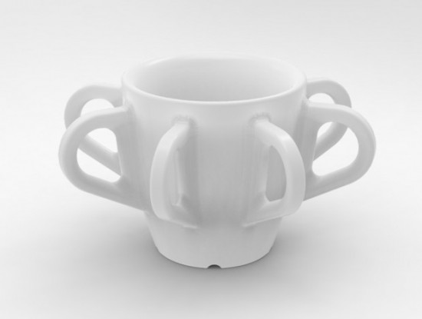 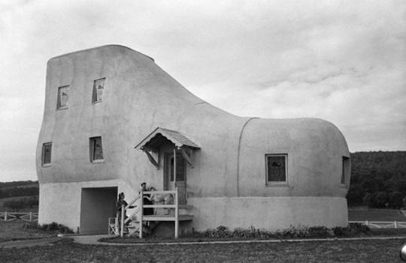 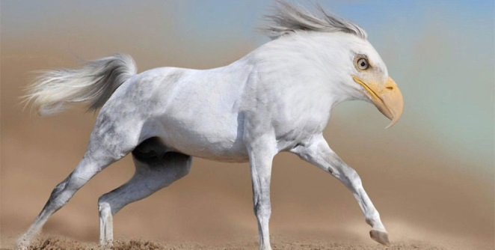

Selecting

 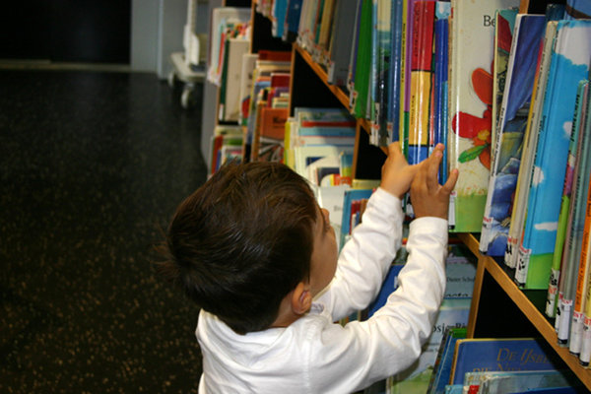 

Snuffled

 

Consisted

 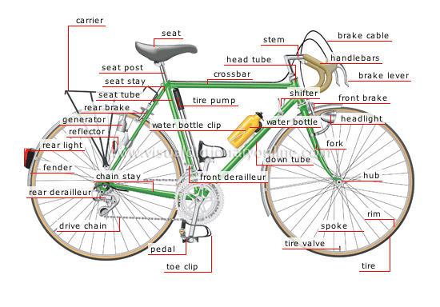

Positive

 

Advanced



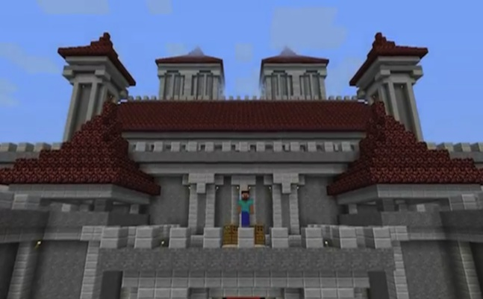

Vocab Slices

|  |  |  |  |
| --- | --- | --- | --- |
| Strange or unusual | Strange or unusual | Strange or unusual | Strange or unusual |
| Breathed noisily from a stuffy nose | Breathed noisily from a stuffy nose | Breathed noisily from a stuffy nose | Breathed noisily from a stuffy nose |
| Certain or sure | Certain or sure | Certain or sure | Certain or sure |
| Picking out among many | Picking out among many | Picking out among many | Picking out among many |
| Made up of different things | Made up of different things | Made up of different things | Made up of different things |
| Beyond the beginning level | Beyond the beginning level | Beyond the beginning level | Beyond the beginning level |

Name: _____________________________________________

Summarize the story using the graphic organizer.

Event