# 

# Classroom Management Plan

# Gina Laura Ciani

# Lehigh University

# TLT/SPED 409 (EDUC 491): Classroom Environment and Management

# Dr. Brenna Wood

**Class Description**

Welcome to Miss Ciani's second grade class at Paxinosa School in Easton, Pennsylvania. The class is comprised of 20 seven and eight-year old students with 12 boys and eight girls. The students are from diverse ethnicities with two students of Indian descent, four students who are African American, ten students from Hispanic cultures, one student of Asian descent and three students of that identify as Caucasian. Three of the ten students from Spanish-speaking backgrounds are English Language Learners (ELL) at the Level 3 (Developing) stage of English proficiency. One of the students of Indian descent has recently moved to the US and is a Level 2 (Beginning) ELL student. There are two students with Individualized Educational Plans (IEP) in the class both for learning disabilities (LD) one specific to reading and one specific to math. Additionally, there are two students (siblings) noted to have behavior problems by previous teachers. Overall the class functions pretty close to grade level although slightly below average. Despite a moderately low socio-economical status (SES), parents are very supportive in the community and at home, and are often welcomed into the classroom to help with various student activities and events.

**Level of Structure**

The classroom has a medium-high level of structure at the beginning of the school year with a planned fade to a medium-low level of structure. The teacher questionnaire (see Appendix A) points out that as a teacher I may need a bit more structure in order to maintain a personal comfort level while the student questionnaire (see Appendix A) indicates that my students should function well at any level of structure. To compromise, the level of structure will remain medium for the full school year but be initiated at a medium-high level with clear and enforced rules and expectations, a high level of structure in transitional routines (i.e. between classes, going to the restroom) but a lower level of structure on whole day and minor routines (i.e. taking out pencils or books). As the school year progresses, the students' behavior and needs will dictate the rate at which structure fades to a medium-low level. Rules and expectations will always stay clear with clear rewards and consequences as appropriate, but the amount of structure in routines will lessen as appropriate for the students’ needs.

**Considerations for Scheduling**

When scheduling material for the second grade class, there are many important elements of time management to consider. First, there must be a balanced distribution of instructional modes such as teacher-directed, independent work and cooperative work. The teacher should maintain a somewhat equal distribution of each mode; however, a slight skew towards cooperative and teacher-directed learning will be necessary. Due to the youth and low SES of the student population, background knowledge may be limited. Cooperative work should be increased to allow for sharing of background experiences and teacher-directed learning should be used to create such experiences when needed. Nonetheless, the teacher should actively note how much time is spent in each learning mode to ensure there is not an unbalanced influx of any one type of instructional modality.

Second, each subject must begin and end with teacher-directed learning time. With the low grade and maturity levels of the students, transition times will be challenging. Using teacher-directed learning to buffer the transitions will both keep students on task until the end of each subject and refocus students to the appropriate subject matter at the start of the subsequent subject. In the beginning of the school year, the teacher-directed time at the end of class should be increased to allow for teaching of expectations during transitions. As the year progresses, this time should be curtailed to allow for more subject-related instruction; however, the behavioral teaching must be reinstated after breaks and periodically throughout the school year.

Finally, subjects that require more independent work such as technology and mathematics must be scheduled in the beginning or middle part of the school day when possible. Subjects that are more engaging and inherently keep students on task such as specials and science may be scheduled near the end of the day. Often students begin to tire near the end of the school day, so keeping subjects requiring extra focus or self-management skills must occur earlier in the day while subjects that students are innately engaging in can take place later in the day.

**Classroom Physical Arrangement (Appendix B)**

The classroom is seated in forward-facing (front to back) rows with desks grouped in pairs rather. The desk pairing will allow for seamless use of peer buddies to enhance the learning of the ELL students and students with special needs and allow for easier student collaboration. The rows lend to much more space within the classroom which allowing for easy movement around the classroom and teacher access to each desk for proximity control and student assistance. Supplies are located on the right side of the classroom below the windows slightly away from student desks and a carpeted group area is located in the back right corner of the room. Coats and personal belongings are also stored nearby in the actual corner of the room, but will be covered with a screen during class time if they prove to be a distraction. Assignments are collected in the front right of the room while expectations are clearly posted in the left front of the room beside the black/white board. Along the left wall is a bulletin board filled with student work and achievements with a large 3 foot tall book case under the bulletin boards contain the classroom library. The teacher sits in the back left corner of the room with full visual access to entire classroom.

Students have unhindered visibility of the black/white board as they are seated facing the board while the teacher can easily see all students and areas of the classroom while seated at his or her desk. All supplies are easily accessible due to space between the students’ desks and the supply area. The assignment area is also slightly aside from the desks to allow for effortless access by both students and the teacher. The pencil sharpener is near the teacher’s desk which allows for accessibility through use of proximity control by the teacher to dissuade excessive pencil sharpening. Similarly, the trash can in near the front of the room to allow for easy access but in a highly visible area to discourage excessive use.

Distractibility may be a concern in this classroom due to the large amount of windows, so the paired front-facing row design was used to encourage focus on the teacher. Bulletin boards highlighting student work are placed on the wall opposite the windows to draw distracted students’ attention to student work in order to help refocus them on the benefits of performing well in school. Student work will serve as a reminder that the teacher and students are proud of exemplary classwork. The pencil sharpener and trash can are situated in awkward areas of the classroom for students to visit in order to discourage excessive use of either. Similarly, computers are in the back of the room by the teacher’s desk so that they will not distract students during class. The coats and personal belongings are in the rear of the classroom as to not distract students while seated at desks; however, they are near the carpeted area. If students become distracted by these items, the teacher will initiate use of a screen placed in front of the items after they are stowed away for the day to limit any distractions. This screen will always be available in the classroom, but only used if needed so that the teacher can have a line of sight on those items when possible.

**Classroom Rules**

1. Follow Directions.

Students will listen carefully to and follow directions given by adults in the classroom. When working independently, students will listen to both the teacher and printed directions as appropriate and ask for help when directions are not understood.

2. Be Respectful and Patient.

Students will quietly raise their hands when they wish to answer a question or comment during class. Students will not interrupt peers or teachers when they are talking and will leave off topic conversations for non-academic times (lunch, before or after class).

3. Be Nice and Kind.

Students will treat other students and adults nicely using kind words and gestures only. Students will refrain from using swear words and use positive language whenever possible. Students will use manners and treat others how they would like to be treated.

4. Think and Be Safe: Keep Hands and Feet to Selves.

Students will consider the safety of themselves and others first by keeping hands and feet to themselves and telling adults when another student may not be safe. Students will always follow safety rules when working with dangerous materials and ask questions to adults when the safest way to do a task is not clear.

5. Be a Ready Student.

Students will come to class on time with all the materials required for the day and all assignments submitted on time unless they are seriously ill. Students will be awake and alert during class and ready to follow the classroom rules.

The above five rules and following expectations were selected because they are short, simple and easy to remember. Only five rules were selected because research suggests students can easily remember up to five rules and follow them (Sugai, Horner, & Gresham, 2009). The same article suggested that rules should be stated in a positive manner for maximum efficacy where students are told what to do rather than what not to do. The style of the rules is modeled off of the rules at Centennial School where the rules are school-wide and seem exceptionally successful. Students at Centennial all know the rules and the expectations of how the rules are to be followed. To further emulate Centennial, rules will be posted near the black/white board in the classroom with expectations as shown above under each. Additionally, students will describe expectations for each rule and posters with those student-created expectations will be posted as well. Ideally, these rules will be used throughout the entire school and are-specific expectations posted throughout the school for each behavior (i.e. hallway, gym, computer lab, science lab).

The order of the rules was also selected intentionally in a way that each rule builds on the preceding rules. The first rule, follow directions, is quintessential to following all the rules as without following directions, students would not follow any of the rules. The second rule, be respectful and patient, gives students the ability to appropriately ask questions about the rules and how to follow them. This allows for more clear expectations and understanding of each rule and direction as well as an important element of structure for the classroom. The third rule, be nice and kind, offers students a way in which to perform the rules but requires the preceding two rules to execute. Students will need to follow directions about how to act kindly in different scenarios and may need to ask questions about how to do so. The fourth rule, think and be safe, again requires all the preceding rules and tells students when it is appropriate to tattle. Being in an elementary school setting, students will be prone to telling on others. By specifically incorporating and instructing about when tattling is appropriate, students will have clear guidance on expectations of when to and not to tell on others. Finally, the fifth rule, be a ready student, incorporates the basic expectations of students into one rule. This rule is equal in status to all the preceding rules and builds on each by providing the best way for a student to be ready in a class and referring back to following the rules to add an element of necessary redundancy.

In order to collect data about rule efficacy and student adherence to the rules, one informal and one formal data collection tool will be used (see Appendix C). Under the poster of the rules will be a mini laundry line with three paper shirts on it. The first will be yellow with "Warning" printed on it, the second orange with "Consequence" printed on it and the third red with "Discipline" printed on it. Next to the line will be a stick full of clothespins with each student's name printed on one. When a student does not follow a rule they will be told to move their pin and they will take their pin and move it from the stick or current level to the next. In this way, there will be a quick visual of where the student is behaviorally during that day and an easy way to keep track of rule infractions. Moreover, students will the minor punishment of needing to move their own clip to remind them that they have broken a rule.

Students will face consequences for not following the rules according to the clothesline system with consequences being low-level punishments such as not being able to use a homework pass or mystery motivator coupon and discipline being a high-level punishment such as not being able to go on a field trip or extra homework. At the end of the day, the teacher will collect data based on the clothesline into a spreadsheet (Appendices C and E) with each child's name, what level they were on at the end of the day, which rule or rules were broken and other comments. The teacher can decide to contact parents based on this formal data but should be sure to send positive notes quarterly when students follow the rules as well as negative notes when appropriate.

For students that have frequent violations of rules, the teacher may have the spreadsheet calculate a graph that graphs no problems as 0, warning as 1, consequence as 2 and discipline as 3 on a line graph for each day of the week, month or marking period. By using a shared spreadsheet program such as Google Docs, the teacher may share this graph with the student's parents to avoid sending notes home and allow parents to see trends in their child's behavior and look for correlations between behavior and other variables at home or at school.

**Classroom Routines**

During transitions, there will be a high level of structure at the start of the school year and a lower level as the year progresses if students permit. When moving from one classroom to another students will line up by clusters (clusters will be assigned small groups of students seated near each other that change every two months) as called on by the teacher. The teacher will call on groups based on which full group is meeting expectations such as having a clear desk, sitting with feet on the floor and listening for directions. When a cluster is called to line up, the cluster will line up in a single file line. When subsequent clusters are called on they will line up, also single-file, behind the cluster called previously. Later in the school year, students may be called to line up all at once if student behavior shows this to be possible. Once all students are lined up, the teacher will ask the students to move into the hallway and line up against the wall. As the students pass, the teacher will count the students to make sure all the students are in line and also look inside the classroom to make sure all students have left. The teacher will return to the head of the line and walk the students to the next room. Students will be quiet in the hallway and pay attention to staying in a single-file line. When the next room is reached, the teacher will again count each student as he or she passes into the next room to make sure all students are there. Once the teacher sees all the children into the new room with the next adult, the teacher will leave as appropriate.

When attention is needed, the teacher will use a wind chime as an attention signal. Use of a calm, quiet attention signal helps maintain a lower classroom volume and a more mild reaction to the signal (Boushey & Moser, 2006). The teacher will strike or blow on the wind chime to have it make noise and this will signal to the class to be quiet, stop their activity and look at the teacher. This mechanism will be used by the teacher when students are getting too loud (perhaps during an experiment) so that the teacher can remind them to keep quiet tones of voice, when students are out of time for an activity and will need to begin to transition to another activity, when students are off task, or during independent activities to bring the class back together as a group. The chime should not be used by students unless they have special permission by the teacher (perhaps during a role playing lesson or classroom presentation).

The routine for splitting into small groups that are not being held at the students’ desks will begin with the teacher calling one cluster at a time and allowing them to choose their location in the room. Clusters will be called based first on which group is meeting all current behavioral expectations, second by which group's members have been adhering to classroom rules during the day and third based on if they chose first last time. This will allow clusters to to work as student modeling of appropriate behaviors and a group contingency in addition to the basic organizational purposes. Once each cluster is in place, the groups may begin group work. When time for group work has ended, the teacher will ring the chimes to signal the transition and students will look to the teacher for directions. The teacher will give directions for clean up and have students return to their seats one cluster at a time. Later in the year, the teacher may allow all students to return to seats at once or allow clusters to move into areas less formally based on the amount of structure the class requires.

**Procedures for Managing Student Work**

When work is assigned, students will be first told about the assignment in class. At the end of that subject, students will be instructed to take out their student planners and write the homework assignment in them. As they are taking out the planners, the assignment will be copied to a white board directly above the assignment bins near the front of the classroom. The teacher will walk around and make sure all students have written the assignment in their planner. If there is a handout associated with the assignment, students will be instructed to put their handout in their "Bring Home" folder on the student side (as opposed to the parent side).

When independent work time occurs, students will be instructed to first work on the currently assigned item. When the student finishes the current assignment, he or she should first work on any work in their "To Do" folder (a folder containing work that has not yet been completed from early in the day or week). In the event that the student's "To Do" folder is empty, the student will have the option to either read silently to themselves using their own book or a book from the classroom library or to work on other assignments written in their planner (this includes homework). Early in the school year, a poster will remain on the wall to remind students about the aforementioned workflow during independent work time. During independent work time, the teacher will circulate the classroom to make sure students are on-task. If a student is not on task, the teacher should first stand near the student's desk and use proximity control. If this does not redirect the student to an appropriate ask, the teacher may issue a quiet reminder to that student about what he or she should be working on. If the student still does not respond, they should move their behavior monitoring clip (described earlier) and the teacher will record an instance of the student not following directions.

When assignments are completed, students should put the finished assignments in the bins on the assignment table. This table, near the front of the room, will be clearly labeled and have two paper bins one reading "Homework" and one reading "Classwork." Students should put the assignment in the bin as appropriate. The table will also have a mail sorter containing extra copies of recent handouts as available, clipped missed assignments for students who were absent and extracurricular handouts for the students to take if they are interested. Students will be taught that if an assignment is completed it will not be counted as on time unless it is in the assignment bins. In the beginning of the year students will be reminded to put assignments in the bins, but the teacher should fade this prompt later in the year.

At the end of the school day, the teacher will collect items from the bins on the assignment table and record whose work is completed and whose is missing. This data will be entered into a spreadsheet with each student's name and a column for any assignment (see Appendix D) with a 1 representing submitted and a 0 representing not submitted. A column next to the student's name will tally the number of 0's to provide a running total of each student's missing assignments.

When an assignment is missing, a student will be reminded that their assignment is late the following school day. A late homework assignment will have 2 days to make it up without grade penalty; however a student will move their behavior clip and cannot earn reward tickets when they have a missing homework assignment. After 2 days, the homework assignment will be added to the student's "To Do" folder but no homework credit will be given (the student may begin earning tickets again at this time). For in-class assignments, the student will first be asked about the location of the assignment. If the assignment is in their "To Do" folder because they did not have enough time to finish the assignment in class, then they will be excused from any penalty. If the assignment was not completed at all, they will move their behavior clip and add the assignment to their "To Do" folder. For projects that are late, an email or note home will be sent to the parents of the child letting them know that they had a project due that was not submitted. Projects will lose one grade level each day they are late. In the event that a student is absent from school, assignments will be collected as if the due date were the first day they return to class. Assignments given while the student was absent will be given to the student with their original due dates (providing they are not the day the student returns); however, students will be allowed to submit any make-up work up to two days late without penalty. In the event a student is out of school for an extended period of time, assignment arrangements will be made on a case by case basis.

All assignments will be returned to the students within one week. Handout-type assignments will be returned within two school days. Assignments will always be marked for correct and incorrect answers. Due to the low grade level, homework will be graded only on whether or not it was completed although items will be marked for accuracy. Assignments will be weighted based on their pertinence with projects being worth the most, then subject specific worksheets and last journal-type work. The longer an item is expected to take for a student or the more cumulative the work, the more value the item will hold in the grading scheme. Assignment-types and values, as well as a list of all projects and tests and approximate due dates for each marking period, will be sent home with a copy for the parents to keep and one for them to sign and return to indicate acknowledgement.

In the event that a student is academically struggling at school, parents will be contacted. When a student's homework percentage or assignment score drops below 80%, the parents will be contacted for a telephone conference. The parents will be informed that their child is not excelling, and be made aware of the currently low scores and opportunities to increase the scores coming up. If a student falls below 65% on homework or assignments, the parents will be called in for a conference with the teacher and their child. At the conference, the group will discuss ways to improve scores by completing work on time, using study techniques, getting extra help in a subject or another alternative. The student will be present to provide input on the plan and help choose a plan that is easy for the student to follow.

**Multicultural Considerations**

In order to fully include all students in the classroom activities, diversity will be highlighted whenever possible. When learning about different parts of the world, students and parents from related ethnicities or cultures will be invited to share items with the class such as food, clothing, stories and photographs. Students with second languages will be asked to share words for classroom items in their home language to both enrich the educational experience of their peers as well as share some of their own heritage. Additionally, the teacher will display mini-flags around the classroom for the many countries from which students represent. The teacher will always make certain that cultural celebration is not derogatory and does not depict stereotypical effigies.

To include ELL students, pictures and graphs will be used whenever possible in class and in notes sent home. Behavioral and academic data for ELL students or students whose parents are ELLs will always be provided in pictorial or graphical form as well as written form in order to enhance family understanding and assistance. Furthermore, rules and expectations will be modeled by teachers and students, and ELL students will be called on to also model these rules to check for understanding. The same adaptations will be used for students with reading learning disorders.

When interacting with families from different cultures, a cultural translator will be contacted and/or used as appropriate. The teacher will always visit with parents on their terms and accommodate their needs as much as possible and appropriate despite culture or ethnicity. If the teacher is uncomfortable with a student's parents or the content matter of a conference, the teacher will contact a third party to be involved in the meeting to act as a moderator or liaison. Whenever possible, this third party should be a translator, school psychologist or cultural medium; however, other school officials may be considered as needed.

**Teaching Classroom Expectations/Routine**

**Classroom Planning Worksheet: Expectations & Routines**

**DEFINING & TEACHING BEHAVIORAL EXPECTATIONS & ROUTINES**

**1. Identify the primary behavioral expectations and routines to teach that will set your students and you up for success in maximizing instructional time.**

|  |  |
| --- | --- |
| **Primary Behavioral Expectations**  **(Classroom Rules)** | **Primary Routines** |
| **1. Follow Directions.** | **1. Morning Routine  (coat away, sit down, pencil out)** |
| **2. Be Respectful and Patient.** | **2. Line Up Routine** |
| **3. Be Nice and Kind.** | **3. Bathroom Routine** |
| **4. Think and Be Safe: Keep Hands and Feet to Selves.** | **4. Fire Drill Routine** |
| **5. Be a Ready Student.** | **5. Afternoon Routine (clean up desk, get coat, line up)** |

**2. Please provide a summary of your plan/schedule for how you will teach *each* of the expectations/routines above during the first days/week of working with your students.**

Rules will be taught during carpeted area time during the first day of the class. Students will sit in the carpeted area of the classroom and each rule will be written on poster paper. Children will suggest items to be written on the poster paper by the teacher to explain what following each rule looks like. These posters will be displayed all year in the classroom. On the second day of class, students will show the teacher what each rule looks like. First one to three students will come up in front of the class and model what it looks like to not follow the rule and then the same students will model what it would look like to follow the rule. Afterwards, the entire class will model not following and then following each rule. Finally, on the third day of class, students will choose a rule and draw a picture of what it would look like to follow that rule. These pictures will be displayed in the student work area of the classroom for the first month of class. Rules will be retaught with the modeling from day 2 at the start of each month, after week long breaks from school and whenever rules seem to be losing efficacy.

Each class of students will have different overall expectations of the rules, however the following basic items will be included in the written expectations (and modeling) each year by being teacher suggestions.

**Follow Directions** (Listen to directions, Comply with the instructions immediately)

**Be Respectful and Patient** (Use appropriate language at school-no cussing, Raise your hand when you wish to speak and wait to be called on by the teacher, Wait your turn to talk in conversations, Stay on topic in class discussions, Let others have a chance to speak)

**Be Nice and Kind** (Treat your classmates how you would like to be treated, Say nice things to peers-don't make fun of others, Share, Give others a turn, Be friendly and helpful)

**Think and Be Safe: Keep Hands and Feet to Selves** (Keep your hands and feet to yourself-no hitting, Walk with quiet feet, Give others personal space)

**Be a Ready Student** (Have everything you need for class, Be on time, Be awake, Do your homework and assignments on time, Listen to the teacher)

Similar to the rules, routines will be taught first in carpeted-area time. On the fourth day of class (after rules have been explained) the class will focus on routines. Poster paper will be used to name each routine and have the name of the routine on the top (i.e. Morning Routine). The teacher will explain each step of the routine after writing it on the poster paper. For example, the teacher will number the Morning Routine paper with a 1 and "hang up coats and backpack." After this, the teacher will show students where they should hang up their coat and backpack and how it should be hung up. A student will be selected to repeat this behavior. Next, the teacher will write a number 2 and "sit down." The teacher will show the class the routine from the beginning by hanging up her coat and backpack and then sitting down. A different student will be selected to first hang up their coat and backpack and then sit down. Finally, a 3 will be written and "take out a pencil". The teacher will model the full routine and then select yet another student to repeat the full routine. This poster paper will be hung up near the coats all year. The same procedure will be used for the remaining routines using the following steps as noted:

**Line Up Routine** Posted near doorway: 1. Sit quietly at desk and look at teacher. 2. Wait for cluster to be called. 3. When cluster is called, line up quietly in a single-file line.

**Bathroom Routine** Posted near bathroom passes: 1. Raise your hand to ask permission to use the restroom. 2. If the teacher grants permission take the bathroom pass and go to the restroom. 3. Be quiet and quick in the halls. 4. Wash your hands when you are finished using the restroom. 5. Return to the classroom quietly and replace the bathroom pass. 6. Return to your seat.

**Fire Drill Routine** Posted in front of classroom: 1. When the alarm rings, line up in a single file line immediately. 2. Follow the teacher out the appropriate exit quickly and quietly. 3. If you are the last person to leave the classroom close the door behind you. 4. Stay with the teacher outside and be quiet. 5. Do not go back inside the building until your teacher instructs you that it is safe. 6. Follow your teacher back to the classroom quietly. 7. Sit down and get ready to continue class.

**Afternoon Routing** Posted near wet wipes: 1. Put everything that you don't need to bring home away in your desk. 2. Use a wet wipe to clean off the top of your desk if it is dirty or you are sick. 3. Sit quietly and listen to the teacher. 4. When your cluster is called get your coat and backpack and put anything you need to bring home in your backpack. 5. When you are done, line up single file.

**3. After explicitly teaching student the Behavioral Expectations and Routines during the first days/week you work with them: Describe the process you will use to quickly review/revisit the expectations & routines on a daily basis at the beginning of your instructional group.**

To revisit expectations, the teacher will ask students to tell her how someone should act if they are following each direction. Before any routines (or right after the morning and fire drill routines) the teacher will review each step of following the routine by having a student name each step. If students cannot remember the rule expectations or elements of a routine, the teacher will point to the poster paper where the rules and expectations are described. She will also remind students that if they ever forget a rule expectation or routine element they can look at those posters. Any time a student breaks a rule and has to move their clip, the teacher will ask that student what expectation they weren't following and for a suggestion of what they could do next time to follow the rule better. If a student follows a routine incorrectly, the teacher should remind them of each element of the routine and have the student read each element back to the teacher off the routine poster.

**4. Practice: Identify one of the Expectations/Routines above and complete the attached lesson plan for teaching that expectation or routine.**

|  |  |
| --- | --- |
| **Teaching Behavior & Social Skills**  **Lesson Plan**  **2nd Grade Class First Day of Class** | |
| **Step 1: Identify the expected behavior and describe it in observable terms.** | |
| Be respectful and patient.  Students will quietly raise their hands when they wish to answer a question or comment during class. Students will wait their turn to talk by not interrupting peers or teachers and will leave off-topic conversations for non-academic times (lunch, before or after class). Students will give peers opportunities to respond and/or talk. Additionally, students will use appropriate language by not cussing. | |
| **Step 2: Rationale for Teaching the Rule (Why is it important, give examples)** | |
| Students must take turns talking and stay on topic in order to maintain a focused and controlled classroom. If students do not raise their hand to respond, they may all speak at once or not allow some students to speak and no one will be audible. Additionally, instruction from the teacher will not be heard if students are interrupting or all speaking at once. Students must stay on topic due to the limited amount of time in the school day. If students often respond off-topic, the focus of lesson will be diminished and learning will not occur during the constrained time of the school day. Students should also refrain from cussing as it is not a socially acceptable practice. By cussing, students appear less civilized and lose respect from others which makes appropriate language optimal. | |
| **Step 3: Identify a Range of Examples** | |
| **Positive Examples of the Expected Behavior**  (this is what the expected behavior looks like) | **Negative Teaching Examples**  (non-examples, what not to do) |
| Student raises his or her hand to ask a question during class.  Student asks a question about where zebras live during a lesson on zebras.  Student tells a story about a weekend activity during lunch.  Student lets a friend talk during a conversation and waits until her or she is done to respond. | Student yells out a question while the teacher is talking.  Student tells a story about an unrelated weekend activity during math.  Student interrupts a friend when talking during small group work.  Student cusses during class.  Student keeps cutting off a classmate when he or she tries to talk. |
| Step 4: Practice/Role Playing Activities | |
| Model **Expected Behavior** 🡺 Lead **Student through Behavior** 🡺 Test **Student** | |
| 1. Teacher selects a student to pretend to be the teacher. The student pretends to be teaching math. The teacher raises her hand quietly and waits for the student to call on her. Once called on, the teacher asks a math related question. 2. Teacher now has the class sit in their desks and pretends to be teaching a lesson on something topical (Justin Beiber for example). Students are asked to show her how to appropriately follow the Be Patient and Respectful Rule. The teacher first calls on the first student to show the correct behavior. The student should be praised for the quiet raised hand and for an on topic question. Next, the teacher just keeps lecturing for almost 2 minutes despite raised hands. If students begin to make noises while raising hands, the teacher should remind them that she will only call on a quietly raised hand. Finally, she should call on a student and pay special attention to making sure there is praise for patience. 3. Now, the teacher will have students break into groups of 4 (using clusters) and prepare a skit of how to follow the rule. One of the five groups should be selected to give a skit of how not to follow the rule. If there are students with problem behaviors, they should be used in the negative example group so that they can relieve any temptation to inappropriately comply with the rule. The students will perform their skits for the class and the group that shows the negative example will be asked to immediately follow their skit with a corrected example. Boushey and Moser (2006) suggest that by having students with problem behaviors model correct compliance after negative examples they prove to themselves that they are capable of following the rule. 4. After the lesson, the teacher will move on to teaching a subject and let the students know that if they all can comply with the Be Patient and Respectful rule during the lesson, then she will end the day 5 minutes early so they can talk. This group contingency will be used to test their understanding and compliance. | |
| **Step 5: Responding to Behavior in Classroom & Role Play** | |
| **Reinforcement** for Expected Behavior | **Corrective Feedback** for Misbehavior |
| Verbal: Great Job; I like how Student used a quiet raised hand to ask me a question; I love how Student waited patiently until I was ready to call on him; I am so proud that everyone used appropriate language at school today; Wow, Student, I’m so happy you waited your turn in that conversation and gave Other a chance to talk.  Tangible: Students will receive a sticker for following all the rules at the end of the day during the first two weeks of class. | Verbal: Student, if you need to ask a question please use a quiet raised hand; I will only call on students who use a quiet raised hand; Student, that wasn’t a word appropriate to use at school. What’s a better word to use?; Please give Student a chance to talk now; Remember that we shouldn’t interrupt others, Student  Tangible: Students that break rules during the first two weeks of class will not receive a sticker at the end of the school day. |
| **Step 6: Prompt/Remind/Preteach Expected Behavior in Classroom** | |
| When students start calling out, they will not be attended to and the teacher will remind students that she is waiting to see students raising a quiet hand before she calls on anyone. Any student that does so will be praised afterwards. After days off from school the teacher will reminder the class that they should be using a quiet raised hand and appropriate language while at school. If students are not raising hands the teacher may make a visual gesture of poking her hand into the air to remind students to raise their hands. She may use a shhh finger if they start talking out of turn or make concerned eye contact if a particular student is talking out of turn or interrupting. | |

Adapted by C. Borgmeier, from Langland, S., Lewis-Palmer, T., & Sugai, G. (1998). Teaching respect in the classroom: An instructional approach. Journal of Behavioral Education, 8, 245-262 *and* Walker, H. M., Colvin, G., & Ramsey, E. (1995). Antisocial behavior in school: Strategies and best practices. Pacific Grove: Brooks/Cole Publishing Company

**Expected/Desired Behaviors**

**ACKNOWLEDGING EXPECTED/DESIRED BEHAVIOR**

**5. Prioritize 5 specific statements you will use to regularly acknowledge students for *each* of the behavioral expectations (class rules) you identified above. Be sure to explicitly label the desired behavior within each statement.**

|  |  |
| --- | --- |
| **Specific Statements to acknowledge Student Desired Behavior.**  **Be sure to clearly state behavior student is engaging in, as well as the expectation they are following.** | **Match w/**  **Expectation or**  **Routine above**  **(e.g., E3 or R1)** |
| **a.** I love how Student is being respectful and patient by quietly raising his hand and waiting patiently to be called on. | E2 |
| **b.** Wow, Student, I'm so proud of you for helping Other get up after he fell down even though some other students were just laughing. You really know how to be nice and kind. | E3 |
| **c.** Great job being a Ready Student, Student. You are sitting down with you book and a pencil out and looking at quietly looking up front for directions. | E5 |
| **d.** Awesome work using the Line Up Routine, Cluster 1. You all were quiet and heard me call your cluster and then lined up single file and were ready to go right away. That was perfect! | R2 |
| **e.** I'm very proud of how Student followed the Fire Drill Routine. She was quiet the whole time so she could hear directions, quickly lined up and followed me and remembered to shut the door since she was the last out. And then, she waited outside quietly and went back into the school in line only after I said it was safe. What a great Fire Driller! | R4 |

**6. Describe a more formalized group system for consistently acknowledging desired student behavior, (a) what will your system look like (e.g. Teacher’s Game, handing out tickets/stickers for positive behavior, Point Cards, etc.)? (b) What would be potential incentives for the group or for students (Please describe)? (c) What would be the criteria for the group of students to earn the incentives?**

During the first two weeks of class, students that follow all rules and routines will go home with a sticker. After the first two weeks, a chart will be posted under the rules and expectations with each student's name on it. If that student has no rule violations during the week (i.e. does not have to move their clip), they will get a sticker for their chart at the end of the day on Friday. Every time a student acquires ten stickers he or she will be able to pick a prize from the teacher's treasure chest which contain pencils, mini erasers, memo pads and other cheap office supplies. If all the students in the class receive a sticker on a Friday, the students will be rewarded with a Monday snack party. For this, the teacher will bring in a bag of snack food (i.e. pretzels, cheese curls or chips) and all students will get a handful and five minutes to talk and eat the snack. After each instance where all the students receive 25 stickers each, the class will earn a party Friday. For this students will be organized to bring in a snack and juice and the teacher will play a movie (related to class) while the students enjoy the snack.

**Responding to Problem Behaviors**

**RESPONDING TO PROBLEM BEHAVIOR/ CONSEQUENCES**

|  |
| --- |
| **PROBLEM # 1 = Student cusses while at school.** |
| **Verbal Redirect to Expected Behavior**  Please use appropriate language while at school.  Compliance: Thank you for using appropriate language today.  Non-Compliance: You need to use appropriate, respectful language at school. |
| **Pre-Planned Consequences**  Student will move clip. For a first offense, student receives a non-compliance verbal redirect as noted above. For a second offense, student receives a consequence of a 10 minute loss of recess. For a third offense, student receives a discipline of writing a problem solving form (note incorrect words and list appropriate words to use in their place) during recess time and a parent contact (phone call or email based on parental preference determined at beginning of school year). |
| **PROBLEM # 2 = Student calls out without raising his or her hand.** |
| **Verbal Redirect to Expected Behavior**  Please quietly raise your hand if you want to share something.  Compliance: Thank you for using a quiet raised hand to let me know you wanted to share with us.  Non-Compliance: You need to quietly raise your hand if you want to share something. |
| **Pre-Planned Consequences**  Student will move clip. For a first offense, student receives a non-compliance verbal redirect as noted above. For a second offense, student receives a consequence of a 10 minute loss of recess. For a third offense, student receives a discipline of writing a problem solving form (write out description of when hand wasn't raised and discuss the appropriate way to raise hand to share information) during recess time and a parent contact (phone call or email based on parental preference determined at beginning of school year). |
| **PROBLEM # 3 = Student shoves another student.** |
| **Verbal Redirect to Expected Behavior**  Please keep your hands to yourself and apologize.  Compliance: Thank you for apologizing and remembering to keep your hands to yourself.  Non-Compliance: You need to quietly keep your hands to yourself, now. |
| **Pre-Planned Consequences**  Student will move clip. For a first offense, student receives a verbal redirect as noted above. For a second offense, student receives a non-compliance verbal redirect as noted above and a consequence of a 10 minute loss of recess. For a third offense, student receives a discipline of writing a problem solving form (student writes out how and why he or she shoved the other student and other ways to appropriately react to the situation) during recess time and a parent contact (phone call or email based on parental preference determined at beginning of school year). |

**Identifying Students for Secondary Supports**

*Note: Screen shots of mock data are included in the Appendix E, but the full workbook can be found at:* [*http://dl.dropbox.com/u/62405197/Behavior%20Data.xlsx*](http://dl.dropbox.com/u/62405197/Behavior%20Data.xlsx)*.*

Rules are formally monitored using the spreadsheet described earlier with totals of daily behavior scores (no problem=0, warning=1, consequence=2 and discipline=3) tallied automatically each week and at the end of every four weeks. Also a count of how many times each rule was violated is calculated cumulatively per month. Students with a weekly behavior score above a five are looked at to see what might be triggering problem behaviors. In the mock data provided, Felicity has a Week 1 behavior score of five signaling to the teacher to look closer at the situation. Darwin and Felicity are brother and sister and sibling rivalry-like behavior problems are occurring between them. At the start of week two, the students are separated in class which leads to some resulting behavior problems (Felicity has a behavior score of seven). Nonetheless, at the end of the week and throughout the remainder of the month the students' problem behaviors subside and occur at a more acceptable rate.

Instances of breaking specific rules should also signal a problem to the teacher when the number of times a rule is violated in a month goes above five. In the mock data, Joseph has 11 violations of the Be a Ready Student rule during the month but never has a weekly behavior score above five. Upon further investigation, Joseph seems to forget his pencil in class often (two to three times a week). Due to the consistency of this error, Joseph would qualify for a secondary intervention. The target rule for intervention would be the violated, Be a Ready Student Rule. Joseph seems competent at all elements except for remembering his pencil according to collected data. The behavior objective for Joseph might read: When Joseph arrives at class, he will place a pencil in the pencil holder on his desk during the first five minutes of the school day five out of five days a week for four consecutive weeks. A custom data collection sheet may be made to note whether or not Joseph put the pencil in his pencil holder during the five minute interval and Joseph will be considered competent when the criterion of five out of five days for four consecutive weeks is achieved.

**Appendix A**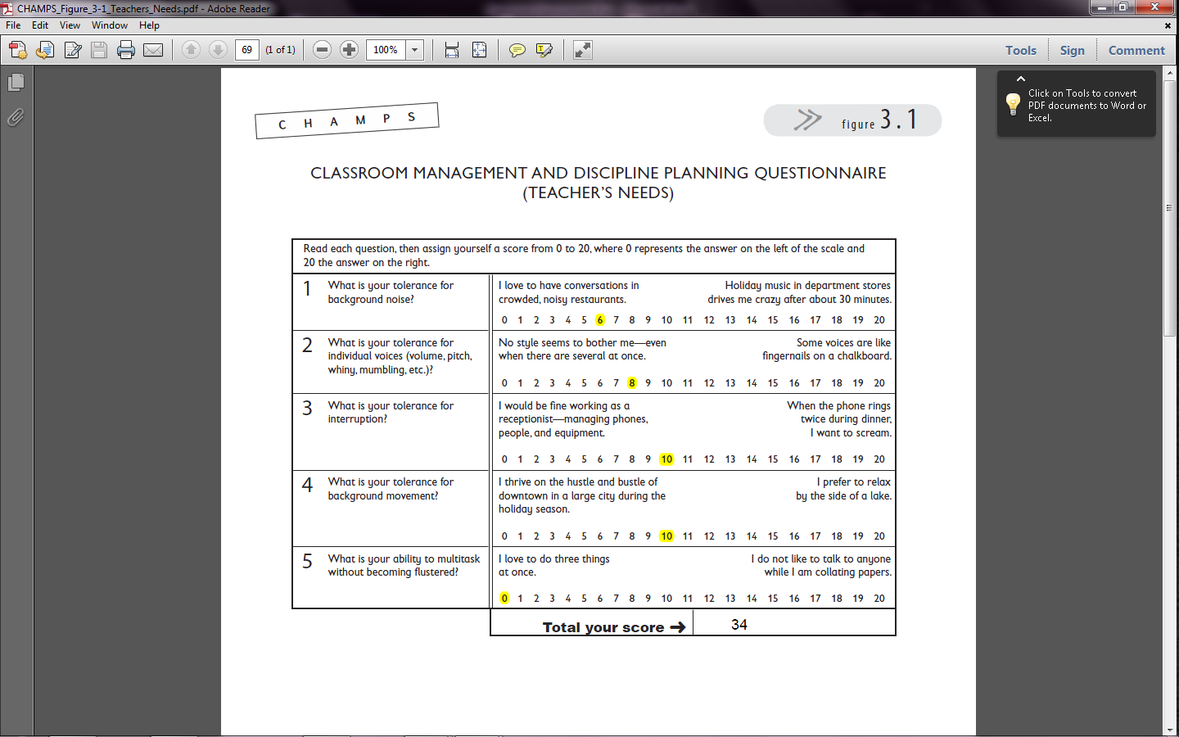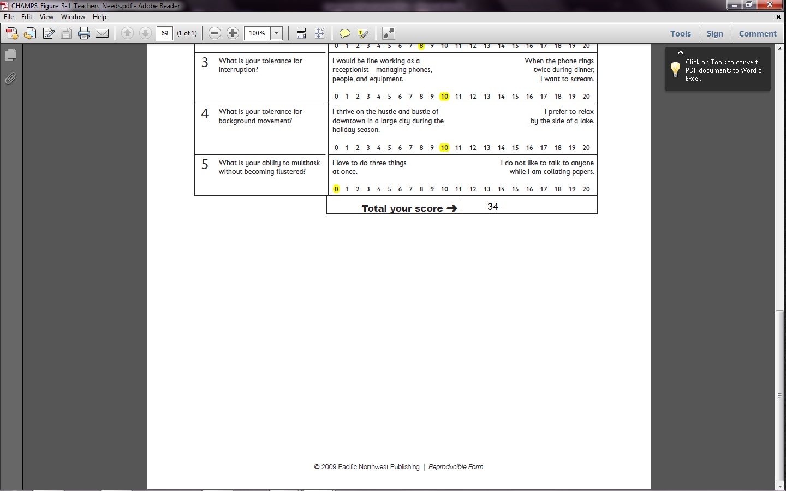

**Appendix A (continued)**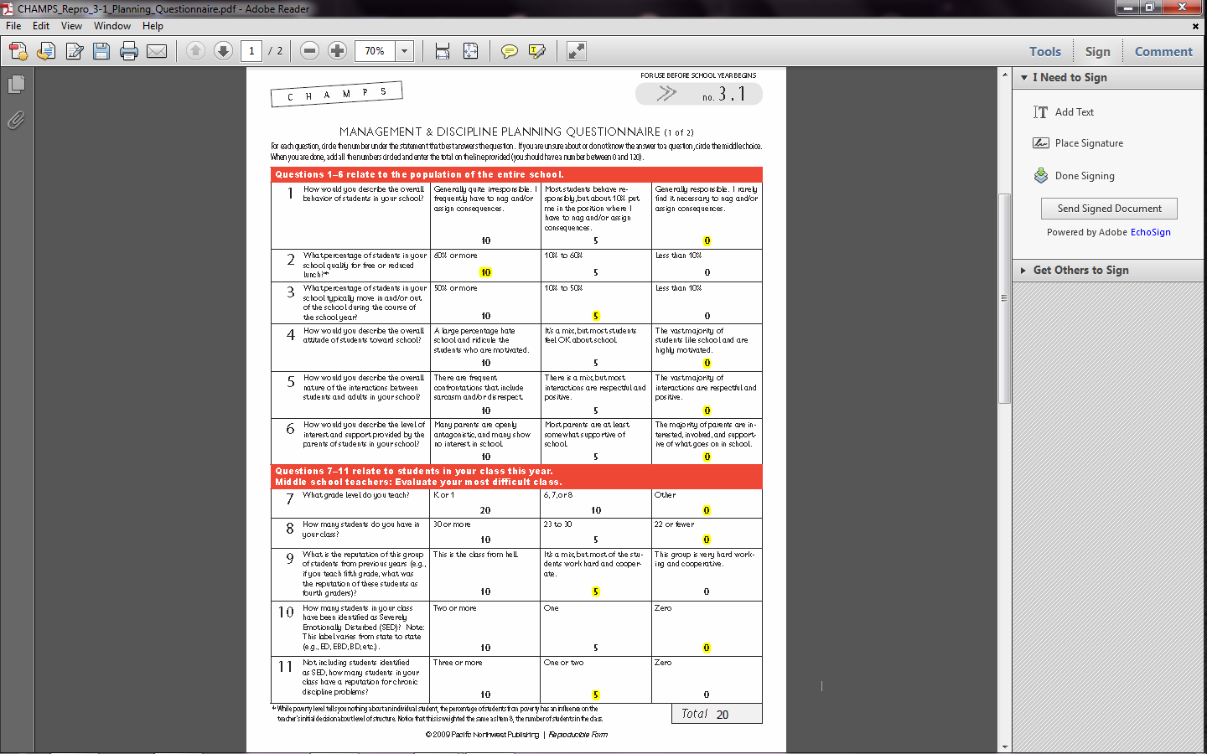

**Appendix B  
Classroom Layout**

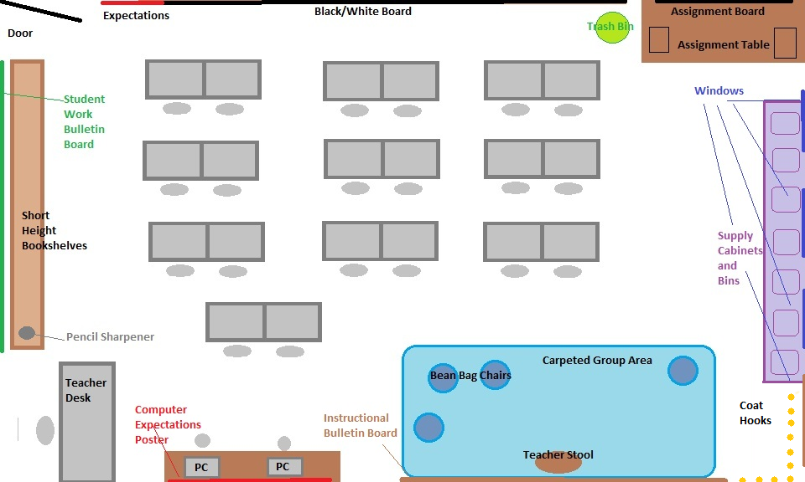

**Appendix C**

**Informal Behavioral Data**

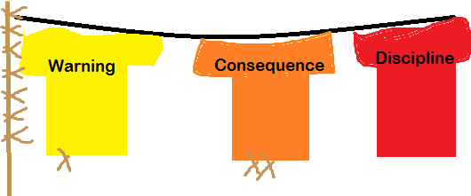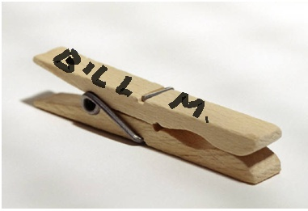

**Formal Behavioral Data:**

|  |  |  |  |  |  |  |  |  |  |  |
| --- | --- | --- | --- | --- | --- | --- | --- | --- | --- | --- |
| Student | Follow Directions | Be Respectful and Patient | Be Nice and Kind | Think and Be Safe | Be a Ready Student | No Problems | Warning | Consequence | Discipline | Notes |
| Alice |  |  |  |  |  | x |  |  |  |  |
| Bill |  |  |  |  |  | x |  |  |  |  |
| Carl |  |  |  |  | x |  | x |  |  | Forgot homework |
| Darwin |  |  |  |  |  | x |  |  |  |  |
| Edward | x |  |  |  |  |  | x |  |  | Missed directions, seemed tired today |
| Felicity |  |  |  | x |  |  |  | x |  | Hit Darwin (brother) again. |

**Appendix D**

**Assignment and Grade Tracking Workbook**

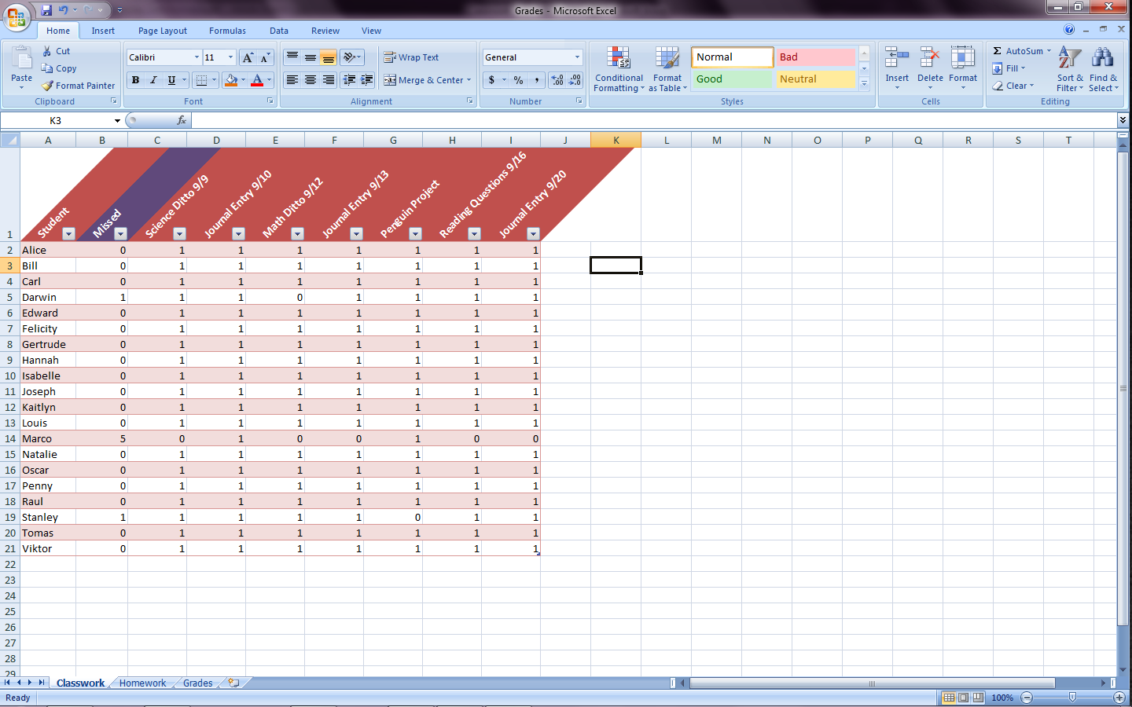

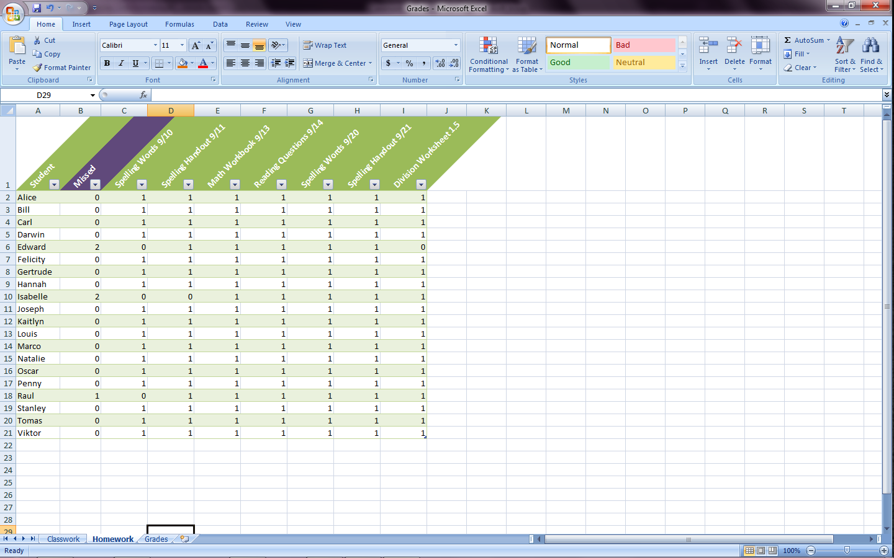

Full workbook available at <http://dl.dropbox.com/u/62405197/Grades.xlsx>.

**Appendix D (continued)**

**Assignment and Grade Tracking Workbook**

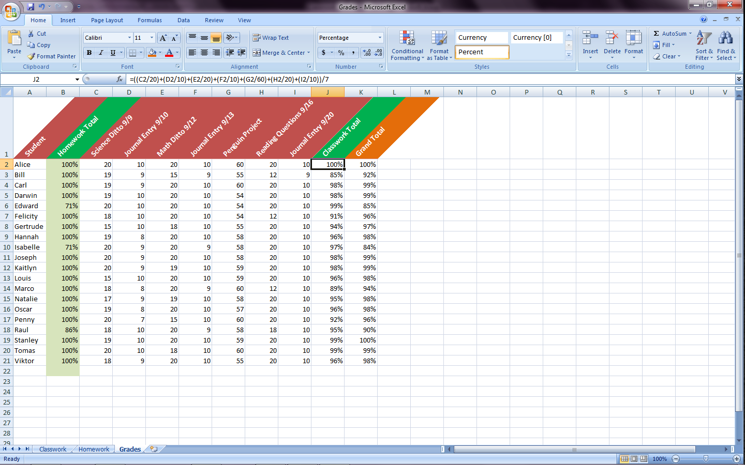

Full workbook available at <http://dl.dropbox.com/u/62405197/Grades.xlsx>.

**Appendix E**

**Behavior Spreadsheet and Mock Behavioral Data**

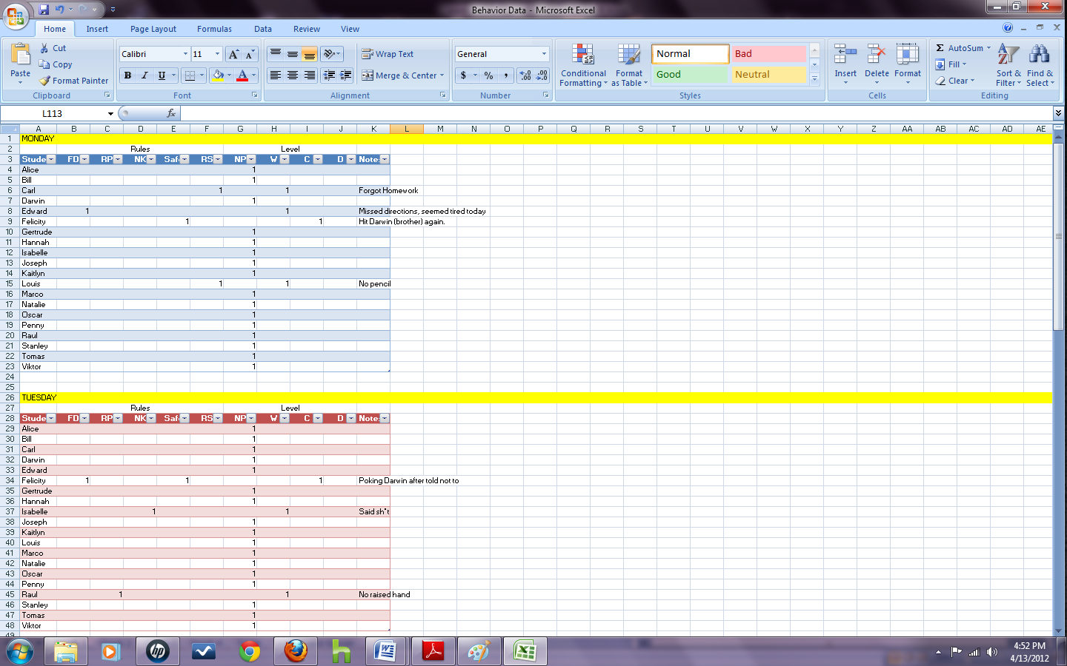

Full workbook available at: <http://dl.dropbox.com/u/62405197/Behavior%20Data.xlsx>.

**Appendix E (continued)**

**Behavior Spreadsheet and Mock Behavioral Data**

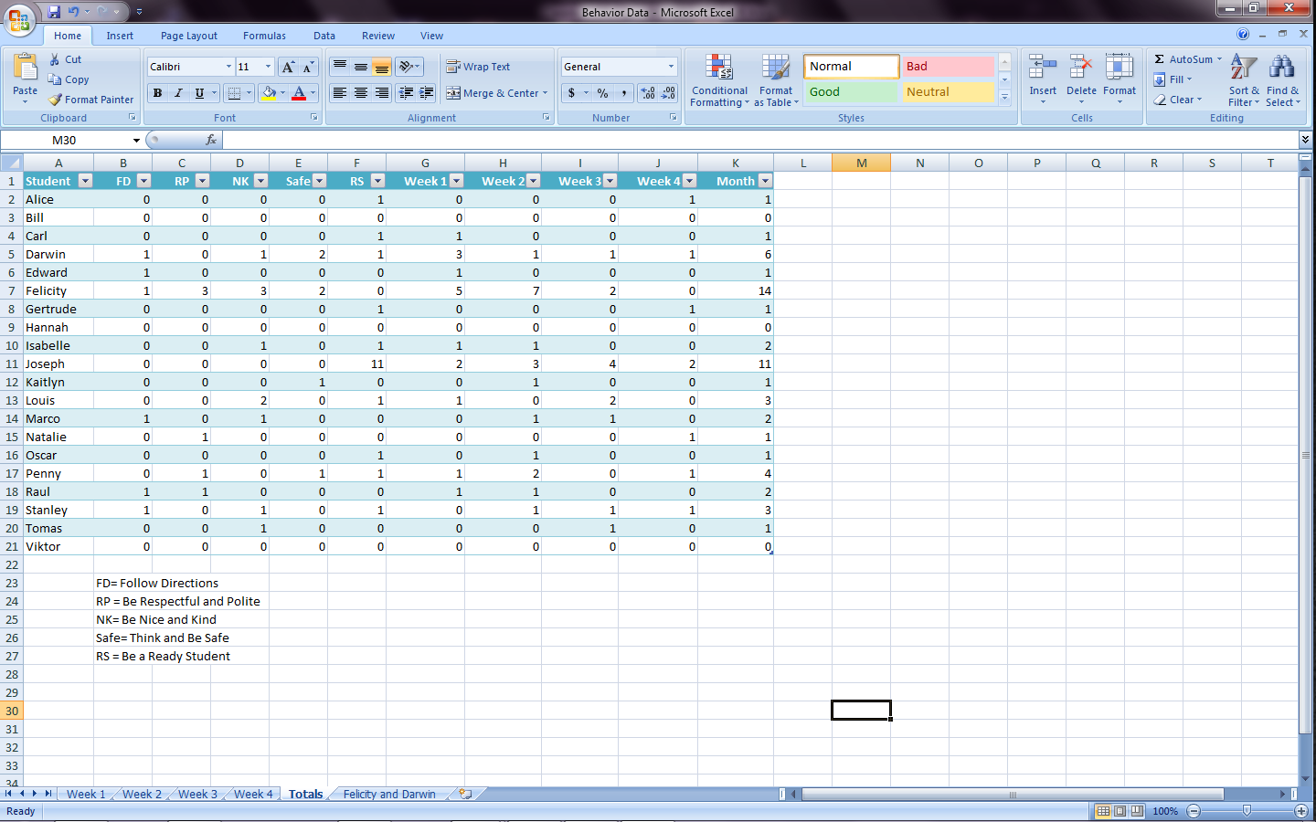

Full workbook available at: <http://dl.dropbox.com/u/62405197/Behavior%20Data.xlsx>.

**Appendix E (continued)**

**Behavior Spreadsheet and Mock Behavioral Data**

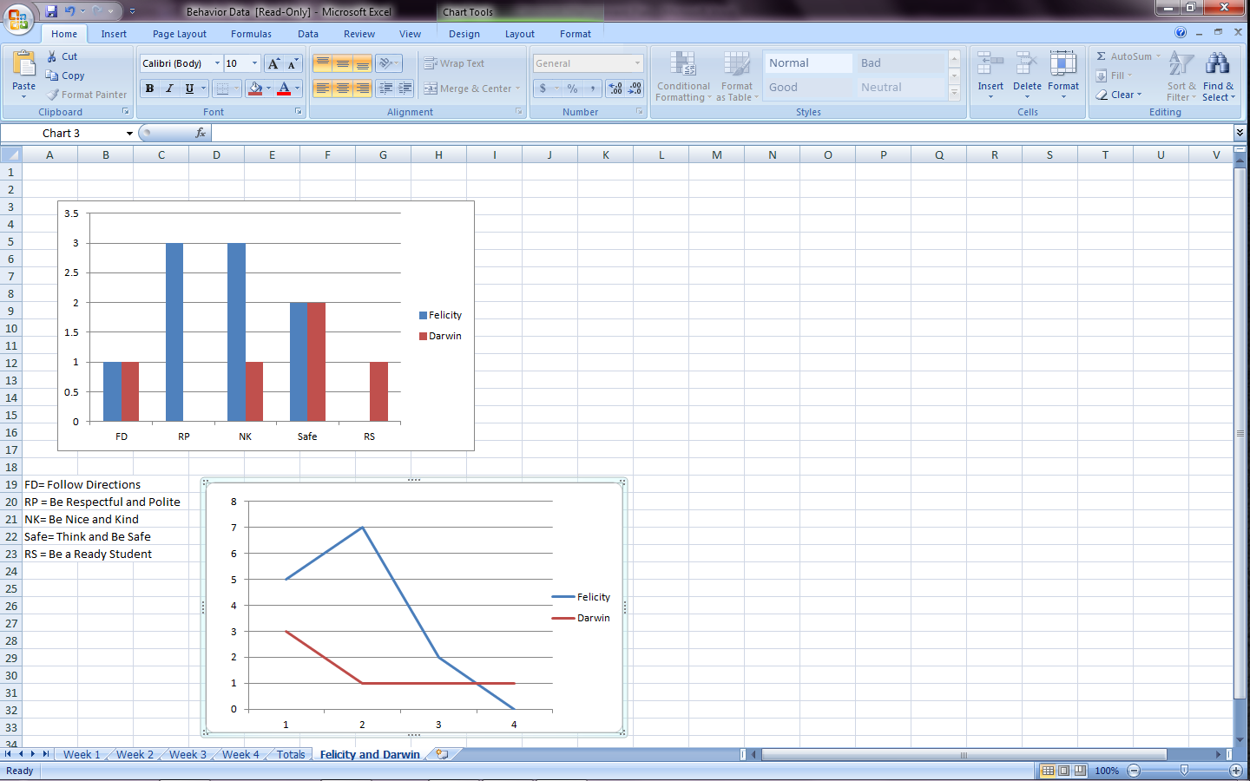

Full workbook available at: <http://dl.dropbox.com/u/62405197/Behavior%20Data.xlsx>.

**References**

Boushey, G. & Moser, J. (2006). T*he daily five: Fostering literacy independence in the elementary grades.* Portland, ME: Stenhouse Publishers.

Sugai, G., Horner, R. H., & Gresham, F. M. (2002). Behaviorally effective school environments. In M.R. Shinn, H.M. Walker, & G. Stoner (Eds.), *Interventions for academic and behavior problems II: Preventative and remedial approaches* (315-350). Bethesda, MD: National Association of School Psychologists.