Content for Unified Lesson Plan Template

Be sure to include student handouts, worksheets, and all assessment items with your submission.
Include PowerPoint presentation or overhead slides as appropriate. Please note all media sources.

1. Target Grade or Age Level. Grade 3
2. Pennsylvania Content Standards
- 3.2 Physical Science: Chemistry and Physics:
  - 3.2.4.A4. Recognize that combining two or more substances may make new materials with different properties.
  - 3.2.3.A6. Science as Inquiry: Use data/evidence to construct explanations and understand that scientists develop explanations based on their evidence and compare them with their current scientific knowledge.
  - 3.2.6.A4. Differentiate between physical changes and chemical changes.
- PA ELPS Level 2 (Beginning)
  - Reading: Locate and classify information associated with natural resources, technologies or tools within a small group. (applied as locating terms on the word wall and classifying information associated with physical and chemical changes with help from students in clustered seating arrangement)
  - Speaking: Describe the parts of the body presented in a model or illustration working with a partner. (applied as giving examples of changes in nature with help from other suggestions by students and trying to name it as a physical or chemical change)
  - Writing: Make collages or drawings to produce phrases and short sentences about objects made of different materials and textures (such as: paper, cotton, or wool). (applied as using pictures and phrases to collect data on observations of changes)
- PA ELPS Level 4 (Expanding)
  - Listening: Follow oral directions in the completion of a scientific process working with a partner. (or in clustered seating arrangement)
3. Learning Objectives:
- The student will recognize that combining two or more substances may make a new material by cratin a polymer from white school glue and borax solution. The student will be able to complete this task with 100% accuracy.
- The student will use data from recorded observations on a Observation Recording Handout (attached) of a melting ice cube and the creation of a polymer and use this data construct explanations and understand the differences between physical and chemical changes. The student is expected to complete the worksheet by filling in 100% of the observation boxes and participating 100% of class votes as described in the objective below.
- The student will demonstrate an understanding of the difference between physical and chemical changes by naming multiple reactions as a class and classifying them as physical or chemical changes by having a class vote whether the reaction is physical or chemical. The student will complete this activity with 90% accuracy.
4. Formative Assessments:
- The teacher will engage the class in conversation about the melting ice cubes to monitor understanding of the physical change. During the polymer creation and observations, the teacher will circulate among students and ask questions to check for understanding. Cues may be given to students to make certain observations of the polymers or comparisons between the polymer creation and ice melting reactions. The class will discuss what made the polymer reaction a chemical change once all students have completed the experiment.
- Students will have a recording sheet handout to help guide their observations of both the melting ice cube and the creation of the polymer. The teacher will look at the recording sheets to see if critical comparisons are being made that help specifically distinguish between what makes each either a physical or chemical change.
- After the completion of the observations, the class will name reactions together and vote on whether they are physical or chemical. When students seem less decisive about certain reactions we will discuss in detail why it is physical or chemical. The teacher will then offer a similar reaction to measure whether the previous explanation clarified the confusion. If a few students seem to vote on the incorrect answer repeatedly, the teach should ask why they believe that answer to be true and explain why the reaction is different from their thinking.
- All ELL and students with special needs will be seated in clusters with general education students. Students in the groups will model task completion and help guide students in their groups on how to fill out the Observation Recording Handout.
- During the class discussion and voting on reaction types, the teacher will be sure to note if students with special needs and ELL are participating. In the event students are not, reactions may be shown with a projector using a quick Google image search or by student modeling.
5. Summative Assessments:
On the end of unit exam, students will be presented with the following list of reactions and the words "chemical change" and "physical change" below each item. The student will be instructed to circle the correct reaction-type. Each item will be work 2 points and the section will account for 20% of the overall exam score. Correct answers are noted in parentheses next to each item. A modified assessment will be used for English Language Learners or children with special needs which includes images of each listed reaction. A word wall will remain up from when the experiment is conducted through the test with the "physical reaction" and an ice tray posted next to it and "chemical reaction" with the polymers created in class next to it. This will be noted before the exam so that ELL and children with special needs can match these words with the words to be circled on the exam. This will also be a visual aid for other students to remember the activity and increase test performance.
- A piece of paper burns (chemical)
- Water boils (physical)
- Glass breaks (physical)
- A nail rusts (chemical)
- Glue and Borax are mixed to make a polymer (chemical)
- Melting butter for popcorn (physical)
- Spoiling food (chemical)
- Mowing the lawn (physical)
- Fireworks exploding (chemical)
- Making chocolate milk (physical)

6. Materials Needed:
For each student:
1 plastic cup
1 spoon (plastic)
1 stirrer
~ 1 Tbsp school glue (may be watered down for easier pouring)
~2 Tbsp borax solution (1 part borax powder, 4 parts water)
Food coloring (optional)
2 paper towel sections

For each group of 2 students:
1 petri dish
1 ice cube

For the class:
2 extra rolls of paper towels
For the teacher:
Copies of Observation Recording Handout
Wordwall poster (with ice tray and polymer if ELL or students with special needs)
-includes: reaction, physical change, chemical change, polymer, baseline
A few pieces of scrap paper for physical change demonstrations
A match for chemical change demonstration

Note: Safety goggles may be necessary for younger students or in classrooms with students with emotional or behavioral disorders. Disposable gloves may be used for students with aversions to material with differing texture.
7. Expectations for Behavior and Class Activities:
- The teacher will remind students of safety needs using the "Three Monkeys" modeling technique where students model the "See No Evil, Hear No Evil, Speak No Evil" monkeys in order to remind us that science material (especially chemicals) do not go in the eyes, ears or mouth.
- The teacher will use the hands down for waiting and hands up for finished approach to monitor children's progress and keep attention as necessary.
- The teacher will explain the when someone is talking then others should be listening quietly. If necessary incorrect and correct models will be used at the start of class to remind students of these behaviors.
8. Description of Learning Activities:
Description of Introductory Activity (Anticipatory Set)
- Teacher will begin by engaging students in conversation about what chemistry is and activate background knowledge that there are plenty of chemicals in the world. Teacher will ask children about when chemicals change and introduce the term “reaction” in this conversation. The teacher should point this word out on the word wall to emphasize it to the class and pay special attention that ELL and children with learning disabilities are attending to the word. Students will be asked to name some changes they see in the environment and the teacher should use cues to include both chemical and physical changes (i.e. a rusting nail and making ice tea). The teacher will introduce the idea that there are two major kinds of changes or reactions in the world and the student will be able to tell her all about them at the end of this class.
Modeling/Demonstration (also elaborations/connections to content)
- Teacher will demonstrate a physical change by tearing a piece of paper and having the children observe that there is no actual change to the paper’s material (ie. The paper is still made only of paper). The teacher will explain that it might be possible to reverse this change and that there is no apparent byproduct to the change. The teacher will emphasize that these traits make this a physical change and point the word out on the word wall paying close attention that students with special needs attend to the gesture. Next, the teacher will explain that there is a different kind of change called a “chemical change.” The teacher will be sure to point this word out on the word wall in the same way. The teacher should light a match and have the children tell what happened and can cue to make sure the children observe the fire, the change of material to ash and that you cannot get back to the starting point. From this discussion, students will be able to answer the teacher’s questions about what a chemical change is and how it differs from a physical change. All students will be able to participate in this discussion/activity as they will be able to hear it and/or see it.
Guided Practice and Feedback (also probing questions/student responses)
- The teacher will have students attend to the ice on the tables they are at and observe how it is when it is first placed on the table. The students will use the handout (attached) to record a picture, what the ice smells like and what the ice feels like. This activity will be engaging for all kinds of learners by using a variety of senses and allowing those with limited language to draw the image rather than record in words. In this way, students with limited language or fine motor skills can still grasp the concepts of the lesson and observation skills. While students are recording their observations, the teacher should introduce the term, “baseline.” The teacher can focus on how baseline means the same as how the object was before anything was done to it or how it was at the beginning. As students begin to finish making observations, encourage those taking longer to be brief and concise with data but that taking time is being careful making it a good practice. Students that finish earlier can help the teacher to put glue and borax solution at each table if it is not already there.
- Once all students have completed the observation task, have students put glue into their cups (demonstrate this once at each table). If students with special needs are present use their cups at each table to demonstrate how to appropriately cover only the bottom of the cup with the glue. Next, have students mix food coloring into the glue using the stirrer (optional) and encourage them to use different colors (you can mention that this was a physical change later) than their peers. The teacher may have students keep their hands down on the table until supplies are present and then put their hands up when they have finished mixing the glue in the food coloring (hands down-hands up method). When all hands are up, students should be instructed to put their baseline observations on their sheets for the glue and borax solution separately. It is important to call this baseline only in order to measure how well students have understood this new term (formative assessment). If the students do not understand “baseline,” the teacher should see students asking peers or the teacher for clarification and the term should be more clearly defined.
- Once baseline measurements are completed, have students record observations on the ice cube (it should have begun melting by this point). This can be recorded as Stage 2 and should be called the beginning of the reaction in conversation. At this time hand out spoons only to students who have finished their ice observations for Stage 2. When all students have spoons review proper lab safety. The teacher may you “hear no evil, see no evil, speak no evil” monkeys and have students model this to remind students no chemicals in ears, eyes or mouth. Next, have students put two spoonfuls of borax solution into the glue, but DO NOT MIX. Have the students immediately record Stage 2 observations when the solution is added and constantly remind them not to mix the chemicals. Students will be anxious to mix the chemicals, so they will quickly complete the Stage 2 observations. Use of the hands down-hands up method would work well here. When all hands are up, students may mix the solutions. While students are mixing remind them of lab safety verbally and make sure to gesture ears, eyes and mouth to ELL students to reinforce the safety behaviors. Student will be excited by the polymer formation. Encourage their excitement and allow conversation. At one point use “eyes on me” and tell the students to record what they are seeing. It is likely that the students will begin the Stage 3 observations on their own, but important for them to remember the significance of observations and recording data. As students finish, instruct them to record their Stage 3 observations for the ice cube. If the ice cube has not completely melted at this time, the teacher might ask students to predict what would happen to the ice in 2 hours and record those hypothetical observations.
- After the activity students should discuss as a class what happened to both the ice cube and the polymer. Make sure to point out the word “polymer” on the word wall. This word is more difficult to remember so pointing out the “Y” in the center of it may be helpful for ELL and children with special needs. As the students discover that the ice cube melt was a physical reaction place and ice cube tray next to the “physical change” on the word wall. Similarly place the teacher’s polymer next to “chemical change.” This word wall should remain up until after the summative assessment for this unit in order to assist ELL and students with special needs.
Independent Practice/Exploring and Discussion Questions
- Make a chart on the board with physical changes on one side and chemical on the other. Ask students to name different kinds of changes or reactions they have witnessed. Next, have the entire class vote on whether this was a physical or chemical change. If the class’ vote is correct place the reaction in the appropriate column. If the vote is incorrect, explain why and put it in the correct column. If the class votes incorrectly be sure to suggest a similar reaction later and make sure they now understand it correctly (as displayed by a correct vote). Be sure to ask students why they are picking each answer. It is advisable to randomly switch between first asking the correct or incorrect side why they think that answer to be accurate. This will keep your reactions unpredictable and maintain accuracy in this formative assessment.
- In order to make sure diverse learners' needs are met, the teacher should make sure they are active in both suggesting reactions and the class votes. If any students are not participating in votes, suggested reactions should be modeled. This can be done by giving a live demonstration (when possible), using a quick Google images search and computer projector to display the reaction or having students model the reaction in front of the class. When live demonstrations are possible allow students to initiate the reaction when possible for a more independent exploration.
- The teacher should give some reaction examples as well. Make sure to include concepts such as suspensions and color changes and to explain why these are only physical reactions (same end product, settling). This is a good time to refer to the different colored polymers and ask students if they all have polymers even though they are different colors. You can use examples from students' lunches such as chocolate milk or sandwiches as well.
Review and Preview
At the end of the lesson tables will split up with half physical and half chemical reactions. The students will explain what makes a change either a physical or chemical change (based on table). At the end of the lesson, each student will be able to give accurate examples of each kind of reaction.
General Accommodations for Diverse Learners
The teacher will make the following modifications for diverse learners:
- Diverse learners will be seated in clusters with students performing at expected grade level. This will give a level of support for each student. The teacher must plan this seating arrangement with as little attention as possible in order to maintain a level of confidentiality for the special needs or ELL student.
- The Observation Recording Handout will be used for all students, but serve as a guided note tool for diverse learners. If students with visual deficits are present, the handout will be enlarged. For students with fine motor deficits, boxes within the worksheet may be enlarged to fit the student's needs.
- A word wall will be present throughout the lesson and during the summative assessment. The word wall will include the following words: reaction, physical change, chemical change, polymer, baseline. If ELL students are present, an ice cube tray will be mounted next to "physical change" and a sample polymer next to "chemical change" at the end of the lesson. This will help trigger knowledge of the activity to associate with the word.
- The teacher will give explicit instructions while modeling each step of the polymer creation activity.
- A wait time of at least 5 seconds will be used after questions or prior to votes to ensure that all students have ample time to understand each question or topic.
- Diverse learners will be expected to complete the objectives with equal accuracy to that of general education students. Any assistive technology used by diverse learners will be allowed for use during the lesson and assessment as it is normally used per the student's needs.
9. Sources:
Annenberg Foundation. (2011). Physical science: Session 4. Retrieved from http://www.learner.org/ courses/essential/physicalsci/session4/closer1.html.
Edinformatics. (2010, October 18). Physical or chemical change? Test your skills! Retrieved from http://www.edinformatics.com/math_science/a_p_chem.htm.

10. Reflections: After teaching the lesson, I think that I can enhance the handout with more images to help diverse learners. I would also never print this handout on double sided paper to avoid the confusion experienced during the lesson. As far as implications for teaching a class this information, I now know that this is more of a Grade 3 class project than Grade 4 although it’s learning objectives are advanced according to PDE expectations. I am now aware of different adaptations I might need to make for diverse learners and know that I need to wander the classroom and use modeling in order to keep students on task. I know that by holding off the initial instinct to mix to polymer materials the anticipation grows in students and the reaction becomes more exciting. I would do my best to captivate this excitement and make children aware of how much fun they had learning. Hopefully this will encourage a love for science in students that will last their lives.
Name: ___________________
Observation Recording Sheet
Stage 1 - Record how everything started (baseline).
Stage 1 |  | Ice Melt | Polymers
 | Drawing
 | Feel |  | Glue | Borax
 | Smell |  | Glue | Borax

Stage 2 - Record the beginning of the reaction. Ice melting and chemicals added together (not mixed).
Stage 2 |  | Ice Melt | Polymers
 | Drawing
 | Feel
 | Smell

Stage 3 - Record the end of the reaction. Ice completely melted and chemicals mixed together and removed from cup.
Stage 3 |  | Ice Melt | Polymers
 | Drawing
 | Feel
 | Smell

Comparisons
Question | Ice Melt | Polymer
Can you undo this reaction? | Yes No | Yes No
Did the state change?  (solid, liquid, gas) | Yes No | Yes No
Is there a byproduct (leftovers)? | Yes No | Yes No
Do you think the chemical changed? | Yes No | Yes No
Did the feeling change? | Yes No | Yes No
Did the smell change? | Yes No | Yes No

MODIFIED SUMMATIVE ASSESSMENT
A piece of paper burns.

PHYSICAL CHANGE
CHEMICAL CHANGE

Water boils. 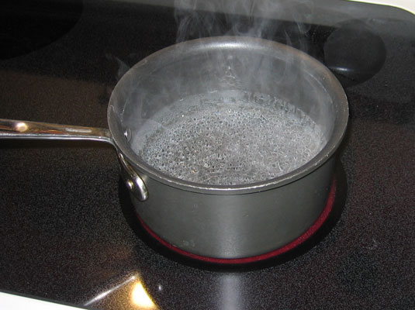

PHYSICAL CHANGE
CHEMICAL CHANGE

Glass breaks. 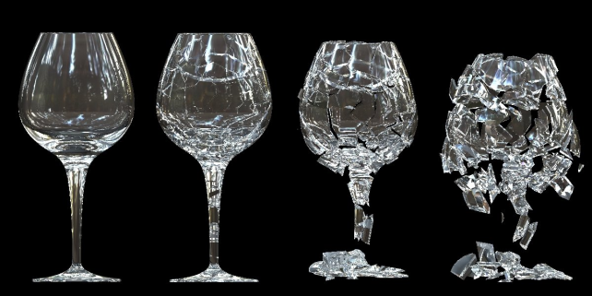

PHYSICAL CHANGE
CHEMICAL CHANGE

A nail rusts. 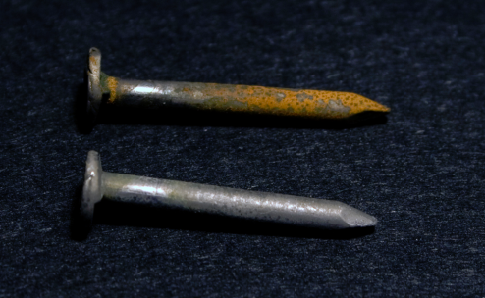

PHYSICAL CHANGE
CHEMICAL CHANGE

Glue and Borax are mixed to make a polymer. 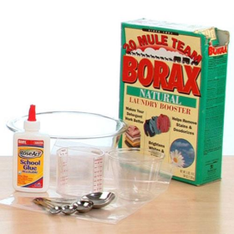 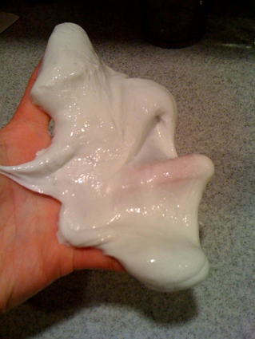

PHYSICAL CHANGE
CHEMICAL CHANGE
Melting butter for popcorn. 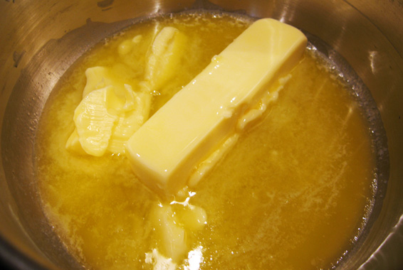
PHYSICAL CHANGE
CHEMICAL CHANGE

Spoiling food. 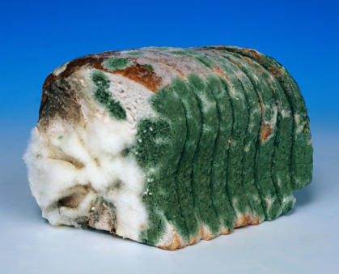

PHYSICAL CHANGE
CHEMICAL CHANGE

Mowing the lawn. 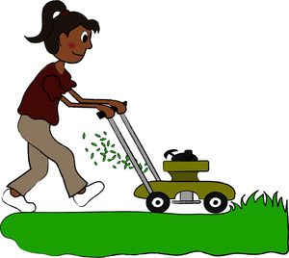

PHYSICAL CHANGE
CHEMICAL CHANGE

Fireworks exploding.
PHYSICAL CHANGE
CHEMICAL CHANGE

Mixing chocolate milk. 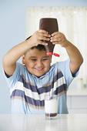

PHYSICAL CHANGE
CHEMICAL CHANGE

