Instructional Unit: Ready for Research

Gina Laura Ciani

Lehigh University

TLT 407: Instructional Design for K-12 Classrooms

April 25, 2013

Dr. Garrigan
Content | Strong presentation of unit plan with effective unit overiew.
Focus / Organization | +
Theory / Big Ideas / APA | Thoughtful integration of theory/research/big ideas  APA: +
Style | You were able to write formally and academically while providing concrete affordances to better communicate with your readers. One of the talents of a good writer is the ability to change styles according to context and readers.
Conventions | +
Summary | Gina, you’ve developed an ambitious unit plan using many techniques that, in theory, should help your students succeed. If you ever get a chance to teach this unit, I’d love to hear your reflections after it’s completed.
Grade | 25 out of 25 points

Instructional Unit: Ready for Research
Unit Overview
Title
Ready for Research
Target Learners
This unit is focused on a set of first grade students late in the academic year (last marking period). The students should have developed social networks within the class and moderate to high interpersonal communication skills with classmates and the teacher. These learners have varying math and reading abilities, and some have special needs or different levels of language learning that make some of the content difficult, but assistance is present both inside and outside the classroom for students requiring further support.
Unit Goal
Students will understand graphing and experiments and be able to ask a research question, predict outcomes, collect data, graph data, and present/communicate the results.
Rationale
This unit fulfills the need for an integrated research project in the first grade curriculum. Research is an ever-present concept in the lives of all people and is referred to regularly in all settings. Children need to understand what research means, entails, and how to effectively produce and communicate research. This unit will serve to introduce the early childhood learner to the act of research through a project-based, creative learning approach that allows for a high level of hands-on interaction, student choice, and multidisciplinary integration. In doing so, the first grade student will be able to understand research through their personal schema and make evaluative decisions of what various research findings mean to them. Furthermore, this unit allows for many other subjects to be taught in a meaningful and useful context.
Description of the Unit
This unit will be taught through the gradual release of modeling approach and project-based learning. The unit will begin with an introduction to the required concepts using literature integration and will continue with both full scale and daily gradual release of responsibility. In other words, the teacher will model each task independently first, guide students through the task with a high level of feedback second, and allow students to work on their own without assistance third. In this way, students will have opportunities to be prepared to achieve success during each element of the unit.
Project-based learning will be used by having students enact a research project in small groups. Students will choose their own research questions, collect data, present data in a pictograph, and share their findings as a group. Students will individually develop research questions, hypothesize outcomes, and determine results. Together, these activities will create a learning-by-doing environment which is conducive to learning skills for long-term success.
Scope of the Unit
In this unit, students will learn the science as inquiry process with a particular focus on each step of the process as defined by the Pennsylvania Department of Education (PDE) in each lesson. Lessons will aim to incorporate elements of other disciplines such as use of tally marks and graphs for mathematics, reading comprehension, and listening and responding skills. The students will achieve success with comprehending graphs, developing research questions, forming hypotheses, collecting data with tally marks, displaying and analyzing data using pictographs, drawing conclusions based on data, and sharing results via oral presentation.
Materials to be Included
The final products of the unit will consist of a summative assessment inclusive of the test items noted in the lesson plans, a pictograph representing each group’s data, and an oral presentation (preferably recorded for grading accuracy) by each group discussing their experiment and results. Additionally, one experiment guiding handout will be submitted from each group to assess their experimental procedures, but this form will be shaped by extensive formative assessment. Other materials include: the handout from day 2 working on comprehending graphs, Smart Board files from most days of the unit where students practice each step of science by inquiry, rough drafts of the guiding handouts per student, and any other drafted items such as data collection tallies or notes taken by students.
General Developmental Guidelines
This unit is designed to teach students how to use and understand data resulting from research in the science by inquiry format. After learning from this unit, students should feel prepared to participate in science by inquiry lessons of other kinds (with appropriate modeling) which are commonly used in second grade instruction and beyond. This unit also gives students the opportunity to work with one another and learn through seamless peer tutoring and assistance in the natural format of group work. In this way, students with special needs and other students will be included in instruction in the same manner as their peers providing for the most natural and inclusive setting possible for their learning.
Goal
Students will understand graphing and experiments and be able to ask a research question, predict outcomes, collect data, graph data, and present/communicate the results.
Related Standards
Using state and national standards for education allows students to seamlessly move between school districts without missing valuable elements of education. For example, a student may move from Michigan to Pennsylvania between grades three and four, but the student’s new teacher would have a general understanding of the child’s previous learning experiences based on the standards of teaching for third grade students in Pennsylvania. Furthermore, if that student moved within the state, there would be little or no change in expectations between the new student and the returning peers. As national, core-content standards are introduced and accepted, these standards will allow interstate movements to work in the same manner as intrastate relocations. Additionally, students in the US will all have equal opportunities for success upon completion of each grade level due to consistent student expectations. With such, the achievement gap seen between location differences, socio-economic status, and rural/suburban vs. urban school students should be lessened.
Pennsylvania Content Standards (PDE, 2010; PDE 2011; PDE, 2012a; PDE, 2012b)
Reading, Analyzing and Interpreting Text
- 1.2.1.E. Read and respond to essential content of text.
Speaking and Listening
- 1.6.1.A: Listen actively and respond to others in small and large group situations with appropriate questions and ideas.
Research
- 1.8.1.A: Generate appropriate questions about a topic.
- 1.8.1.C: Create and explain a research-based project in a small group.
Statistics and Data Analysis
- 2.6.1.A: Gather data from surveys and observations within the classroom or homes.
- 2.6.1.B: Organize and display data using pictures, tallies, charts, bar graphs and pictographs.
- 2.6.1.C: Describe data displayed in a diagram, graph or table.
- 2.6.1.D: Answer comparative questions based on representations of data.
Probability and Predictions
- 2.7.1.B: Predict and explain the outcomes of events.
- 2.7.1.E: Answer questions about predictions and actual outcomes based on data.
Science and Technology and Engineering Education
- 3.1/2/3.1.A9: Science as inquiry:
  - Distinguish between scientific fact and opinion.
  - Ask questions about objects, organisms, and events.
  - Understand that all scientific investigations involve asking and answering questions and comparing the answer with what is already known.
  - Plan and conduct a simple investigation and understand that different questions require different kinds of investigations.
  - Use simple equipment (tools and other technologies) to gather data and understand that this allows scientists to collect more information than relying only on their senses to gather information.
  - Use data/evidence to construct explanations and understand that scientists develop explanations based on their evidence and compare them with their current scientific knowledge.
  - Communicate procedures and explanations giving priority to evidence and understanding that scientists make their results public, describe their investigations so they can be reproduced, and review and ask questions about the work of other scientists.
Scarcity and Choice
- 6.1.1.D. Identify a choice based on classroom interest.
Common Core State Standards (National Governors Association Center for Best Practices, 2010)
- CCSS.ELA-Literacy.SL.1.1a Follow agreed-upon rules for discussions (e.g., listening to others with care, speaking one at a time about the topics and texts under discussion).
- CCSS.ELA-Literacy.SL.1.2 Ask and answer questions about key details in a text read aloud or information presented orally or through other media.
- CCSS.Math.Content.1.MD.C.4 Organize, represent, and interpret data with up to three categories; ask and answer questions about the total number of data points, how many in each category, and how many more or less are in one category than in another.
Content Analysis
Content Listing
This unit focuses primarily on conducting research using a social experiment and graphical data representations. Students use elements of reading, science, mathematics, and economics (a social study) collaboratively to thoroughly understand experimentation and analysis of data. The unit is based on the model displayed in Figure 1 where students learn the various steps of research which lead from a question to a discussion of results. Content is defined by elements of research as noted below.
Research
- Question
  - Hypotheses = Educated Guess
  - Answers = Facts (sometimes collection of opinions)
  - Social or Scientific
- Prediction
  - Is it possible? Likely or unlikely?
- Data Collection
  - Tallies
  - Social interaction
- Data Presentation (Analysis)
  - Graphs
    - Bar graph, pictograph, line graph (will use pictograph)
    - Discern more or less (or equal)
  - Were predictions correct? Why or why not?
    - Being wrong is ok too.
- Data Communication (Results/Discussion)
  - Public speech
    - Confidence, volume
  - What are the important parts to share?
    - Summarization
Content Sequence
The sequence of unit lessons is presented in Figure 2 which displays each conceptual idea by lesson focus in the order it would be instructed. Not all items noted in the content listing are presented in the content sequence because some skills are previously taught skills which are included in this lesson as a review or maintenance component. These skills include social interactions, explicit instruction of discerning more or less, understanding that being wrong is acceptable, public speech skills, and summarization. This lesson would be taught near the middle to end of the first grade year and the previously mentioned skills would have already been taught.
Objectives
- When presented with a graph, the student will identify which values are the least and greatest with 100% accuracy. (Knowledge; PA 2.6.1.C, PA 2.6.1.D; CCSS MD.C.4)
- When presented with questions and/or class discussion during a read-aloud of “Tiger Math,” the student will actively discuss items from the story by providing at least one comment or question related to the book (does not need to be a correct answer) with one or fewer verbal prompts. (Comprehension; PA 1.2.1.E; CCSS SL.1.2)
- Given a guided example with modeling in the prior lesson, the student will identify a preferential choice that students in the class make by writing (with words or pictures) two or three similar items students make a choice between with 100% accuracy (meaning, all items are related options for a choice). (Knowledge; PA 6.1.1.D)
- When involved in small group discussion, the student will use proper social interaction skills as determined by the Listening and Responding Checklist (Appendix A) with at least 75% accuracy. (Application; PA 1.6.1.A, CCSS SL.1.1a)
- Given a guided example with modeling in the prior lesson and a guiding hand-out, the student will work in a small group to plan and conduct an experiment which includes 100% of the following elements (do not need to be correct): a research question, a prediction, data collection (filled tally sheet), data presentation (filled pictograph), and data communication (picture or sentence about results). (Synthesis; PA 1.8.1.A., PA 1.8.1.C., PA 2.7.1.B., PA 3.1/2/3.1.A9)
- Given a blank tally chart, the student will work in a small group to use tally marks to collect data on a predetermined research question collecting at least one tally mark of data for each student in his or her class (outside the small group). (Application; PA 2.6.1.A, PA 2.6.1.B, CCSS MD.C.4)
- When presented with a blank graph, tally data, and stickers; the student will arrange the stickers into a pictograph that reflects the tally data with at least 90% accuracy. (Analysis; PA 2.6.1.B, CCSS MD.C.4)
- After conducting a study and discussing the results in a small group, the student will explain the results of his or her experiment to the class with the aid of a pre-created pictograph by including at least three out of the following five reflections: (1) what the prediction was and if it was correct, (2) which answer occurred more and less often, (3) how much more or less each group had, (4) disagreements in the data collected between group members and how they were resolved, and (5) what the overall result was (i.e. students in the class prefer chicken nuggets over pizza). (Evaluation; PA 1.8.1.C, PA 2.6.1.D, PA 2.7.1.E, PA 2.7.1.D, PA 3.1/2/3.1.A9, CCSS MD.C.4)
Assessment Plan
This unit has embedded assessments placed throughout which offer a highly engaging instructional environment with opportunities for formative assessment that do not interrupt or deter learning experiences. As such, there are no formal pre-assessments planned in the unit, but rather review of critical skills through student participation and chances for peer-facilitated tutoring through small group work. These approaches are used due to the vast level of variability between learner profiles within the present learning community. Mastropieri, Scruggs, and Berkely (2007) suggested that use of cooperative learning groups and peer tutoring helped struggling students achieve at levels similar to their peers and allowed teachers to meet the needs of increasingly diverse student populations. Through these methods, the need to pre-assess is negated due to multiple opportunities for students to acquire prerequisite skills for the unit.
Objectives and Aligned Assessments
Objective 1. When presented with a graph, the student will identify which values are the least and greatest with 100% accuracy. (Knowledge; PA 2.6.1.C, PA 2.6.1.D; CCSS MD.C.4)
This objective will be assessed both formally and informally through formative assessment methods. The teacher will read Nagda and Bickel’s (2002) “Tiger Math” to students, which offers text and a graph on each set of facing pages to tell the story of a zoo and a tiger cub struggling to keep the baby tiger alive and well. When each graph is presented to students, the teacher will describe how to read that kind of graph and then have students identify the greatest and least values in each chart. Before identification, the teacher must review what the greatest and least values refer to (highest and lowest values) in order to ensure prerequisite knowledge is available. For the first chart, the assessment will be done through a class vote on which value is the greatest and least to assess overall understanding. If students do not understand, the teacher must pause and reteach the concepts. On subsequent pages, one student will be called on to identify the greatest and another student the least value on the graph on each page. The teacher should use a checklist of all student names and mark a plus or minus sign to note whether or not the student correctly identified the value and to ensure all students have an opportunity to respond (OTR). Students who do not identify the correct value should be corrected, re-instructed, and given another OTR correctly.
The next formative assessment will be more formal in nature and use a handout for students to complete individually. For this, four exact copies of graphs from “Tiger Math” will be copied onto a handout prior to the lesson with questions requesting that students circle the greatest value and put an X on the least value on the graphs (copied in advance to prepare any teacher to give assessment). Directions will be read to students and printed on the handout to reduce the risk of depleted validity of the assessment due to the incorporation of reading or listening skills. If students perform poorly on this assessment, a review and possible reteaching of this skill will be incorporated into the next day’s lesson. If a select group of students need extra help, they can either be grouped with excelling students or quickly retaught in a small group during individual or small group work on the next class day.
Objective 2: When presented with questions and/or class discussion during a read-aloud of “Tiger Math,” the student will actively discuss items from the story by providing at least one comment or question related to the book (does not need to be a correct answer) with one or fewer verbal prompts. (Comprehension; PA 1.2.1.E; CCSS SL.1.2)
To assess comprehension “Tiger Math,” the teacher will periodically use an informal formative assessment where she will ask general questions about the story where children can give a thumbs up or thumbs down to agree or disagree and call on particular students to discuss the material in more detail. Comments about the story will also be accepted from students to demonstrate understanding. To be sure that each student understands the story more than just agreeing or disagreeing with the class, the teacher should use the checklist of student names described in Objective 1 to mark when students either present their own story-related feedback or answer particular questions. The teacher should provide a direct prompt (for example, “Jose, why do you think the tiger cub lost weights?”) on time to each student who does not initially volunteer a comment to evaluate that student’s individual comprehension. If the student cannot respond, the teacher should reteach some comprehension strategies in the context of the story to facilitate comprehension for that student. No formal assessment or summative assessment is necessary for this objective.
Objective 3: Given a guided example with modeling in the prior lesson, the student will identify a preferential choice that students in the class make by writing (with words or pictures) two or three similar items students make a choice between with 100% of items being related and possible items for a choice. (Knowledge; PA 6.1.1.D)
The instruction noted in the condition of the above stated objective will be inclusive of an informal pretest through practice that will guide teaching during that lesson. Here, the teacher will ask the students for suggestions of choices students make after providing the example of chicken nuggets versus pizza as a choice of favorite food. If students cannot identify choices, the teacher must explicitly instruct the students to identify choices that are made in a student’s day. She might go through her day and note choices she made including what clothes she wore, what she ate, how she did her hair and so forth. This should help students understand student choices.
During the class where this objective is assessed, students will be provided with a blank sheet of paper (with or without lines as preferred by the student). Then, the student will describe, list or draw a choice students make between two or three items. This choice will be something that the students could collect data about by asking the other students in the class what they chose. For example, if the student wrote the choice which shirt did you want to wear today and had options of long sleeve, short sleeve or tank top all students could answer that question. The teacher will look at each student’s choice listing and assess it for accuracy as a choice and guide students to correct any errors until 100% accuracy is achieved. From here, students will choose from the choices created in this assignment for their group’s experimental choice in Objective 5.
Objective 4: When involved in small group discussion, the student will use proper social interaction skills as determined by the Listening and Responding Checklist (Appendix A) with at least 75% accuracy. (Application; PA 1.6.1.A, CCSS SL.1.1a)
This objective will be assessed in both a summative and formative manner using the Listening and Responding Checklist (LRC, see Appendix A). At some point on days five and six of the unit, the teacher will observe each student when working in a small group and check off items as appropriate on the LRC. If a student is below 75% at this time, she will take him or her aside on Day 7 to discuss and teach listening and responding skills as relevant to this objective and standard PA 1.6.1.A. At some point on the last two days of this unit (preferably day nine), students will be summatively assessed on this objective in the same manner (teacher observation using LRC). This score will assess their listening skills after instruction.
Objective 5: Given a guided example with modeling in the prior lesson and a guiding hand-out (Appendix B), the student will work in a small group to plan and conduct an experiment which includes 100% of the following elements (do not need to be correct): a research question, a prediction, data collection (filled tally sheet), data presentation (filled pictograph), and data communication (picture or sentence about results). (Synthesis; PA 1.8.1.A., PA 1.8.1.C., PA 2.7.1.B., PA 3.1/2/3.1.A9)
This objective will be assessed first formatively and then semi-summatively as part of a group effort. In the first assessment, an "I do-We do-You do" format lesson will be used over several class days. On day one, the teacher will show the students how to conduct an experiment from start to finish using the guiding handout (Appendix B) that will be used in the assessment. The students will have their own copy of the handout to copy what the teacher writes down as an example and as an opportunity to practice writing skills. On the second day, the teacher will work through the same experiment format in a “we do” style where she will have the handouts distributed in the same way. Then, she will have the class create an experiment together, discussing each step in the group. Finally, they will correct their handouts to the same information to reflect accuracy. This is the formative assessment.
On the subsequent lesson days, students will work through their own studies by first identifying a topic and research questions and creating data collection sheets, then collecting data and graphing data, then interpreting their data and drawing conclusions, and finally presenting their data to the class. Throughout this, the students will use the handout (Appendix B) used in the previous experiment walk-throughs. On the day before the students present the data to the class, each group will hand in one completed handout and the teacher will provide feedback on that handout (spelling and major error corrections). During the next class, the students will have some time to correct any errors and will hand in a final copy of that handout when they present on their experiment to the class. This version of the handout will be used as a summative assessment of this objective where 100% completion will be expected.
Objective 6: Given a blank tally chart, the student will work in a small group to use tally marks to collect data on a predetermined research question collecting at least one tally mark of data for each student in his or her class (evaluated by group). (Application; PA 2.6.1.A, PA 2.6.1.B, CCSS MD.C.4)
This objective will be assessed both formatively and semi-summatively. For the formative assessment, the students will create a tally chart and collect data on the students in the class as part of the group experiment project. At the end of the class, the teacher will come around to make sure that there is a tally mark present for each student in the class outside the small group. If there is, the students will continue. If not, students will be instructed to try again and be very careful to include all students. To look at this skill in a summative format, the handout (Appendix B) described in Objective 6 will be assessed to make sure tally marks are included for each student in the class. This summative assessment may not be completely reflective of the application skill if the students achieved competence on the formative assessment because it would simply reflect the students copying this data onto the handout; however, the overall skill of being able to accurately collect data using tally marks will be assessed in a summative manner as no feedback will be given to further instruct students during the formative assessment when accuracy is initially achieved.
Objective 7: When presented with a blank graph, tally data, and stickers; the student will arrange the stickers into a pictograph that reflects the tally data with at least 90% accuracy. (Analysis; PA 2.6.1.B, CCSS MD.C.4)
For this objective, students will be assessed first formatively and then summatively. For the formative assessment, students will create this graph independently during the “we do” part of the instruction for Objective 4. When this graph is handed in, further instruction will be given as needed to particular students who did not achieve 100% accuracy. To summatively assess this objective, students will create a pictograph on a large blank graph (created by the teacher) that is reflective of each group’s research question. The students in the group will use stickers to graph their tally marks and hand that graph in after using it to present their data on the last day of the unit. These graphs will be the summative assessment permanent product.
Objective 8: After conducting a study and discussing the results in a small group, the student (as part of a group) will explain the results of his or her experiment to the class with the aid of a pre-created pictograph by including at least three out of the following five reflections: (1) what the prediction was and if it was correct, (2) which answer occurred more and less often, (3) how much more or less each option had, (4) disagreements in the data collected between group members and how they were resolved, and (5) what the overall result was (i.e. students in the class prefer chicken nuggets over pizza). (Evaluation; PA 1.8.1.C, PA 2.6.1.D, PA 2.7.1.E, PA 2.7.1.D, PA 3.1/2/3.1.A9, CCSS MD.C.4)
After conducting the group experiment previously discussed, the students will present their data and data findings as part of a group. Each group will have the large pictograph created as part of Objective 7 to assist in this presentation. This assessment will be completely summative and evaluated using a checklist of the five items described in Objective 8. The students will be provided with the prompts for each of the five objectives when planning the presentation of their group’s results. When the groups present, each group member will be required to talk about one or two parts of the experiment based on the prompts. If the groups’ conclusions or findings are not accurate, the objective will still be achieved as the evaluation process is being assessed rather than the accuracy element. Some formative assessment of this objective may be provided to groups as appear needed. This would be very informal and consist of the teacher circulating among groups while they are planning and asking question related to each prompt. This will only be done if group discussions are off-topic or not occurring at all as more of a redirection strategy with a side effect of formative assessment.
Learner Analysis
General Description
Eighteen first-graders ranging from ages 6 to 8 make up the present class with 56% male students and 44% female students. All students speak English as their first language and live at home with family, although compositions vary. Of the students families, 13 are traditional families with one including grandparents. Of the remaining four families, one student lives with both grandparents, two live with single mothers, and with a one single father. The class is modestly diverse with students of 67% Caucasian descent, 22% African American descent and 11% Hispanic descent. Students generally come from a range of middle socio-economic status (SES) families with 6% low class, 28% lower-middle class, 44% middle class and 22% upper middle class. Overall, the class tends towards a majority of white, middle-class, male students, but has a moderate amount of diversity.
Students bring a large amount of variability to the class with incoming academic abilities. Most students are at level in reading (38%), while 33% are below level and 28% are above. Similarly, students are mostly at level in mathematics with 22% below, 61% at and 17% above level. Unfortunately, much of the class is below level in writing (44%) with only 28% at level and 28% above level. Nevertheless, research indicates that first grade is a key time for intellectual growth, which is often greater in lower SES students whom comprise 34% of the present class (Kieffer, 2012). This suggests that despite the high percentages of low performing students in reading and writing, significant growth during first grade may compensate for any gaps in achievement.
Social skills data suggest that 39% of the students are below expected levels of interaction ability with many students showing shyness or bossiness. Increased social function and occasional bossy tendencies in first grade students are consistent with the findings of Howe (1993). Students show a large amount of variability in emotional development with prominent issues displayed through fears, tendencies to cry and attention-seeking behaviors. Howe suggests that these behaviors are characteristic of typically developing first grade students. Furthermore, 78% of the class shows appropriate attention skills while the remainder need some guidance. More promising, 89% of the class has appropriate or better fine motor skills while 94% have adequate gross motor skills, which are beneficial in acquiring the skills necessary for writing (Adolph, 2008).
Generally, researchers note that first graders are particularly energetic and enthusiastic about school and learning (Wood, 2007). With this inquisitiveness, first graders are prone to germ exposure and often become sick with colds, flus and other viral and bacterial infections. Furthermore, students are growing immensely at this age and often experience loose teeth, growing pains and initial experiences with visual and auditory impairments. The first grade student is just entering Erikson’s (1975) industry versus inferiority stage, which often results in emotional sensitivity leading them to cry easily when upset while relishing in achievements. According to Piaget, first graders are transitioning from the pre-operational to concrete operational stages of development where they will shift from an ego-centrical world view to one that represents multiple viewpoints and a greater sense of understanding (Santrock, 2004). With these transitions, first grade is a critical time when teachers must provide students with opportunities for success and guidance to develop meaningful comprehension of their environment.
Strengths
The first grade class has clear advantages in motor skills, which will facilitate writing development (Adolph, 2008) and physical skills required for play and mobility. With a propensity towards learning to write legibly and an ability to learn through well-controlled movements, the class will have opportunities for success. Ames and Archer (1988) found that increased academic success lead to the development of adaptive motivational habits. If success occurs in the target class, resulting motivation will help the students to attend to areas where they struggle and foster a continued excitement for learning.
Students are strong in math with 78% of the class at or above grade level. Similarly, the children are from mostly middle class families, which generally have computers at home. This will likely result in better overall technology skills. With these strengths, students will have an advantage towards learning in the science, technology, engineering and mathematics (STEM) domains, highly desirable skills in today’s world. Furthermore, a majority of the students have good attention skills that will enable them to learn effectively and acquire skills in areas where they struggle more easily. Together the strengths of the class will facilitate learning for all students.
Weaknesses
Students show clear weaknesses in reading and writing skills with 33% and 44% of the class below level, respectively. Similarly, most students are still developing social skills with 39% of the class showing signs of delay. With challenges in both of these areas, both teacher-to-student communication and inter-student communication will likely present difficulties. The teacher will need to ensure that directions are especially clear and communicate using a variety of methods. Furthermore, students in this age group are often very concerned with pleasing others and are often fearful of making mistakes (Erikson, 1975). This may discourage some students from trying to answer questions when they are not sure. Teachers should use confidence building exercises to assist in the development of a classroom community.
Areas of Potential Difficulty
Of most concern is the potential difficulty of facilitating communication between class members using proper social skills. More than one third of the class present social skill challenges such as bossiness and shyness, which seems typical for this age group. This will make all instruction requiring group discussion challenging, as some students may fear speaking in the group setting. Similarly, small groups will likely present challenges due to bossy personalities in groups, especially when shy individuals are present in the same group. Furthermore, students with aural processing deficits and developmental delays require thoughtful placement in groups to facilitate inclusion. Wood (2011) suggests that first graders often aim for perfection and are scared of making errors. Students will need experiences where they can succeed to facilitate confidence and deter fears of mistakes.
Another major area of difficulty may occur in the instructional pace necessary to help all students in the class achieve on or above grade level status in reading, writing and math skills. Many students are below in reading and writing and some in math as well. Moreover, most students below grade level in the previously stated skills are deficient in two or more skills. Some students will have a large amount of growth to acquire in general skills while others have little to learn. As with most learners, highly differentiated instruction is necessary to meet the needs of all students through fast-paced instruction for those who are behind, and engaging extracurricular instruction for those who have already mastered first grade skills.
Special Needs/Circumstances
To address special needs, the class will need to have focused instructional differentiation which changes by subject. Students will have leveled, homogeneous groups for writing and reading where students are grouped by being below, at or above grade level in reading or by writing level. Teachers will conduct monthly progress monitoring using the Dynamic Indicators of Basic Early Literacy Skills (DIBELS) inventory to evaluate reading (Good & Kaminski, 2002) and using the K-8 Continuum for Assessing Narrative Writing to evaluate writing (The Reading and Writing Project, 2013). Furthermore, teachers will monitor math competency using the AIMSweb test of early numeracy (Baglici, Codding & Tryon, 2010); however, math instruction will use heterogeneous grouping based on research displaying higher efficacy in mixed learning groups during math (Burns, Hueburt & Levin, 2006). Students will begin the year by taking each of these tests in order to confirm the accuracy of the previously collected data prior to sorting students into groups for instruction.
During the rest of the instructional day, students will work in small groups of four to five students, specifically mixed by academic and social ability levels. These groups will help to facilitate growth in students whom are struggling and keep those who are excelling engaged. In addition to helping build friendships, the use of cooperative learning groups was shown to lead to greater learning than individual conditions (Hsiung, 2012). As such, teacher will use small groups as much as possible throughout the school day, and teachers will make suggestions for homework groups to parents. Preliminarily group compositions are presented in Table 1.
Some students have specific special needs. Tony and Erica have developmental delays in both academic and physical domains. Tony will be paired with a peer buddy, Rebecca, who has strong social skills and is academically advanced. Similarly, Erica will be paired with a peer buddy, Alex, who has strong social and academic skills. She will also be paired with a Feeling Friend, Richie, who has similar home life patterns for extra emotional support to both students.
Antonio has aural processing challenges, which prevent him from understanding spoken directions. The special education team will continue to work with Antonio on aural processing, while he will highlight his excellent reading and writing skills in the general education classroom. Teachers will provide Antonio with a dry erase board to help him communicate with other students at all times and write all spoken directions on the board to aid Antonio in following directions, while exposing the rest of the class to extra written language. To help both Antonio and Jack develop, they will be paired as peer buddies. Jack needs to develop vocabulary and is a strong writer while Antonio may need help with spoken directions.
Finally, Billy struggles on days when he is tired or might have a developmental delay. At the start of the year, the teacher will conduct a functional analysis of Billy’s behaviors to help determine where he needs assistance most. The school may conduct a family conference to discuss Billy’s eating and sleeping patterns. If necessary, Billy might be able to have breakfast at school or take a nap at the beginning of the school day when needed. These would be temporary accommodations set in place until permanent lifestyle interventions are determined and implemented.
Conclusion
Despite the challenges of many below level learners, strengths in motor skills and mathematics will help allow for a focus on the students’ strengths in order to develop their weaknesses. Developing social skills and transitions to operational thinking styles make the incorporation of direct social skill instruction into other disciplines very important and create a need for a well-structured and reinforcing classroom management plan. Unique needs of individual children facilitate the use of peer buddy systems and heterogeneous grouping to allow for peer tutoring and cooperative learning groups. Meanwhile, different levels of literacy development make progress monitoring vitally important and use of homogeneous grouping to meet diverse student needs critical. Together mixed and tracked grouping will work in conjunction to facilitate the most effective learning community for this classroom, which focuses on students strengths to develop their weaknesses and provide optimal opportunities for student growth.
Instruction Plan
This unit will introduce students to graphing and help them develop proficiency with creating and evaluating a pictograph. The students will do this through a social experiment where they will create an experiment to determine a preference among students in their class, collect data using tally marks, analyze the data using a pictograph and share their findings with classmates. In short, students will use science as inquiry to develop a thorough understanding of pictographs, choices and the scientific inquiry process. The instruction will occur over ten subsequent school days with 40 minute lessons daily as delineated below. A graphical description of the unit flow is available in Figure 3.
Day 1/2: The first day will start with the teacher reading the first two thirds (pages 1-19) of “Tiger Math” by Nagda and Bickel (2002) to students. At each graph in the story (one on each set of facing pages), the teacher will explain how that kind of graph is read and then ask two different students to identify either the greatest or lowest value in the graph to check for understanding and objective completion. The teacher will use a checklist to make sure all students receive an OTR correctly. Periodically, the teacher should ask the class a question about the book or accept comments from students to check comprehension. At first she might use thumbs up or thumbs down replies from students to check for understanding, but she should transition to use of individual OTR. A mark should be placed on the same checklist noted above to make sure every student has an OTR to the story and has hence been evaluated for comprehension of “Tiger Math.”
The second day of instruction will proceed in the same manner as described above for the remaining third of the book (pages 20-29). After the book is completed and discussion time is concluded, students will be assessed using a handout picturing four exact copies of graphs from the book where they will identify the greatest and least values on each graph. Directions on the handout will be provided written on the handout and read aloud to the students to reduce invalidity of the assessment to measure the stated objective.
Day 3: This day of instruction will introduce the science inquiry process with respect to student preferences and choice. After a brief discussion about what an experiment is and how they are used in general, which provides opportunities for students to connect to background knowledge, the teacher will introduce the concept of choices and preferences. To begin, the teacher may talk about what each child would bring to school for lunch if they could pick anything. Then, she could mention that the answer reflects their preference for lunch foods. She would then provide time for the students to identify some other choices and preferences such as favorite colors, video games, clothing styles, and so forth. This will segue into the social experiment.
The teacher can begin by saying that she wants to use an experiment to determine the preference of students in her class. The teacher hands out the Experiment Guiding Handout (Appendix B) for the class to copy her on at this point. Next, she would pick a research question and write it into an enlarged copy of the handout: Do students in Miss Ciani’s class prefer pizza, chicken nuggets, or hamburgers? Next, the teacher would identify her hypothesis, reminding students that this is her educated guess of what the experiment will show. She will state this out loud and write it into the handout. For example, students in Miss Ciani’s class prefer pizza over chicken nuggets and hamburgers. Next, the teacher will collect data on the provided tally chart. She will label columns for each option and use tally marks to record each student’s response to the research question noting their individual preference. Next, she will use stickers to transcribe the tally marks into a pictograph on the second page of the handout. From the pictograph, the teacher will identify the highest and lowest values and write a conclusion that reflects the data. Students will save their handouts to use as a guide when doing their own social experiments.
Day 4: Day 4 will run almost identically to Day 3. Instruction will take the “we do” format as opposed to yesterday’s “I do” format. Instruction will begin with the class identifying a new preference-based research question. Then, all steps described after that point in Day 3 will be followed with the teacher following and guiding student suggestions to proceed through each element of the experiment. Students should tell the teacher what steps come next and how to do each step. Students will also come up to fill in each part of the guiding handout (Appendix B) and fill in individual copies for reference.
Day 5: Students will work individually today to explore student preferences. Using a blank or lined sheet of paper, students will identify a choice that reflects a preference that students make from either two or three options. The students may draw pictures or use words to describe these options. The teacher will discuss the Experiment Guiding Handout with students to close the week’s learning and have them think about experiments to conduct in their cooperative learning groups during the following school week.
Day 6: The teacher will begin with a very short review of the science inquiry process using the guiding handout (Appendix B). Next, the students will break into their pre-determined cooperative learning groups. These groups should be interspersed with high level and low level students with regards to math, reading, and writing. Students who do not get along should not be grouped together. In groups, the students will select a choice preference from the activity on Day 5 to use as their research question and write this on the guiding handout. The students will then individually determine their hypothesis for the experiment and the group as a whole will create or use the handout to make a tally data collection tool. While students work in groups, the teacher will assess their listening and responding skills using the LRC (Appendix A). This assessment may be conducted on either Day 6 or 7.
Day 7: Students will use their tally charts created on Day 6 to collect data from all students in the class. The teacher will draw straws to select the order of groups which are asking for student data to ensure that only one group is collecting data at a time. Each student in each group should collect his or her own data on their handout and then compare that data with his or her group to make a final data tally on the chart created on Day 6. This will allow students to check data for consistency (quality control). The teacher should check each group’s data to confirm that there is one tally mark for each student outside the small group. While students work in small groups, the teacher will assess their listening and responding skills using the LRC (Appendix A). This assessment may be conducted on either Day 6 or 7 and formative feedback should be provided on Day 7.
Day 8: Today students evaluate and analyze their data collected on Day 7. The students work in their group to first individually create a pictograph of the results and then draw and record a conclusion about the results on their guiding handout (Appendix B). Then, the students should work in their group to create a large copy of the pictograph to present to the class. The group should talk about the results and draw a conclusion as a group. Guiding handouts will be individually turned into the teacher for formative assessment at the end of this lesson. The teacher will evaluate the general accuracy and completion of these handouts and hand them back to students on Day 9.
Day 9: Students begin by getting back their guiding handouts and working in their small groups to create a final copy of the handout (one per group) to be handed in as a summative assessment reflective of their performance in completing their experiments (permanent product of performance). Next, the teacher will write the components of a good data presentation on the board as noted in Objective 8: (1) what the prediction was and if it was correct, (2) which answer occurred more and less often, (3) how much more or less each option had, (4) disagreements in the data collected between group members and how they were resolved, and (5) what the overall result was (i.e. students in the class prefer chicken nuggets over pizza). The students will talk in their small groups and plan their presentation for the next class day. The teacher must tell students that each group member is expected to talk during the presentation and give one to two of the components noted. Finally, students will have time to practice their presentations in their small groups.
While students are in their small groups, the teacher will summatively assess their listening and responding skills using the LRC (Appendix A). This data should be collected on all students during Day 9 if possible. Students who scored above 75% on the formative assessment using the LRC do not need to be reassessed as the formative assessment may count as a summative item due to the lacking need of feedback.
Day 10: Today students will present their research. Using the reverse order of the data collection on Day 7, students will present their data as a group (one group at a time) to the class. During presentations, the teacher will use a checklist noting the five elements in Objective 8 as criteria. Students will receive a grade of “Exceeds Expectations” if all five elements are discussed, “Above Expectations” if four of the five are discussed, “Meets Expectations” if three out of five are discussed, “Below Expectations” if two out of five are discussed, “Did Not Meet Expectations” if one out of five expectations are discussed, and “Denied Expectations” if no elements are discussed. Pictographs of the student’s work and the final copy of the experiment guiding handouts will be posted in the hallway to celebrate students’ success with the project.
Lessons for Further Development
Lesson plans will be provided for Days 1/2 and Day 8 in order to evaluate both lower level and higher level thinking according to Bloom’s Taxonomy. The lesson for Days 1/2 was chosen because it is difficult to construe the level of detail involved in teaching those lesson without giving information about the instruction explicitly. Also, these days of learning will build the graph comprehension and data meaningfulness required for students to achieve success with the remainder of the unit. With such importance, a detailed lesson is needed for this day set in order to provide for a clear unit basis. Day 8 was chosen because it highlights an activity that relies heavily on previous elements of the project-based, student-led research project. The pictograph construction and result determination activities showcase the link between the research activities and the collaboration of all previous learning activities to build a fuller understanding of the research purpose as a whole.
Lesson Plans
Days 1/2: Multiday Lesson Plan

Lesson Introducing Graphs with “Tiger Math”
Subjects Science/Math/Reading

Target Grade/Age Level: Grade 1
This class is comprised 56% male and 44% female students from diverse cultural and socio-economic backgrounds. Two students have IEPs one for aural processing deficits and another for developmental delays. There are a few ELL students in the class in the developing stage of English language proficiency.

Pennsylvania/National Standards:
PA Standards Reading, Analyzing, and Interpreting Text:
1.2.1.E: Read and respond to essential content of text.
PA Standards Statistics and Data Analysis:
2.6.1.C: Describe data displayed in a diagram, graph or table.
2.6.1.D: Answer comparative questions based on representations of data.
PA English Language Proficiency Standard for ELLs standards:
English language learners communicate in English for SOCIAL AND INSTRUCTIONAL purposes within the school setting.
English language learners communicate information, ideas, and concepts necessary for academic success in the content area of LANGUAGE ARTS.
English language learners communicate information, ideas, and concepts necessary for academic success in the content area of MATHEMATICS.
English language learners communicate information, ideas, and concepts necessary for academic success in the content area of SCIENCE.
Common Core State Standards:
SL.1.2: Ask and answer questions about key details in a text read aloud or information presented orally or through other media.
MD.C.4: Organize, represent, and interpret data with up to three categories; ask and answer questions about the total number of data points, how many in each category, and how many more or less are in one category than in another.

Learning Objectives and Aligned Summative Assessments:
Learning Objectives | Aligned Summative Assessments
When presented with a graph, the student will identify which values are the least and greatest with 100% accuracy. (Knowledge; PA 2.6.1.C, PA 2.6.1.D; CCSS MD.C.4)  When presented with questions and/or class discussion during a read-aloud of “Tiger Math,” the student will actively discuss items from the story by providing at least one comment or question related to the book (does not need to be a correct answer) with one or fewer verbal prompts. (Comprehension; PA 1.2.1.E; CCSS SL.1.2) | Handout with pictures of graphs (4 graphs total) where students will place an X on the highest value and circle (O) the lowest value.  NOTE: this will act as a formative assessment if the criterion accuracy (100%) is not met, and reteaching will occur.  Formative assessment only.

Materials Needed:
- “Tiger Math” by Nagda and Bickel (preferably scanned into a SMART Board file or as a ‘big book’)
  - SMART board File included with project submission – (technology)
  - If using SMART board file, SMART board needed for lesson
- “Tiger Math” individual book for special need learner(s)
  - “Tiger Math” text and graphs are available in uploaded pdf with the same name
- One handout for each student (attached)
- Computers with Internet access (especially for gifted learners)

Expectations for Behavior and Class Activities:
- When others are talking students will listen quietly to what they are saying.
- When students want to answer a question they quietly raise their hands and wait to be called on.
- Students will sit safely, criss-cross applesauce on carpet during reading of “Tiger Math.”
- Students will sit safely at desks during independent work.
- Students will actively participate in all activities giving their best efforts.
- Students will ask a peer for help before asking the teacher during independent or group work.
- Students will always give their best effort during activities, instruction and on assessments.
- Students will come to class on time and prepared with a pencil and ready to listen.

General or Specific Accommodations for Special Needs Learners:
- English Language Learners (ELL):
  - ELLs will be paired with native English speaker peer-buddies during independent work that they can go to for assistance.
  - During the read aloud, the teacher will point to images and graphs to facilitate a better understanding of the story for ELLs.
- Student with aural processing deficit:
  - All verbal instruction will also be provided visually (usually through standard, grade-level text) to provide for equal learning opportunity.
  - During the read aloud, the target student will have an individual copy of “Tiger Math” to read along with the teacher’s reading.
  - The target student will be able to use a speech to text device during all parts of the lesson to facilitate comprehension.
- Student with developmental delays:
  - Student will be seated near the front of the class for increased access to teacher assistance and proximal preference during modeling.
  - Student will have access to a pre-trained peer buddy to assist with any task as needed during the lesson.
- General Accommodations:
  - All methods of assistive technology normally available to students will be available during this lesson.

Description of Learning Activities:
Introductory Activities (Anticipatory Set):
The teacher should ask the students to tell what they know about statistics and graph data. Students should give responses along the lines that statistics are numbers of people that do different things or think different things. They might cite the news or the internet as sources of these things. For graphs they might note lessons in kindergarten, weather graphs on the news, or other sources. Use this as a time to share background knowledge about graphs and data.

Once students have finished sharing, introduce the book, “Tiger Math,” to the class. Ask students to identify the authors and title on the cover of the book (skill previously taught). Talk with students to make predictions about what the story could be about and what genre the story my represent (non-fiction). Show pictures on the introductory pages for students to use as tools to help clarify their predictions, and then begin reading.

Modeling/Demonstration:

Read the first page (7) and then refer to the graph on page 8. Read the caption to help describe how to read the graph. Then use a think-aloud technique to help students understand how you use your knowledge about the graph to determine the values.

Teacher: From the text I know that each picture of a tiger means 500 tigers. If I look at the pictograph and find the columns, it says Bengal Tiger, Indo-Chinese Tiger, Sumatran Tiger, and Siberian Tiger. They all say tiger and I remember that Sumatran Tiger is a kind of tiger that is different than a Siberian Tiger. So, I think each column is talking about a different kind of tiger. I remember that the largest or greatest value means the one that has the most, and see that Bengal tiger has the most tiger pictures. 8 tigers. I know that Bengal tigers must be the most tigers. I can look at the number of tigers on the left side to know that 8 tigers is 4,000 tigers. I can look again and see that Sumatran and Siberian tiger is tied for one tiger. I remember that means 500 tigers just like the graph says. Those must have the least or smallest amount. So, Bengal tigers are the most and Sumatran and Siberian tigers are tied for the least amount of tigers.

NOTE: If you are using the SMART Board version of the book, you should circle the largest value and place an X on the lowest values. This will foreshadow the activity they will do in independent practice. – (technology)

Guided Practice and Feedback:
Read page 9 and learn a little bit about TJ and his mom, Buhkra. Then look at the pie graph on page 10. Read the description of the graph and guide students to interpret the graph for the largest and smallest values.

Teacher: Now I know what a pie graph is. I remember that the least value is the smallest value. Who can help me find the smallest value on this graph.
Student 1: This student should point out the tiny sliver of yellow that represents tigers in South China and explain that it was the smallest part of the circle that was one color.
Teacher: Great work, Student 1! You saw the smallest part of the graph was South China. South China tigers only make up 1% of the tigers in the world. Who can help me find out from this pie graph what kind of tiger is the most?
Student 2: This student should respond that the big, black part of the circle is Bengal and that is the most because it is bigger than all of the other parts.
Teacher: Good job, Student 2! Who can tell me anything else we can tell from this graph?
Students will respond about the order of different values in the graph. Once 2-3 students have responded read onward.

Continue reading one page and then one graph at a time. After each graph, have two different students identify the least and greatest values on the graphs. Use a checklist to make sure each student responds at least once. As you continue reading, ask students questions about the text on the pages to check for understanding. For instance, after reading page 11 the teacher could ask whether TJ or his dad weighed more at six weeks old or what a veterinarian is or does. Again, use the checklist to make sure each student responds to a comprehension question at least once. – (Memory techniques (repetition/rehearsal/practice)

Read in the manner described above through page 19 on DAY 1. Read the remainder of the book in the same way on DAY 2. Before beginning the reading on DAY 2, review what was already occurring in the book. Ask students if their predictions are the same or different than the previous day and how. Finally, read the remainder of the book. When the book is over, talk about how students’ predictions were or were not accurate and ask students questions to help retell the story and review the content.

NOTE: If you are using the SMART Board version of the book, you should have students circle the largest value(s) and place an X on the lowest value(s) on each graph. This will foreshadow the activity they will do in independent practice. – (technology)

Independent Practice/Exploring:
Distribute the handout (see attached). Students should work independently unless described otherwise in the accommodations for special need learners section of this lesson plan. Students will practice identifying the least and greatest values on graphs from the actual book, “Tiger Math.” If students finish early, please refer to the extension activities section for additional activities which may provide further enrichment and learning relevant to the unit. Students may also choose to spend time rereading or reviewing the “Tiger Math” book independently once they finish this practice. This handout will serve as a summative assessment of the graph reading skill unless students do not perform at criterion (100%). If this occurs, the teacher should review this handout with the entire group using a document camera. As needed, more practice may be provided with other graphs from the book. When these extra reviews are needed, the bonus item from the summative assessment portion of this lesson should be added to the next math summative assessment.

Formative Assessments:
Various opportunities for formative assessment are interspersed within the guided practice portion of the lesson. Every time a teacher has students identify the least and greatest values, she should be formatively assessing. If students do not select correctly, another opportunity should be provided later in the book after more examples have been provided to the student or students. In the same way, comprehension questions throughout the text will serve as a check for understanding. When students do not understand an item, the teacher should use that time as an opportunity to teach about the topic and develop a more adequate comprehension of the item. The teacher can also use thumbs up, thumbs down group responses to check for overall comprehension at various times during the text.

Review and Preview:
DAY 1: Quickly review the content of the story so far and note that the remainder of the story will be read the following lesson.

DAY 2: Bring the class back together. Using a student vote, have students pick their favorite graph from the day. Ask one or two students to explain why they selected each kind of graph. Revisit the pictograph. Take the data collected from the students on the previous vote and organize it into a quick pictograph on the board. Tell students that over the next few lessons they will be working with similar kinds of data and using pictographs to understand the data.

Extension Activities:
If students finish early allow them to explore the “Tiger Math” book or visit the following game using a computer or tablet. (http://www.kidsmathgamesonline.com/numbers/mathdata.html) – (technology)
On this site, kids can explore collecting data using tally marks and organizing it into graph form. This will preview the material coming later in the unit.

Potential Areas of Difficulty with the Content and Correction Procedures:
Students might be confused when a graph has more than one highest and lowest value. The teacher should try to explicitly note that there may be more than one value that is the highest or lowest See the teaching in the modeling portion of the description of learning activities for an example of how to do this in the first graph.
Many of the graphs in “Tiger Math” have the lowest value on the left most portion of the graph and the highest value on the right most portion. The teacher should check that students are not incorrectly assuming left and right determine the highest and lowest values by having students explain how they knew that was the highest or lowest value. The teacher should identify the actual value frequently and have gifted or higher level students identify the values as appropriate.
The story of “Tiger Math” expects students to understand that when an animal is gaining weight slowly or not eating that it is not developing well. Some students might not have the background knowledge to know this. The teacher must gauge student comprehension of this connection using the comprehension questions (ideally using whole group approaches such as thumbs up or down). If students do not understand this connection, it is important that the teacher make this clear. The teacher should use a concept that makes more sense to students such as a pet or younger sibling. Talk about what you would think if that person or animal did not grow as it got older or if it did not eat. Have students develop their own understanding of the connection by relating it to these familiar entities and continue reading. – (simulations/ relevant examples)

Summative Assessments:
See attached handout

Bonus item (to be used on math test as question if 100% accuracy is not achieved on handout or as an extra credit item if criterion is achieved on handout). – (Memory techniques (repetition/rehearsal/practice)

Look at the graph below.
- Circle ( ) the highest value or values.
- Put an “X” on the lowest value or values.

Reflections:
This lesson should be strong overall. It is engaging as it is quite a dramatic story and has real-life photographs in the book. Furthermore, students will likely be engaged by the opportunity to come up to the Smart Board and interact with the graphs. Students may be disappointed because the book will need to be split over two lesson days due to the length of the story, especially when paired with the graph interactions. Furthermore, students who are shy will likely not want to participate in the response-dependant portions of this lesson and will need prompting to do so. This lesson could be improved by including more options for shy students to participate without prompting.

Sources:
Kids Math Games Online. (2012). Math data game for kids. Retrieved from: http://www.kids mathgamesonline.com/numbers/mathdata.html
Nagda, A. W., & Bickel, C. (2002). Tiger Math. New York, NY: Scholastic.
National Governors Association Center for Best Practices, Council of Chief State School Officers (2010). Common core state standards. Washington, DC: National Governors Association Center for Best Practices, Council of Chief State School Officers. Retrieved from: http://www.corestandards.org/the-standards
Pennsylvania Department of Education. (2010, May 18). Academic standards for mathematics: Pre-K to 3. Retrieved from: http://static.pdesas.org/content/documents/Academic_Standar ds_for_Mathematics_Pre-K-3.pdf
Pennsylvania Department of Education. (2011, Jun 14). Academic standards for reading, writing, speaking, and listening: Pre-K to 3. Retrieved from: http://static.pdesas.org/content/docu ments/Academic_Standards_for_Reading_Writing_Speaking_and_Listening_Pre-K-3.pdf
Name: _____________________________________________________
Look at each graph.
- Circle ( ) the highest value or values.
- Put an “X” on the lowest value or values.

Name: ___KEY_______________________________________________
Look at each graph.
- Circle ( ) the highest value or values.
- Put an “X” on the lowest value or values.

Day 8: Lesson Plan

Lesson Tally to Pictograph
Subjects Science/Math

Target Grade/Age Level: Grade 1
This class is comprised 56% male and 44% female students from diverse cultural and socio-economic backgrounds. Two students have IEPs one for aural processing deficits and another for developmental delays. There are a few ELL students in the class in the developing stage of English language proficiency.

Pennsylvania/National Standards:
PA Standards for Reading, Writing, Speaking, and Listening:
1.8.1.C: Create and explain a research-based project in a small group.
PA Standards for Mathematics:
2.6.1.B: Organize and display data using pictures, tallies, charts, bar graphs and pictographs.
2.7.1.B: Predict and explain the outcomes of events.
PA Standards for Science and Technology:
3.1/2/3.1.A9: Science as inquiry:
• Distinguish between scientific fact and opinion.
• Ask questions about objects, organisms, and events.
• Understand that all scientific investigations involve asking and answering questions and comparing the answer with what is already known.
• Plan and conduct a simple investigation and understand that different questions require different kinds of investigations.
• Use simple equipment (tools and other technologies) to gather data and understand that this allows scientists to collect more information than relying only on their senses to gather information.
• Use data/evidence to construct explanations and understand that scientists develop explanations based on their evidence and compare them with their current scientific knowledge.
• Communicate procedures and explanations giving priority to evidence and understanding that scientists make their results public, describe their investigations so they can be reproduced, and review and ask questions about the work of other scientists.
PA English Language Proficiency Standard for ELLs standards:
English language learners communicate in English for SOCIAL AND INSTRUCTIONAL purposes within the school setting.
English language learners communicate information, ideas, and concepts necessary for academic success in the content area of MATHEMATICS.
English language learners communicate information, ideas, and concepts necessary for academic success in the content area of SCIENCE.
Common Core State Standards:
MD.C.4: Organize, represent, and interpret data with up to three categories; ask and answer questions about the total number of data points, how many in each category, and how many more or less are in one category than in another.
Learning Objectives and Aligned Summative Assessments:
Learning Objectives | Aligned Summative Assessments
Given a guided example with modeling in the prior lesson and a guiding hand-out (attached), the student will work in a small group to plan and conduct an experiment which includes 100% of the following elements (do not need to be correct): a research question, a prediction, data collection (filled tally sheet), data presentation (filled pictograph), and data communication (picture or sentence about results). (Synthesis; PA 1.8.1.C., PA 2.7.1.B., PA 3.1/2/3.1.A9)  When presented with a blank graph and tally data; the student will arrange stickers or hand-drawn pictures into a pictograph that reflects the tally data with at least 90% accuracy. (Analysis; PA 2.6.1.B, CCSS MD.C.4) | Semi-Summative: Attached handout will act as a formative assessment during this lesson, and handed back with suggestions for corrections. If the student achieves 100% accuracy on this handout after this lesson, the handout may serve as a summative assessment. The handout will be completed the next day per group as a summative assessment measure. – (Project-based learning; Inquiry-Based Learning)  The student will create a pictograph using stickers or hand-drawn picture as part of a small group. They will have time to draft this on their guiding hand out, but the group copy of the graph created during this lesson will serve as a summative assessment of the group’s pictograph creation skills. - (Making / Building / Constructing / Doing / Designing; Group/ Team Assessment and Work)

Materials Needed:
- One guiding hand out for each student (attached)
- One piece of large white construction paper
- Markers for each group
- Stickers for each group (ideally related to their chosen research question)
- Computer with Internet access and projector
  - Web address to access: http://www.youtube.com/watch?v=O7VZaoJeY6U
- SMART Board
- SMART Board file for demonstration (submitted with project)

Expectations for Behavior and Class Activities:
- When others are talking students will listen quietly to what they are saying.
- Students will use manners and kind words with each other while participating in small group work.
- Students will use “inside voices” while working in small groups.
- Students will sit safely, criss-cross applesauce on carpet or sit safely at desks during small group work.
- Students will actively participate in all activities giving their best efforts.
- Students will ask a peer for help before asking the teacher during independent or group work.
- Students will always give their best effort during activities, instruction and on assessments.
- Students will come to class on time and prepared with a pencil and ready to listen.

General or Specific Accommodations for Special Needs Learners:
- English Language Learners (ELL):
  - ELLs will be paired with native English speaker peer-buddies during small group work that they can go to for assistance.
  - Whenever possible, ELL students will be placed in groups with bilingual students of the same language.
- Student with aural processing deficit:
  - All verbal instruction will also be provided visually (usually through standard, grade-level text) to provide for equal learning opportunity.
  - The target student will be able to use a speech to text device during all parts of the lesson to facilitate comprehension.
  - The target student will be grouped with a student with strong written language skills to help facilitate intergroup communication. Both students in this pairing will have access to a dry-erase board and marker to act as a communication tool.
- Student with developmental delays:
  - Student will be seated near the front of the class for increased access to teacher assistance and proximal preference during modeling.
  - Student will be grouped to a pre-trained peer buddy to assist with any task as needed during the lesson.
- General Accommodations:
  - All methods of assistive technology normally available to students will be available during this lesson.

Description of Learning Activities:
Introductory Activities (Anticipatory Set):
Allow students to break into their experimenting groups (3-4 students per group) that they have been working in since Day 5 of this unit. Tell students to get out their tally data and guiding worksheets. Tell students that today they will put their tally data into a pictograph. Show them the area on the guiding hand out where they can draft their graph and then show them the large white paper that they should create the final graph on. Remind the students that they should take their time on this graph because it will be displayed in the hallway, and that each group will only submit one graph. Next, explicitly show students each part of the graph that should be included (title, scales, labels, data). You may choose to write these requirements on the board. Next, use the example pictograph (image of one is attached) as an example of good work. Keep this posted throughout today’s lesson. As students to identify the least and greatest values on the example graph and tell you what the graph shows. (Least = mayonnaise and most = ketchup; the graph shows that most kids like ketchup on their French fries or that the fewest kids like mayonnaise on their French fries.)

Modeling/Demonstration:
Next, show the short movie via projector available at http://www.youtube.com/ watch?v=O7VZaoJeY6U. This video reviews how to take data and put it into a pictograph as was originally instructed on Day 3 of this unit. Before showing the film, tell students that a pictograph and a picture graph mean the same thing. After the film, allow time for students to ask any questions. – (Technology, Visualization w/ images, animation, video; simulations / relevant examples)

Guided Practice and Feedback:
Quickly (5-10 minutes) review the modeling and demonstration from Day 3 of the unit relevant to today’s activity. Use the SMART Board to review with students how to take tally data and create a pictograph from the data. Using the hair color prompt in the SMART Board file, have one student write tally marks for each hair color (4 students total) and count the students in the class with each hair color. Next, have four different students come up and place the pictures into the graph to make a pictograph that reflects the class’ hair color data. Remind students as necessary that one picture equals one student. Finally, remind students that this graph includes a title, scale, data, and labels just like theirs should.

Tell groups that they can begin making their pictographs. Remind the students of the following directions and keep them posted on the SMART Board (included in file).

First, have students draft pictographs on their guiding handouts (attached).
Next, students in each group should compare their graphs to make sure they are the same. Once the graphs are the same, one student from each group can come up to show the teacher that the handouts are complete and the teacher will give that student a piece of paper, markers and stickers to bring back to his or her group for making their final copy of the pictograph. (At this time, the teacher should provide feedback as needed on the drafted graphs and return the handouts to the student to bring back to the group.)
Next, the students should create their pictographs and discuss results.
Finally, the students should draw a conclusion and write that on their guiding handout. The guiding handouts from each student will be submitted for review along with the summative assessment of the group’s pictograph.

Independent Practice/Exploring:
During this time, groups will create and discuss their pictographs – (Creative Application). Students will use large white paper to make either a vertical or horizontal pictograph with a one-to-one representation. The graphs should be neat and easy to read. Students may use either stickers or hand-drawn pictures to represent each unit. Graphs should be labeled with a title, option labels, scale, and include all the data from the tally collection. When each group finishes their pictograph, the group should discuss the data to make a conclusion about what they found. This conclusion should be written on the guiding handout. Pictographs and guiding handouts should be submitted at the end of this lesson for grading and review, respectively.

Formative Assessments:
During class, the guided practice activity will allow for the teacher to provide real time feedback to students as needed. The students’ success with the tally collection and pictograph creation activity should reflect their learning and preparation for today’s summative assessment.

When students bring up their draft pictographs as a ticket to get the final copy of the pictograph supplies, the teacher will have the opportunity to quickly assess each student’s mastery of the pictographing concepts. If students are struggling, the teacher may provide feedback and an opportunity for the students to correct their errors or reteaching as appropriate.

When students submit their guiding hand out at the end of this lesson, the teacher will formatively assess multiple objectives from this and previous lessons. The teacher should provide specific feedback on the completion of each item and on the accuracy of each item. This will be different for different parts of the handout, and a rubric for these items is included in the summative assessment section. If this handout reflects, 100% accuracy this will reflect mastery of the associated learning objective. This item will then serve as an individual summative assessment as well as an opportunity for formative assessment. Students will still submit a final copy of the handout as a group in the next lesson in order to provide a consistent version of this document written neatly enough to display with their pictograph.

Review and Preview:
Bring students back together as a group. Ask students to raise their hands if their hypotheses were correct and to raise them in a second vote if they were not correct. Ask some students what it felt like to feel correct or incorrect. Specifically highlight that when students made incorrect predictions that they were still able to learn just as much as the other student. Remind students that the wrong answer is sometimes just as good as the right answer as long as you can show that you learn the same in the end. – (Failure for learning)

Tell students that they will continue working on their group experiments tomorrow where they will begin to plan how to share their data with the class.

Potential Areas of Difficulty with the Content and Correction Procedures
Some students might have difficulty participating in group work due to behavioral of social concerns. These students will be thoughtfully paired with socially or behaviorally strong group mates and a special focus will be maintained on these groups by the teacher for interventions as necessary.
ELL student might have trouble following instructions due to limited language. Pictures are incorporated into the written instructions in the Smart Board file to assist students with these.
Students might have trouble with writing their conclusions due to lacking vocabulary or spelling skills. Students will be encouraged to sound words out and spelling and word usage will be corrected without penalty of the guiding handouts submitted for formative assessment.
Summative and Semi-Summative Assessments:
See attached handout and example pictograph.

Handout Rubric:
 | Research Question | Prediction/  Hypothesis | Data | Graph | Conclusion
Included  (1 point each for total of 5, which equals 100%) | Question regarding a choice is present. (Ex: Do students in Miss Ciani’s class prefer chicken or steak?) | A prediction of the results is present. (Ex: Miss Ciani’s students prefer steak.) | Tally, counter, or numerical data is collected for at least some of the students in the class. | Any attempt at a graph is made including at least 2 columns of data. (Graphs other than pictograph ok) | A statement that reflects the research question is written. (Ex. Miss Ciani’s students preferred chicken.)
Not Included  (0 points each) | Not filled in or item does not reflect a question. (Ex: Joe likes milk) | Not filled in or item is irrelevant.  (Ex. I saw a cow.) | Not filled in or data collected is not in tally, counter, or numerical form) | Not filled in or only one column of data is attempted. | Not filled in or statement does not reflect any other item on handout. (Ex. Melissa)
___ out of 5 points achieved. 5/5 = 100%; 4/5 = 80%; 3/5 = 60%; 2/5 = 40%; 1/5 = 20%; 0/5 = 0%

Graph Rubric:
 | Graph reflects tally data | Completeness | Neatness
Excellent  4 | One item is included in each category for each tally mark in each category. | Graph includes title, scales, labels, and data written in correct places | All text is legible and pictures are consistent.
Meets Expectations  3 | At least 90% of tally mark data is reflected by items in the pictograph. (At least 18 out of 20 data points correct) | Graph includes title, scales, labels, and data. | All text is legible.
Below Expectations  2 | Pictograph is created, but does not reflect data with at least 90% accuracy. | Graph includes at least 3 of the following: title, scales, labels, and data. | Text is difficult or hard to read.
Incomplete  1 | Pictograph is not created or no data is included. | Graph includes 2 or less of the following: title, scales, labels, and data. | Text is not yet formed at all.
Score | ______ (3 or better required to meet mastery of objective)
Reflections:
I feel like this is a strong lesson, but might take longer than I am anticipating. The lesson is very engaging and part of a larger project for a very student-led project based learning experience. Students get to pick their own research topic which will likely make the assignments and learning experiences more meaningful to each student as an individual. I am concerned that time and resource management will be a problem during this lesson. Students might need multiple opportunities to correct mistakes on their guiding handouts before the entire group has consistence responses or all groups might come up at the same time. It would be best if a paraprofessional, parent volunteer, or co-teacher could be present to assist with handout checking and material management during this lesson. The teacher may not be able to walk around to provide feedback and behavior management due to a focus on providing tally and draft pictograph feedback and distributing materials. Unfortunately, it is impossible to preplan the most effective way to manage these items without fully knowing the class dynamics or staffing situation. Nevertheless, this lesson is part of a series of learning by doing activities that will create meaningful, long-term learning for the students.

Sources:
National Governors Association Center for Best Practices, Council of Chief State School Officers (2010). Common core state standards. Washington, DC: National Governors Association Center for Best Practices, Council of Chief State School Officers. Retrieved from: http://www.corestandards.org/the-standards
Pennsylvania Department of Education. (2012a, April). Academic standards for science and technology and engineering education: Pre-K to 3. Retrieved from: http://static.pdesas.or g/content/documents/PreK-2_Science_and_Technology_Standards.pdf
Pennsylvania Department of Education. (2010, May 18). Academic standards for mathematics: Pre-K to 3. Retrieved from: http://static.pdesas.org/content/documents/Academic_Standar ds_for_Mathematics_Pre-K-3.pdf
Pennsylvania Department of Education. (2011, Jun 14). Academic standards for reading, writing, speaking, and listening: Pre-K to 3. Retrieved from: http://static.pdesas.org/content/docu ments/Academic_Standards_for_Reading_Writing_Speaking_and_Listening_Pre-K-3.pdf
Schoepke (2012, Jan 27). Primary graphing activities (file on SMART Exchange). Retrieved from: http://exchangedownloads.smarttech.com/public/content/d6/d6ccb6de-d465-49d6-86ad-3eba3a020daf/primary%20graphing%20activites.notebook.
Name: ______________________________________________________________________
Social Experiment Guiding Handout
- Research Question (What do you want to learn?)
____________________________________________________________________
____________________________________________________________________
_____________________________________________________________________________
- Hypothesis (What do you think will happen?)
_____________________________________________________________________________
_____________________________________________________________________________
_____________________________________________________________________________
- Collect Data (Use tallies to record classmate preferences.)
Option 1: | Option 2: | Option 3:

- Analyze/Graph Data (Make a pictograph using your data.)

5. Conclusion (What does your data say happened?)
_____________________________________________________________________________
_____________________________________________________________________________
_____________________________________________________________________________

Example Pictograph:
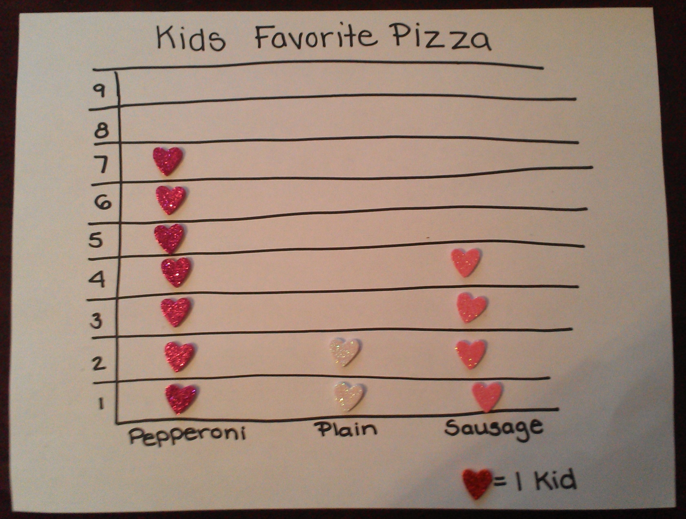
(Creative Application)

References
Adolph, K.E. (2008). Motor/physical development: locomotion. In M. Haith & J. Benson (Eds.). Encyclopedia of Infant and Early Childhood Development (pp. 359–73). San Diego, CA: Academic Press.
Ames, C., & Archer, J. (1988). Achievement goals in the classroom: Students’ learning strategies and motivation processes. Journal of Educational Psychology, 80(3), 260-267.
Baglici, S. P., Codding, R., & Tryon, G. (2010). Extending the research on the Tests of Early Numeracy: Longitudinal analyses over two school years. Assessment for Effective Intervention, 35(2), 89-102.
Burns, C., Heubert, J. P., & Levin, H. M. (2006). Accelerating Mathematics Achievement Using Heterogeneous Grouping. American Educational Research Journal, 43(1), 105-136.
Erikson, E.H. (1975). Life history and the historical moment. New York, NY: Norton.
Good, R. H., & Kaminski, R. A. (Eds.). (2002). Dynamic Indicators of Basic Early Literacy Skills (6th ed.). Eugene, OR: Institute for the Development of Educational Achievement. Available: http://dibels.uoregon.edu/. (Summary Source)
Howe, F. (1993). The child in the elementary school. Child Study Journal, 23(4), 227-363.
Hsiung, C. (2012). The effectiveness of cooperative learning. Journal of Engineering Education, 101(1), 119-137.
Kids Math Games Online. (2012). Math data game for kids. Retrieved from: http://www.kids mathgamesonline.com/numbers/mathdata.html
Kieffer, M. (2012). Before and after third grade: Longitudinal evidence for the shifting role of socioeconomic status in reading growth. Reading and Writing, 25, 1725-1746.
Mastropieri, M. A., Scruggs, T. E., & Berkeley, S. L. (2007). Peers helping peers. Educational Leadership, 64(5), 54-58.
Nagda, A. W., & Bickel, C. (2002). Tiger Math. New York, NY: Scholastic.
National Governors Association Center for Best Practices, Council of Chief State School Officers (2010). Common core state standards. Washington, DC: National Governors Association Center for Best Practices, Council of Chief State School Officers. Retrieved from: http://www.corestandards.org/the-standards
Pennsylvania Department of Education. (2010, May 18). Academic standards for mathematics: Pre-K to 3. Retrieved from: http://static.pdesas.org/content/documents/Academic_Standar ds_for_Mathematics_Pre-K-3.pdf
Pennsylvania Department of Education. (2011, Jun 14). Academic standards for reading, writing, speaking, and listening: Pre-K to 3. Retrieved from: http://static.pdesas.org/content/docu ments/Academic_Standards_for_Reading_Writing_Speaking_and_Listening_Pre-K-3.pdf
Pennsylvania Department of Education. (2012a, April). Academic standards for science and technology and engineering education: Pre-K to 3. Retrieved from: http://static.pdesas.or g/content/documents/PreK-2_Science_and_Technology_Standards.pdf
Pennsylvania Department of Education. (2012b, May). Academic standards for economics: Pre-K to 3. Retrieved from: http:// http://static.pdesas.org/content/documents/PreK-2_Econo mic_Standards.pdf
Santrock, John W. (2004). Life-Span Development (9th Ed.). Boston, MA: McGraw-Hill College.
Schoepke (2012, Jan 27). Primary graphing activities (file on SMART Exchange). Retrieved from: http://exchangedownloads.smarttech.com/public/content/d6/d6ccb6de-d465-49d6-86ad-3eba3a020daf/primary%20graphing%20activites.notebook.
The Reading and Writing Project. (2013, January 25). K-8 continuum for assessing narrative writing. Retrieved from http://readingandwritingproject.com/resources/assessments/ writing-assessments
Wood, C. (2011). Yardsticks: Children in the classroom ages 4-14. Turner Falls, MA: Northeast Foundation for Children.

Figures

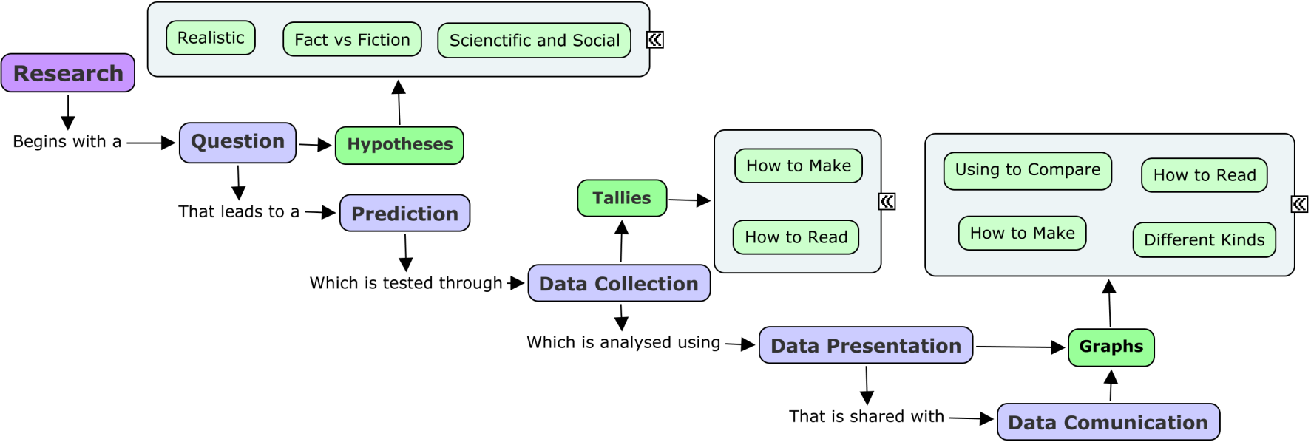
Figure 1. Logical progression of content listing by steps of research process

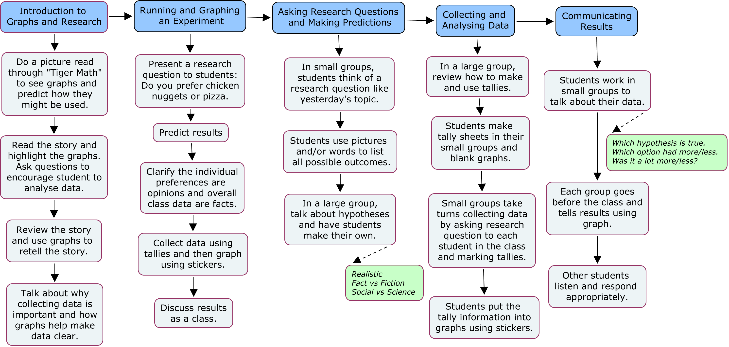
Figure 2. Lesson content sequence by instructional concept

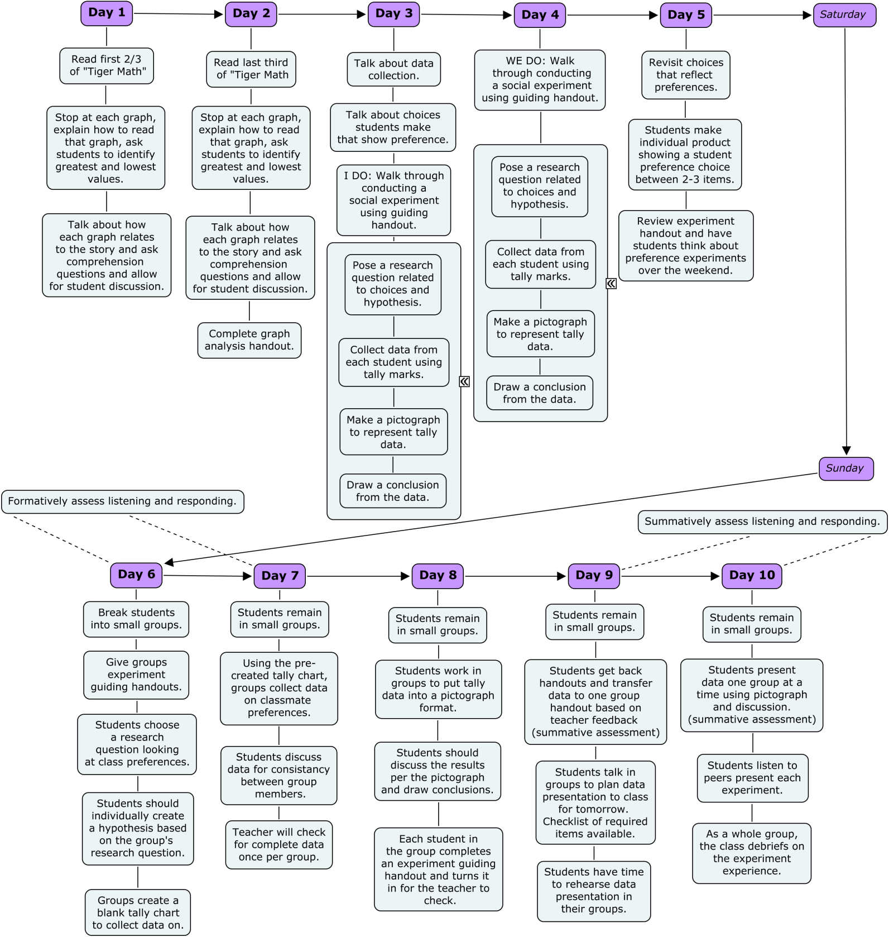
Figure 3. Lesson sequence and content of unit.
Appendix A

Listening and Responding Checklist
Student Name: ________________________
Observation Date:______________________
Observer Name:________________________

⁪ Child listens quietly to peers without interrupting.
- Student is quiet when peers are speaking
- Student does not interrupt
- Student makes eye contact or indicates listening (nodding, replying).

⁪ Child communicates in a proper volume voice.
- Student does not yell communications
- Student does not whisper communications
- Communications are easily heard by others in student’s group

⁪ Child communicates clearly.
- Student speaks words in an understandable manner to teachers and students
- Student uses words in complete sentences to communicate
- Student pronounces most words accurately (4/5 words correct)

⁪ Child makes eye contact when speaking
- Student looks at who he or she is speaking to

___ Items Checked / 4 Items = _____%

Appendix B
Name: ______________________________________________________________________
Social Experiment Guiding Handout
- Research Question (What do you want to learn?)
____________________________________________________________________
____________________________________________________________________
_____________________________________________________________________________
- Hypothesis (What do you think will happen?)
_____________________________________________________________________________
_____________________________________________________________________________
_____________________________________________________________________________
- Collect Data (Use tallies to record classmate preferences.)
Option 1: | Option 2: | Option 3:

- Analyze/Graph Data (Make a pictograph using your data.)

5. Conclusion (What does your data say happened?)
_____________________________________________________________________________
_____________________________________________________________________________
_____________________________________________________________________________

