Lesson Plan 5

Lesson Exploring the 7 Wonders with Maps
Subject Social Studies Date Lesson Day 6; 45 minutes

Target Grade/Age Level: Grade 2

Pennsylvania/National Standards:

PA Standards Reading, Writing, Speaking, Listening:
1.1.2.C: Use meaning and knowledge of words (e.g., synonyms, antonyms) across content areas to develop a speaking and reading vocabulary.
1.2.2.C: Identify essential and nonessential information within and across a variety of texts.
1.2.2.E: Read, understand, and respond to essential content of text in all academic areas.
1.8.2.B: Conduct research on self-selected or assigned topics using specified sources.

PA Standards Geography:
7.1.2.A: Identify how basic geographic tools are used to organize information.
7.2.2.A: Identify the physical characteristics of places.

PA English Language Proficiency Standard for ELLs standard:
English language learners communicate information, ideas, and concepts necessary for academic success in the content area of SOCIAL STUDIES.

NCSS Theme: People, Places, and Environments
The study of people, places, and human-environment interactions assists students as they create their spatial views and geographic perspectives of the world beyond their personal locations. Students need the knowledge, skills, and understanding to answer questions such as: Where are things located? Why are they located where they are? What do we mean by “region”? How do landforms change? What implications do these changes have for people? In schools, this theme typically appears in units and courses dealing with area studies and geography.

Common Core State Standards: English/Language Arts:
CCSS.ELA-Literacy.RI.2.4: Determine the meaning of words and phrases in a text relevant to a grade 2 topic or subject area.
CCSS.ELA-Literacy.RF.2.4: Read with sufficient accuracy and fluency to support comprehension.
CCSS.ELA-Literacy.W.2.8: Recall information from experiences or gather information from provided sources to answer a question.

Generalizations: People can use and create tools to better understand their environment.
People can organize information to make finding specific information easier.
Discussion/Essential Questions:
- How can people use maps to better understand places in the world and the environment of those places?
- How do text and maps work together to describe a place?
- How can I organize information to make it easier to find specific information
Key Concepts/Skills:
Reading concepts: comprehension strategies, fluency
Geographical concepts: map skills, wonder of the modern world
Learning Objectives and Aligned Summative Assessments:
Learning Objectives | Aligned Summative Assessments
When presented with a map and a paragraph about the area shown, the student will summarize the information by filling in a graphic organizer requiring location, purpose, and people information with at least 80% accuracy as determined by a rubric. (Comprehension and Synthesis). | Students will read a paragraph about the Pyramids of Giza and look at a picture of where it is on a map. Students will fill in a graphic organizer similar to the “I Can Locate and Classify Information About a Topic” handout requesting information about the location, purpose, and people involved with at least 80% accuracy as determined by a rubric.

Materials Needed:
- Seven computers with internet access for students
- One projected computer for teacher
- One set of the following for each student:
  - Make Your Own Multiple Choice handout (Polk Brothers, 2008)
  - I Can Locate and Classify Information About a Topic Handout (Polk Brothers, 2011)
- Verbal and Visual Word Association laminates for each group (Eeds & Cockrum, 1985)

Expectations for Behavior and Class Activities:
- When others are talking students will listen quietly to what they are saying.
- When students want to answer a question they quietly raise their hands and wait to be called on.
- Students will sit safely, criss-cross applesauce on carpet during group instruction.
- Students will sit safely at desks or computers during small group and independent work.
- Students will use computers only as directed by only visiting instructed sites and being careful to not damage the technology.
- Students will actively participate in all activities giving their best efforts.
- Students will ask a peer for help before asking the teacher during independent or group work.
- Students will always give their best effort during activities, instruction and on assessments.
- Students will come to class on time and prepared with a pencil and ready to listen.

General or Specific Accommodations for Special Needs Learners:
- English Language Learners (ELL):
  - ELLs will be paired with native English speakers during small group work or provided with a peer buddy whom they can go to for assistance during independent work.
- Students with reading disabilities:
  - All written instruction will also be given verbally to provide for equal learning opportunity.
  - Students with reading disabilities will be grouped with high level readers during small group work (reading intensive).
- General Accommodations:
  - All methods of assistive technology normally available to students will be available during this lesson.

Description of Learning Activities:
Introductory Activities (Anticipatory Set):
The teacher will show images of the following 7 Wonders of the Modern World: Chichen Itza, Christ the Redeemer, Great Wall of China, Machu Picchu, Petra, Colosseum, and Taj Mahal. Example images are attached. The teacher should ask if students can recognize any of the locations. If students can identify one or all of the places, ask students to tell what they know about each place. Prompt for information about the location, history, and purpose of each place. If students cannot identify the location, tell the students the name of the location, but do not explain the other information.

Modeling/Demonstration:
The teacher will open web browser windows for http://www.mibazaar.com/new7wonders/, http://goo.gl/maps/NB4TQ and http://www.wikiforkids.ws/. She will tell the children that today they will be exploring the 7 Wonders of the Modern World using maps and non-fiction text. Have students explain what maps are and what non-fiction text is using a question and answer approach. Next, tell the students they will review how to research information and learn how to use maps to continue that research by looking at the Eiffel Tower. Remind them that the Eiffel Tower is not one of the 7 wonders of the modern world, but they will use it as an example to of how to practice summarizing information. Go to the Eiffel Tower map. As the students to explain what they see. Next, tell the students that you want to learn information about the Eiffel Tower by researching. Hang up enlarged copies of the Make Your Own Multiple Choice (MYOMC) handout and the I Can Locate and Classify Information About a Topic (ICL&C) handout.

Teacher: First, I want to guide my research, so I need to make a good question. I think I want to know what city the Eiffel tower is located in. I will write that in the Question Maker box on my handout. (write: What city is the Eiffel Tower located in? on your MYOMC handout in the Question Maker box). Now, I have a research question that is important to me that I will look for the answer to when I do my research. Next, I want to write my research topic on my other handout. (write: The Eiffel Tower on the topic line of the ICL&C handout) First, I will use my map to locate information about the location of the Eiffel Tower. I can zoom out of the map by using the minus sign and zoom in using the plus sign. (demonstrate this) I can also move around my map by clicking and dragging the map. (demonstrate this) I want to know the city the Eiffel Tower is in, so I am going to look for names near the tower. I see Champ de Mars, this might be the city name, so I am going to write it on my handout as an option. (write Champ de Mars as option a.) Champ de Mars looks like it is probably the name of the park, so I am going to zoom out until the map tells shows me what I think is a city name. (Zoom out nine times until Paris becomes clearly the closest city). Oh, it looks like Paris is the closest city that I know. I think this is probably the answer to my question, so I will write that as one option on my handout. (write on handout by letter b.) I’m going to keep zooming out to be sure. (zoom out three more times until France is written largely) Maybe the city is France, let me write that as another option. (write France as option c.). I should find one more option, so I will zoom out some more. (zoom out all the way). I remember that the countries I see are the countries in Europe. I will write Europe as my last option. (write: Europe as option d.) OK, I know that Europe is a continent and France is a country, that means those are not cities. I remember hearing about the city of Paris, so that is a city. I will circle that as the right answer. Next, I will check this using a non-fiction text.

Go to the http://www.wikiforkids.ws/ webpage and search for the Eiffel Tower. When the page comes up select the first item (Simple English Wiki). Read the introduction and history paragraphs to the students modeling fluency (tell students explicitly to listen to how you read and remind them that that is how fluent readers sound). Once you finish reading the first sentence, show the students that your answer was confirmed, so you are sure it is correct. Continue reading. Now guide students through the ICL&C handout.

Now I know some information about the Eiffel Tower from my map and from the text. Look at the ICL&C handout. I first want to find information about the location. I remember this information from my question. First, I know the Eiffel Tower is in a park called Champ de Mars. (write “in Champ de Mars park” in location column of handout) I know that it is in the city of Paris, which is in the country of France in Europe. (write “in Paris, France” and “on Europe” in the location box). Wow, I knew a lot about where to find the Eiffel Tower. The next column says, “Purpose” and I remember that a purpose is what something is used for. Let me think. I remember seeing that it was an entrance for something in my paragraph. I’m going to go back and re-read to find out what. (re read the paragraph until you finish reading Exposition Universelle.) Oh yes, it was the entrance to the fair called the Exposition Universelle. I’ll write that down. (write “entrance to Exposition Universelle fair” in the purpose box). Now I just need to know about the people that have to do with the Eiffel Tower. I remember seeing someone named Eiffel. (go to the history portion of the text and read again until you have read about Eiffel). Now I remember Gustave Eiffel was the man who built the tower. I also see that the tower was built to celebrate France’s 100th year of freedom. That is more information about the purpose. (add “to celebrate 100 years of free France” to the purpose box and “built by Gustave Eiffel” in the people box). Wow, look at all this information. Now I can easily tell others about the Eiffel Tower. (reread each box and the MC question to the class).

Guided Practice and Feedback:
Teacher: Now that I’ve shown you how to research information, let’s try it together. (erase the blow up copies of the handouts to start again) Let’s try this with Mount Rushmore. This is also not a wonder of the modern world, but we will practice using this. Let’s start by making a question. In the same way as before, walk through finding information to fill out both handouts related to Mount Rushmore. If children have trouble with anything reteach or guide the students in the skill. The question students come up with does not need to focus on the location, but it should be something that can be answered by using the map. A completed example of the Mount Rushmore activity is included in the attachments. Guide students to supply all the answers noted. When they have finished this activity and the teacher is sure they understand how to complete this activity, show the students the http://www.mibazaar.com /new7wonders/ website. Tell them to just click on the picture of the wonder to go to that, and answer any questions about using that site that the students might have. Be sure to remind students that they can use the Verbal and Visual Word Association laminates in the classroom to help them understand any words that they are unfamiliar with (this skill would have been taught in previous lessons).

Independent Practice/Exploring:
Break the students into seven groups and assign one wonder of the world to each group. Let the students research the items on the computers in their groups. You should expect a handout from each student, but it does not matter if they have the same answers. While the students are in groups they will use the mibazaar site (which uses google maps) to learn about the location of their wonder and use the wikiforkids site to read a narrative about the location. This set of information should be used to fill out both the MYOMC and ICL&C handouts as described earlier in the lesson. At the end of class, students will come together to share the information they found. If students finish early, they can be guided to complete the extension activity.

Formative Assessments:
The guided feedback portion of this lesson is completely formative assessment of how well the students can perform the skills needed for this lesson and success with the lesson’s objectives. During the independent practice, the teacher should circulate around the room to interact with students. At this time, the teacher must make sure that every student is participating in the group activities. If students or one student is struggling, the teacher should take time to reteach or facilitate comprehension of the learning activities amount the student or students. Finally, the MYOMC and ICL&C handouts should be collected at the end of the class to check each one for completion, accuracy, comprehension of the learning activity.

Review and Preview:
At the end of the class, each group should select one speaker to come in front of the class and share what the group found on the ICL&C handout(s). Students will be responsible for remembering some of the information they learned here. Particularly, students will be expected to match at least five out of seven images and hints about a wonder with the name of the wonder on the test. Tell the students to pay close attention. After the presentations, congratulate the students on the researching skills. Tell the students that tomorrow they will learn how to work in Google Earth and use latitude and longitude. Once they have a chance to locate all of the wonders using latitude, longitude and GIS mapping in Google Earth.

After Class:
After the exploration activity, make a collection of all the students MC questions and hand these out to the class for personal fun. On the summative assessment, allow students who finish early to work on these questions (with no answers) to earn some extra credit.
Grade all the ICL&C handouts against the attached keys. Make a copy of each handout either using the key or copying an exemplary students work and hand this out to the students. Include a picture of each wonder on this handout. This packet should be used to study for the summative assessment at home, but other exposures will be present in later lessons by which the students may rehearse this information in preparation for the summative assessment.

Extension Activities:
Gifted students and groups that finish early can be encouraged to explore the other wonders of the modern world. Tell the students they do not need to fill out the handout if they do not want to during this exploration, but have extra copies available if they wish to do so.

Ask students that finish early to add anything new they want to learn to the KWL chart from day one or to cross off things that were learned in today’s class.

Potential Areas of Difficulty with the Content and Correction Procedures:
Lower level reading students might have some trouble with vocabulary in the wiki readings. Verbal and Visual Word Association laminates will be available for their use during the independent exploration of this lesson. These laminates would be explicitly instructed on how to use them in previous reading lessons and would be used routinely in lower level reading groups as an assistive tool. If a teacher sees a student using this laminate, they should be immediately praised for using the learning strategy and assistance should be provided as needed.
ELL students might not know all the words for the readings on the wiki. Each wiki reading is available in multiple languages. As ELL students are provided with iPads in this class, those students will be able to read the selection in their native language using the translate function on the left side of the wiki on their iPad. Answers should be recorded in English to facilitate language learning, but this could be heavily assisted by group members.

Summative Assessments:
The following items will be included on the summative assessment at a 10 point total value for the matching item and a 10 point value for the summarization item:

Read the non-fiction text and look at the map below. Fill out the chart to research information about the Great Pyramid of Giza.

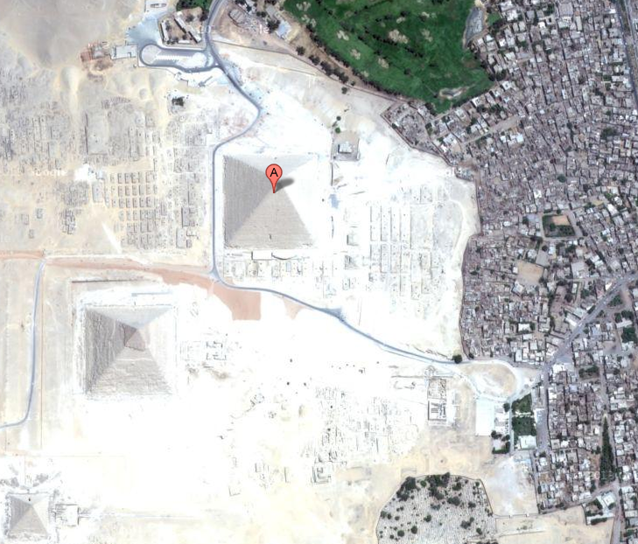 | The Great Pyramid of Giza is a huge pyramid built by the Ancient Egyptians. It stands near Cairo, Egypt and is one of the seven wonders of the ancient world. It was the tallest building in the world for over 3 thousand years. Archaeologists think the pyramid was built as a tomb or grave site for Khufu, an Egyptian pharaoh.  The great pyramid of Giza was made from limestone and granite. The pharaoh's body was placed in the heart of the pyramid, but when the archaeologists looked for the body it was missing.

Location  (where is it?) | Purpose  (what was it used for?) | People  (who’s there?, who made it?)

Rubric:
Location | Purpose | People
- Egypt (2 points)  - Cario (2 points)  - Dessert (1 bonus point, 10 points max) | - Tomb or grave site  (2 points) | - Khufu (2 points) or just pharaoh (1 point)  - Built by ancient Egyptians  (2 points)
Maximum of 10 points (if at 10 and get bonus, no additional points)

Reflections: n/a- lesson not implemented

Sources:
Ajmani, V. (2009, Aug 3). MIBAZAAR: The new 7 wonders of the world. Retrieved from: http://www.mibazaar.com/new7wonders/
Eeds, M., & Cockrum, W. A. (1985). Teaching word meanings by expanding schemata vs. dictionary work vs. reading in context. Journal of Reading, 28(6), 492-497.
National Council for the Social Studies. (2004) Expectations of excellence: Curriculum standards for social studies. Retrieved from: http://www.socialstudies.org/standards/execsummary
National Governors Association Center for Best Practices, Council of Chief State School Officers (2010). Common core state standards. Washington, DC: National Governors Association Center for Best Practices, Council of Chief State School Officers. Retrieved from: http://www.corestandards.org/the-standards
Pennsylvania Department of Education. (2008. Dec). Pennsylvania English Language Proficiency Standards. Retrieved from: http://www.portal.state.pa.us/portal/server.pt? open=18&objID=357587&mode=2
Pennsylvania Department of Education. (2011, Jun 14). Academic standards for reading, writing, speaking, and listening: Pre-K to 3. Retrieved from: http://static.pdesas.org/content/docu ments/Academic_Standards_for_Reading_Writing_Speaking_and_Listening_Pre-K-3.pdf
Pennsylvania Department of Education. (2012, May). Academic standards for geography: Pre-K to 3. Retrieved from: http://static.pdesas.org/content/documents/PreK-2_Geography_ Standards.pdf
Polk Brothers (2008). Make your own multiple choice question. Retrieved from: http://teacher.depaul.edu/bilingual/Make%20Your%20Own%20Multiple%20Choice%20Question.pdf
Polk Brothers (2011). I can locate and classify information about a topic. Retrieved from: http:// teacher.depaul.edu/files/documents/Icanlocateandclassifyinformationaboutatopic.pdf

Example Images of 7 Wonders of the Modern World:
Chichen Itza:
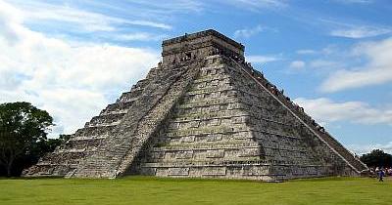
From: http://www.chichenitza.com/images/chichenitza.jpg

Christ the Redeemer:
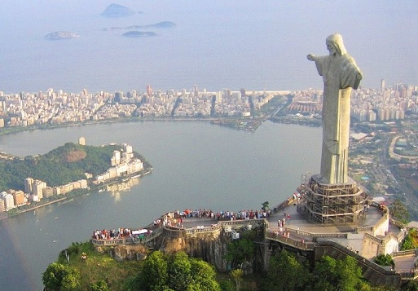
From: http://3.bp.blogspot.com/_J3etfOCrPwI/TTb3taJkGbI/AAAAAAAAETk/vHZJWjoDeJ M/s1600/brazil_christ-the-redeemer_01.jpg

Great Wall of China:
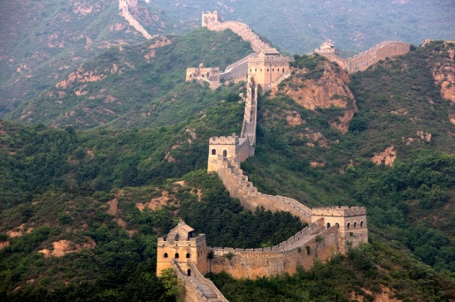
From: http://1.bp.blogspot.com/-VmEJqGsRKl8/Ta2n1S9gLeI/AAAAAAAAMns/sW0ipRGr BVg/s1600/great-wall-of-china.jpg

Machu Pichu:
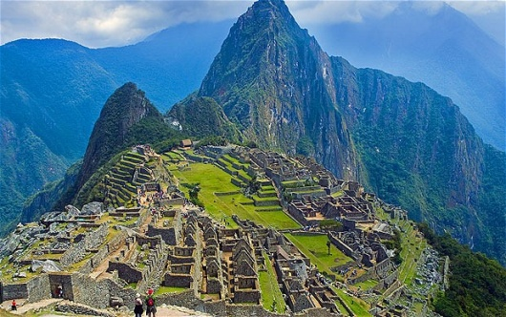
From: http://i.telegraph.co.uk/multimedia/archive/02354/MachuPicchu_2354046b.jpg

Petra:
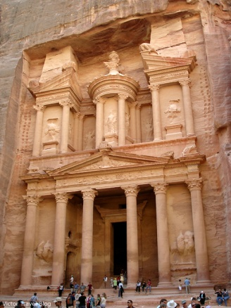
From: http://victortravelblogdotcom.files.wordpress.com/2013/01/petra-jordan-1.jpg?w=780

Colosseum:
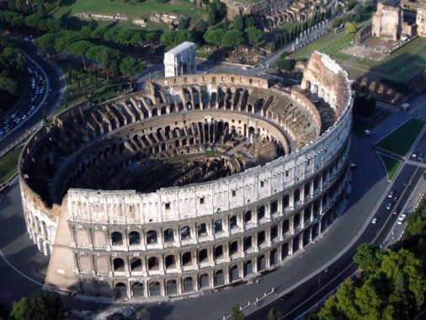
From: http://0.tqn.com/d/architecture/1/0/E/l/Colloseumaerial.jpg

Taj Mahal:
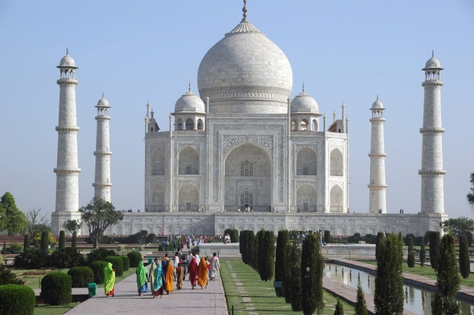
From: http://3.bp.blogspot.com/_dHj0_yTcK4Q/TGdhaOJtKRI/AAAAAAAAD7k/GQ9RbaCb HhE/s1600/AGR+Agra+-+Taj+Mahal+panorama+with+watercourse+and+indian+visitors+after +sunrise+3008x2000.jpg

Name: _______________________________________________________
Name: _______________________________________________________
People
Purpose
Location

Write on me with DRY ERASE MARKERS ONLY!
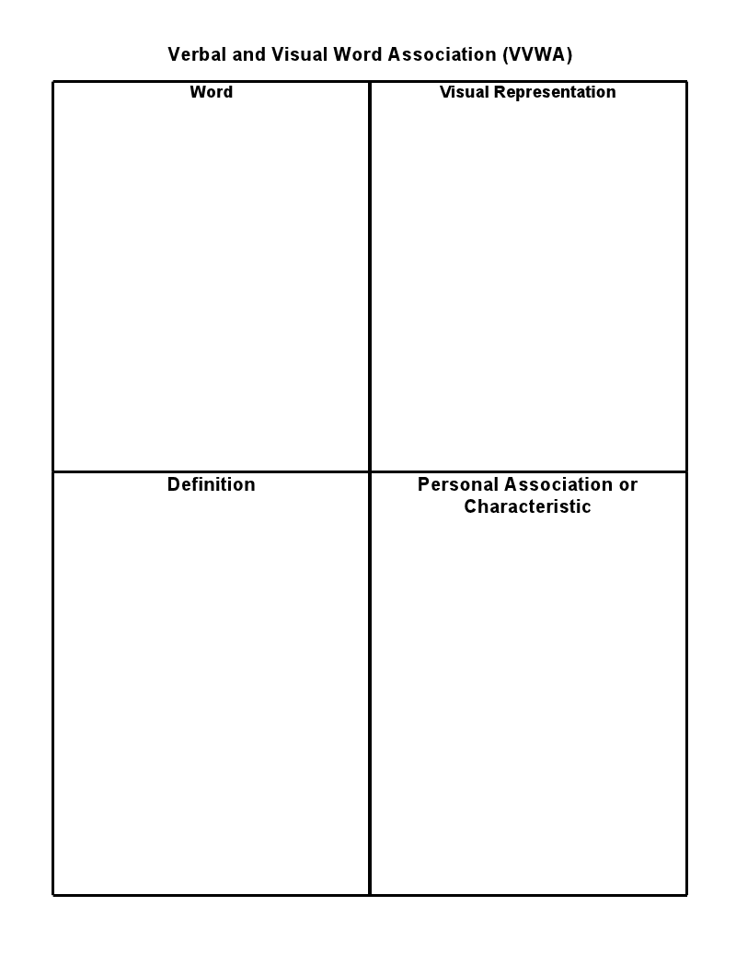
Laminated

