Social Studies Unit: 2nd Grade Maps in My World

Gina Laura Ciani

Lehigh University

TLT 412: Social Studies in Elementary Education

April 23, 2013

Dr. Snyder

Table of Contents

Introduction 2
Generalizations 4
Learning Objectives 4
Lesson Plan 1: Introduction to Mapping 6
Lesson Plan 2: Mapping My Room 10
Lesson Plan 3: The Compass Rose 18
Lesson Plan 4: Scaling Up Maps 25
Lesson Plan 5: Exploring the 7 Wonders with Maps 33
Lesson Plan 6: Latitude and Longitude with Google Earth 55
Lesson Plan 7: Finding the Wonders 62
Lesson Plan 8: Geocaching 74
Summative Assessment 91
Evaluation 101
References 103

Social Studies Unit: 2nd Grade Maps in My World
This unit aims to develop the second grader’s comprehension of maps and map-using skills by integrating reading, social studies, visual arts, mathematics, and technology skills in a manner that will both enrich and complement student understanding. In this way, the unit focuses on elements of maps such as symbols, keys, the compass rose, cardinal directions, and the scale, and subsequently builds on this knowledge using satellite maps, latitude and longitude, hemispheres, and ultimately geospatial direction in a culminating geocaching task. In order to achieve learning of each element, the present unit employs a highly engaging and immersive instructional style where students have the opportunity to apply skills right after they are learned. Teachers prepare students for these activities through use of the general release of responsibility modeling technique where teachers first model the skill independently (I do), then guide students through the skills (We do), and end by allowing students to independently practice the skills (You do). Together these approaches allow for a high level of learning for a diverse population of students.
The present unit also integrates a large amount of technology including Google Earth, GPS tracking devices, web-based video games, and Smart Boards. These additions prepare students to use maps in the modern world where GPS and geolocation tags are becoming more common each day. Familiarity with satellite images and how to pilot the systems that supply these maps provide students with the tools they need to access information about the entire world and navigate their environments in an effective and educated manner. To ensure students have the knowledge of these skills needed for success a performance assessment requiring integration of all map and technology skills is included in addition to a traditional summative assessment. Together, each element of the present unit works in harmony to produce well-rounded learners prepared to interact with the world using maps.
Generalizations
- People can use and create tools to better understand their environment.
- People can organize information to make finding specific information easier.
Concepts
- Reading concepts: comprehension strategies, fluency
- Geographical concepts: maps, symbols, bird’s eye view, cartography, compass rose, cardinal directions, map scale, map skills, wonder of the modern world, latitude, longitude, satellite, prime meridian, equator, hemispheres, GPS tracking, geocaching
- Art concepts: color, space, proportions
- Mathematics concepts: measuring with standard units
Learning Objectives
- When presented with a fill in the blank item with a word bank, the student will write in the correct term on questions related to map, key and symbol with 100% accuracy. (Knowledge)
- When presented with a map, the student will identify locations on the map using the map key with 100% accuracy. (Comprehension)
- When presented with a word box including symbols, compass, and key, the student will create a map of his or her bedroom including 100% of the following: symbols to represent the furniture, a compass to show the front of the house, and a key to describe what each symbol represents. (Synthesis)
- When presented with a map including a compass rose, the student will be able to answer questions about the map requiring application of the cardinal directions using the compass rose with 100% accuracy. (Application)
- Given a map and map scale, the student will be able to use the scale to answer four questions about the map with at least 75% accuracy. (Application)
- When presented with a map and a paragraph about the area shown, the student will summarize the information by filling in a graphic organizer requiring location, purpose, and people information with at least 80% accuracy as determined by a rubric. (Comprehension and Synthesis).
- When presented with a fill in the blank item with a word bank, the student will write in the correct term on questions related to latitude, longitude and satellite maps with 100% accuracy. (Knowledge)
- When presented with latitude and longitude coordinates and a GPS tracker, students will navigate to five given locations within 25 minutes. (Application)
- When presented with the latitude and longitude coordinates of a place on Earth, the student will be able to deduce which hemispheres that location lies in with 100% accuracy. (Analysis)
- When presented with a fill in the blank item with a word bank, the student will write in the correct term on questions related to the prime meridian, hemispheres, and the equator with 100% accuracy. (Knowledge)
Lesson Plan 1

Lesson Introduction to Mapping
Subject Social Studies Date Lesson Day 1, 40 minutes

Target Grade/Age Level: Grade 2

Pennsylvania/National Standards:

PA Standards Reading, Writing, Speaking, Listening:
1.1.2.D: Demonstrate comprehension / understanding before reading, during reading, and after reading on grade level texts through strategies such as think aloud, retelling, summarizing, note taking, connecting to prior knowledge, supporting assertions about text with evidence from text, and non-linguistic representations.
1.1.2.E: Demonstrate accuracy and automaticity, in oral reading of grade level text.
1.2.2.E: Read, understand, and respond to essential content of text in all academic areas.

PA Standards Geography: 7.1.2.A: Identify how basic geographic tools are used to organize information.

PA English Language Proficiency Standard for ELLs standard:
English language learners communicate information, ideas, and concepts necessary for academic success in the content area of SOCIAL STUDIES.

NCSS Theme: People, Places, and Environments
The study of people, places, and human-environment interactions assists students as they create their spatial views and geographic perspectives of the world beyond their personal locations. Students need the knowledge, skills, and understanding to answer questions such as: Where are things located? Why are they located where they are? What do we mean by “region”? How do landforms change? What implications do these changes have for people? In schools, this theme typically appears in units and courses dealing with area studies and geography.

Generalization: People can use and create tools to better understand their environment.
Discussion/Essential Questions:
- How does a map describe and organize information about different places?
- How are maps used in the real world?
Key Concepts/Skills:
Reading concepts: comprehension strategies, fluency
Geographical concepts: maps, symbols
Learning Objectives and Aligned Summative Assessments:
Learning Objectives | Aligned Summative Assessments
When presented with a fill in the blank item with a word bank, the student will write in the correct term on questions related to map, key and symbol with 100% accuracy. (Knowledge) | Test item on summative assessment which asks the student to fill in blanks near a sentence describing a term using a word bank.

Materials Needed:
- Copy of Mapping Penny’s World by Loreen Leady
- Dry erase board and markers

Expectations for Behavior and Class Activities:
- When others are talking students will listen quietly to what they are saying.
- When students want to answer a question they quietly raise their hands and wait to be called on.
- Students will sit safely, criss-cross applesauce on carpet during group instruction.
- Students will actively participate in all activities giving their best efforts.
- Students will always give their best effort during activities, instruction and on assessments.
- Students will come to class on time and prepared with a pencil and ready to listen.

General or Specific Accommodations for Special Needs Learners:
- English Language Learners (ELL):
  - ELLs will be given a copy of the book in their native language whenever possible.
  - ELLS will sit near the front of the room to have better visual access to the images in the book.
- Students with reading disabilities:
  - These students will not be called on to read a page of the book to the class, but will have time to re-read the book during instruction with special education or paraprofessional teachers.
- General Accommodations:
  - All methods of assistive technology normally available to students will be available during this lesson.

Description of Learning Activities:
Introductory Activities (Anticipatory Set):
The teacher will tell the students that they will start learning about maps today. Create a KWL chart on the dry erase board. Ask students to tell first what they already know about maps. Write their items on the board. Then, ask the students what they want to know about maps. Write this in the W portion of the chart. Finally, hand out sticky notes or memo pads. Tell the students to listen actively while they listen and read “Mapping Penny’s World” and to write notes about what new things they learn about maps as they go.

Modeling/Demonstration:
Introduce “Mapping Penny’s World” to the students. You might want to use snippets from the following blurb about the book.

Mapping Penny’s World by Loreen Leedy is a children’s story about a little girl named Lisa who maps out the places she likes to go with her dog Penny. She and Penny map out her bedroom, the backyard where Penny hides her toys, the neighborhood, and even places around the world where Penny might like to go. The maps that Lisa create include the cardinal directions, a key of images found on the map, a title, and a scale for measuring the distances on the map. The illustrations of the maps are very colorful and they are all displayed from a birds- eye view. (Bria, 2009)

Begin reading the book, on the specified pages below use the following prompts suggested by Bria (2009):

- “On this map, some of the symbols stand for the goodies she has hidden outside. The rest of the symbols represent the fence, table, and other things that are supposed to be out there.” (pg. 11)
- “Maps are good for giving directions. Suppose Penny’s friend Maxine wants to come over. You could say, ‘Go out your back door, turn right by the trash cans, crawl under the gap in the wooden fence (watch out for the big orange cat!)…’ ” (pg. 13)
- “The map’s scale shows the real distances in the park. According to the map, the distance between point A and point B is two- tenths of a mile.” (pg. 20)

Once you are about ¼ way through the book, select students who are strong readers to come up and read a set of pages to the class (by volunteer only). Read the entire book and give students opportunities to respond to each set of pages and discuss what is happening.

Independent Practice/Exploring:
During the reading, students take notes on what they learn, which they will share at the end of the lesson.

Guided Practice and Feedback:
After the book is read, prompt the students to re-tell the book to the class. This should assess their comprehension of the story. Finally, go back to the dry erase board and allow student to stick their learning notes to that section. Read each to the class and summarize them by writing them on the board. If there are key items the students did not note, this is the time to add them and explicitly teach.

Formative Assessments:
The teacher must use question and answering and discussion throughout the story to gauge student comprehension of the story and introduction to maps. When the L part of the KWL chart is filled in, students will provide assessment information about what they have gotten from the book and learned.

Review and Preview:
Review the KWL chart with the whole class. Explain that sometimes we don’t get all the information we wanted to know from one source. Circle any W items that were not learned. Next, explain that sometimes learning more about a topic lets you ask more questions. Create another W column at the end of the chart. Ask students to tell you what new things they want to learn about maps and put these in the chart. Tell students that they can add sticky notes to the chart during the entire unit if they find out more things that they want to learn. Also, tell them that they will cross items off as they are learned. Preview that in the next lesson, the students will make their own maps in the same way that Lisa did for Penny.

Extension Activities:
Students can be given opportunities to read the book to the class for an extra challenge. If the lesson ends early, allow students to talk in a group discussion format about when they or their families have used maps in real life.

Potential Areas of Difficulty with the Content and Correction Procedures:
ELL students might have trouble understanding the book, so copies of the book or at least the text of the book will be given to those students whenever possible.

Summative Assessments:
The following items will be included on the summative assessment at a 3 point total value each:

Fill in the blanks below using the words in the word box.
Key Symbol

A _________ is a collection of pictures and what they mean. It is used to help a person understand a map.

Maps can use a ____________ to show, or represent, a different item or place on the map rather than drawing every detail.

Reflections:
n/a- lesson not implemented

Sources:
National Council for the Social Studies. (2004) Expectations of excellence: Curriculum standards for social studies. Retrieved from: http://www.socialstudies.org/standards/execsummary
Leedy, L. (2000). Mapping penny’s world. New York, NY: Henry Holt and Compancy, LLC.
Pennsylvania Department of Education. (2008. Dec). Pennsylvania English Language Proficiency Standards. Retrieved from: http://www.portal.state.pa.us/portal/server.pt? open=18&objID=357587&mode=2
Bria (2009, Nov 1). Teaching geography with children’s literature: Mapping penny’s world. Retrieved from: http://blog.richmond.edu/openwidelookinside/archives/1954.
Pennsylvania Department of Education. (2012, May). Academic standards for geography: Pre-K to 3. Retrieved from: http://static.pdesas.org/content/documents/PreK-2_Geography_ Standards.pdf
Lesson Plan 2

Lesson Mapping My Room
Subject Social Studies Date Lesson Days 2 and 3; 40 minutes each

Target Grade/Age Level: Grade 2

Pennsylvania/National Standards:

PA Standards Geography: 7.1.2.A: Identify how basic geographic tools are used to organize information.

PA English Language Proficiency Standard for ELLs standard:
English language learners communicate information, ideas, and concepts necessary for academic success in the content area of SOCIAL STUDIES.

NCSS Theme: People, Places, and Environments
The study of people, places, and human-environment interactions assists students as they create their spatial views and geographic perspectives of the world beyond their personal locations. Students need the knowledge, skills, and understanding to answer questions such as: Where are things located? Why are they located where they are? What do we mean by “region”? How do landforms change? What implications do these changes have for people? In schools, this theme typically appears in units and courses dealing with area studies and geography.

National Visual Arts Standards: K-4
3b. Select and use subject matter, symbols, and ideas to communicate meaning
6b. Identify connections between the visual arts and other disciplines in the curriculum

Generalization: People can use and create tools to better understand their environment.
Discussion/Essential Questions:
- How does a map describe and organize information about different places?
- What are the important elements to include in a map and how are they used to organize and communicate information effectively.
Key Concepts/Skills:
Geographical concepts: symbols, key, bird’s eye view, cartography
Art concepts: color, space, proportions
Learning Objectives and Aligned Summative Assessments:
Learning Objectives | Aligned Summative Assessments
When presented with a map, the student will identify locations on the map using the map key with 100% accuracy. (comprehension)  When presented with a word box including symbols, compass, and key, the student will create a map of his or her bedroom including 100% of the following: symbols to represent the furniture, a compass to show the front of the house, and a key to describe what each symbol represents. (synthesis) | Test item on summative assessment which asks the student to locate bathrooms and ATMs with X and O, respectively, on a mall map.  Performance assessment item where students will create a map of their bedroom including symbols, a key, and a compass graded using a rubric. Formative assessment feedback will be provided on ‘sloppy copy’ prior to summative assessment on final copy.

Materials Needed:
- SMART® Board
- SMART® Board file: Mapping (includes two maps and classroom mapping interactive)
- Mapping My Room completed project by teacher
- Mapping My Room project set for each student and teacher
  - 1 piece of graph paper
  - 1 pencil
  - 1 piece of nice white paper (to be hung up)
  - Coloring instruments (crayons and colored pencils recommended)
  - 1 ruler as requested for neatness
- 1 copy of summative assessment per student at end of unit (assessment item in Section 10)

Expectations for Behavior and Class Activities:
- When others are talking students will listen quietly to what they are saying.
- When students want to answer a question they quietly raise their hands and wait to be called on.
- Students will sit safely, criss-cross applesauce on carpet during SMART® Board instruction.
- Students will sit safely at desks during independent work.
- Students will actively participate in all activities giving their best efforts.
- Students will ask a peer for help before asking the teacher during independent or group work.
- Students will always give their best effort during activities, instruction and on assessments.
- Students will come to class on time and prepared with a pencil and ready to listen.

General or Specific Accommodations for Special Needs Learners:
- English Language Learners (ELL):
  - ELLs will be paired with native English speakers during small group work or provided with a peer buddy whom they can go to for assistance during independent work.
- Students with reading disabilities:
  - All written instruction will also be given verbally to provide for equal learning opportunity.
  - Written material will be read to students with reading disabilities up to three times by independent student request.
- General Accommodations:
  - All methods of assistive technology normally available to students will be available during this lesson.

Description of Learning Activities:
Introductory Activities (Anticipatory Set):
The teacher will review what students have already learned about maps by asking students what they remember from the previous lesson. Students should be prompted to remember that maps always appear from a ‘birds eye view’ which means that they are aerial views of the world. Students should also be prompted to recall that maps show you how to get around the world and that they are created by cartographers. The teacher will tell students that today they will begin to learn how to be cartographers themselves by using and creating their own maps.

Activity A:

Modeling/Demonstration:
Show the students the image of the mall map on the SMART® Board and ask them to locate the legend. Tell students that a legend and a key are the same thing. Once students have located the key, note different items from the key and have students come up to mark each element. The teacher should do this first. For example, the teacher can begin by noting the symbol for the information booth and marking each with a green O.

Guided Practice and Feedback:
After the teacher has provided modeling, the teacher should have one student put a blue X on all of the restrooms. Next, have the class use thumbs up or down to tell if he or she marked all of the restrooms. Continue until all the restrooms are marked. Continue with another element from the key. Move on to the zoo map, mark items as done previously. Now, have the students use the map: Ask student to tell you where the closest ATM to the kangaroo exhibit is and have another student explain how to get there. Continue until you have formatively assessed all or most of the students and they seem to understand.

Activity B:

Modeling/Demonstration:
Now explain that students are going to practice using what they know about reading and using maps to become cartographers. Show the students the pre-made Mapping My Room project. Show first that you used a ‘sloppy copy’ to remember where everything was and try to make everything smaller and at a similar scale using the graph paper. Next, show the students the final copy. This should be colorful and clean. Make sure both include a key, symbols, and are drawn using a bird’s eye view. For students that need more instruction, the teacher might want to complete the assignment in front of the students. The present learning community is comprised mostly of advanced students who do not require this instructional element.

Guided Practice and Feedback:
Using the SMART® Board and the mapping file activity to create the classroom map, work with the students. First, show the students the pre-made key. Note that the key shows each symbol that will be used in the map and what it means. Next, draw a compass rose on the map the show the front of the school. Explain that a compass rose helps direct the user of the map so they know how the map relates to the real world. Continue to explain that most compass roses show north, south, east and west, but today we will use one that points to the front of our building to help the makes make sense to us. Get student input on which way the front of the school should be on the compass rose. Now, use the infinite cloning feature in the SMART® Board file to create the classroom map. Allow students to come up and add different elements of the classroom to the map as much as possible. Once the classroom map is complete, it could be left on the SMART® Board as an example of a good map for all students.

Independent Practice/Exploring:
DAY 1: Have students use graph paper and a pencil to create a ‘sloppy copy’ of their room map. Throughout the activity, go around making sure each student is using symbols, including a compass rose, and has a map key. At the end of the day, allow students to take the ‘sloppy copy’ home to continue working on or to check against their room for accuracy.

DAY 2: Begin by reviewing the important elements to include in a map. Then, provide students with nice white paper and coloring supplies after checking to make sure their sloppy copy includes a bird’s eye view, key, symbols, and compass rose. Tell the students to make their fancy copy of their room maps based on their ‘sloppy copies.’ Answer questions as they arise. If students finish early, invite them to participate in the extension activity noted below.

Formative Assessments:
Teacher should use thumbs up and thumbs down signals from the students to check for understanding throughout the lesson. Guided practice during the Activity A will provide opportunities for formative assessment of the students’ comprehension of map skills. Finally, the sloppy copy of the students’ room maps will serve as a formative assessment of their map production skills.

Review and Preview:
DAY 1: Tell students to take their sloppy copies home and check them against their room for accuracy. They should also write in a compass rose on their map at this time that points towards the front of their home to indicate directionality of their map. Remind students that they will continue to work on their maps by creating a final copy of their maps during their next class.

DAY 2: Allow students to come up and share their maps (2-3 students). Ask them to point out the key, use of symbols and the compass rose. Have at least one student describe how to get from their room door to a piece of furniture in their room using verbal directions (extension activity). Tell students that you will hang up their maps so that other people can know how to navigate their rooms. Next, have students suggest what should be crossed off of the W columns in the KWL chart from day 1. Invite students to come up and add any new items they want to learn to the W column. Before ending instruction, invite students to learn more about each other by looking at each other’s maps during the next weeks. Finally, tell students that they will use maps to explore the rest of the world in the next class.

Extension Activities:
If students finish early or need another level of challenge with the mapping activity, provide the following challenge. Have students create a short written piece providing directions to a certain item in their room. Students can use a folded piece of paper to hide that item in the map similar to a pop-up book. The written piece should be about three to five sentences leading a reader from the door of the room to the hidden item. An example of this should be included in the teacher example.

Potential Areas of Difficulty with the Content and Correction Procedures:
Students from lower socio-economic-status (SES) families might have highly shared rooms or no particular bedroom at all. These students could be given the option to map another area of their home or the school.
Some students may have trouble understanding the proportions of items. These students can use the SMART Board activity further for clarification or work in a team with a peer buddy for assistance. This practice should help to develop a better understanding of proportions within their map.
ELL students might not know all the words for items on their map. These students will be allowed to write the names of the items in their native language and look up the English version of these words to add to their map along side of the native language words in the key. This should help to enhance the students’ English vocabulary.

Summative Assessments:
The following item will be included on the summative assessment at a 10 point total value:

Look at the following map.
- Place an X on the restrooms. (4 points, 2 per restroom)
- Circle (O) the fishing pier. (2 points)
- Square ( ) the school house. (2 points)
- Put a triangle ( ) on the campground (2 points)

Reflections:
n/a- lesson not implemented

Sources:
National Art Education Association (1994). The national visual arts standards. Retrieved from: http://www.arteducators.org/store/NAEA_Natl_Visual_Standards1.pdf
National Council for the Social Studies. (2004) Expectations of excellence: Curriculum standards for social studies. Retrieved from: http://www.socialstudies.org/standards/execsummary
Pennsylvania Department of Education. (2008. Dec). Pennsylvania English Language Proficiency Standards. Retrieved from: http://www.portal.state.pa.us/portal/server.pt? open=18&objID=357587&mode=2
Pennsylvania Department of Education. (2012, May). Academic standards for geography: Pre-K to 3. Retrieved from: http://static.pdesas.org/content/documents/PreK-2_Geography_ Standards.pdf

Example Student Maps

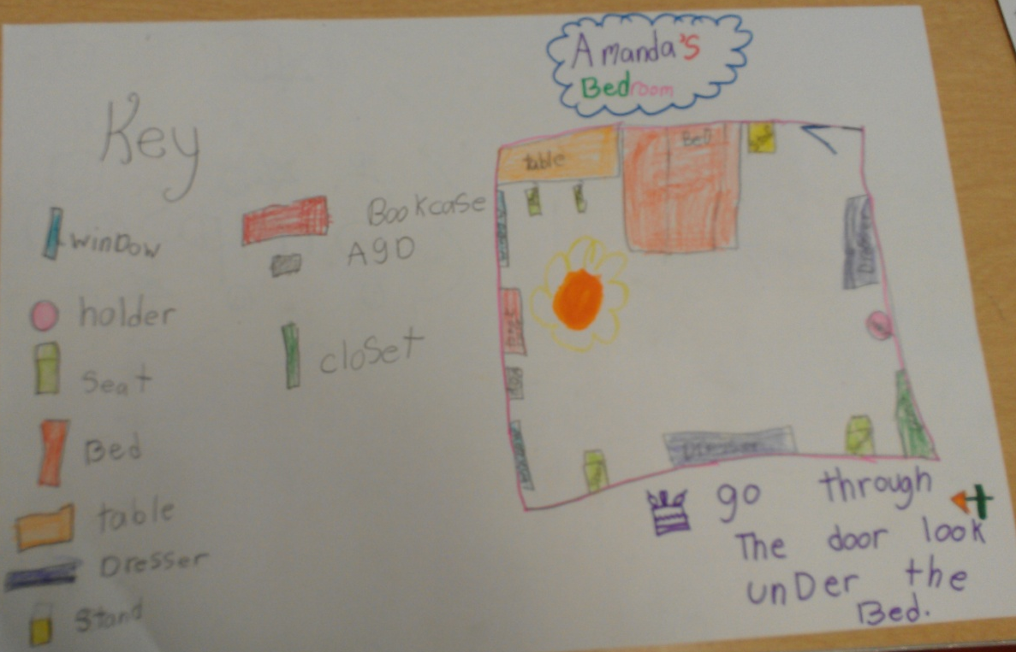

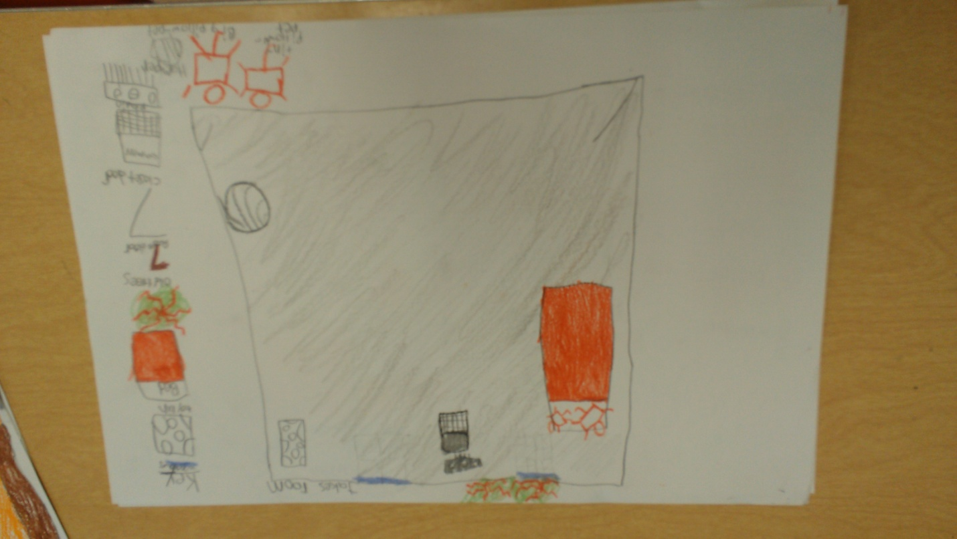
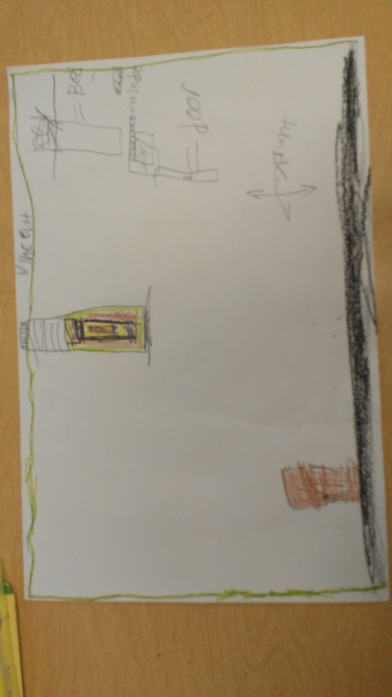
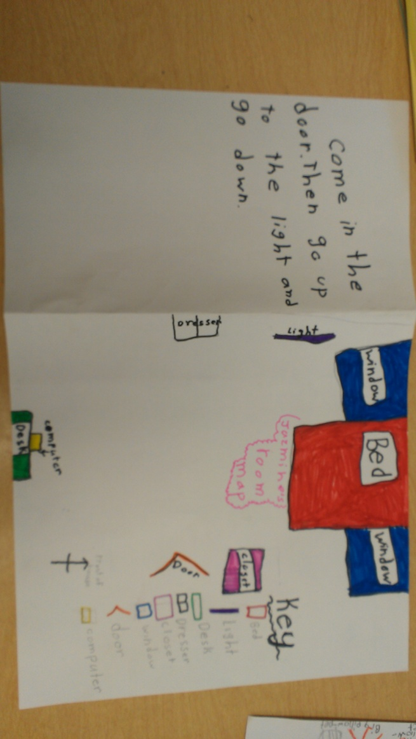
Lesson Plan 3

Lesson The Compass Rose
Subject Social Studies Date Lesson Day 4; 40 minutes

Target Grade/Age Level: Grade 2

Pennsylvania/National Standards:

PA Standards Geography: 7.1.2.A: Identify how basic geographic tools are used to organize information.

PA English Language Proficiency Standard for ELLs standard:
English language learners communicate information, ideas, and concepts necessary for academic success in the content area of SOCIAL STUDIES.

NCSS Theme: People, Places, and Environments
The study of people, places, and human-environment interactions assists students as they create their spatial views and geographic perspectives of the world beyond their personal locations. Students need the knowledge, skills, and understanding to answer questions such as: Where are things located? Why are they located where they are? What do we mean by “region”? How do landforms change? What implications do these changes have for people? In schools, this theme typically appears in units and courses dealing with area studies and geography.

Generalization: People can use and create tools to better understand their environment.
Discussion/Essential Questions:
- How does a map describe and organize information about different places?
- What is a compass rose and how is it used in geography?
Key Concepts/Skills:
Geographical concepts: compass rose, cardinal directions
Learning Objectives and Aligned Summative Assessments:
Learning Objectives | Aligned Summative Assessments
When presented with a map including a compass rose, the student will be able to answer questions about the map requiring application of the cardinal directions using the compass rose with 100% accuracy. (application) | Test item on summative assessment which asks the student to write the names of places on a map to the north, south, east, or west of other places.

Materials Needed:
- Computers with internet access for each student
- Computer with projector for teacher
- Move Around worksheet for each student

Expectations for Behavior and Class Activities:
- When others are talking students will listen quietly to what they are saying.
- When students want to answer a question they quietly raise their hands and wait to be called on.
- Students will sit safely, criss-cross applesauce on carpet during group instruction.
- Students will sit safely at desks or computers during small group and independent work.
- Students will use computers only as directed by only visiting instructed sites and being careful to not damage the technology.
- Students will actively participate in all activities giving their best efforts.
- Students will ask a peer for help before asking the teacher during independent or group work.
- Students will always give their best effort during activities, instruction and on assessments.
- Students will come to class on time and prepared with a pencil and ready to listen.

General or Specific Accommodations for Special Needs Learners:
- English Language Learners (ELL):
  - ELLs will be paired with a native English speaking peer buddy whom they can go to for assistance during independent work.
- Students with reading disabilities:
  - All written instruction will also be given verbally to provide for equal learning opportunity.
  - Written material will be read to students with reading disabilities up to three times by independent student request.
- General Accommodations:
  - All methods of assistive technology normally available to students will be available during this lesson.

Description of Learning Activities:
Introductory Activities (Anticipatory Set):
The teacher should draw the class’ attention to one of the better maps from yesterday’s cartography activity. A document camera might be used for this. Draw students’ attention to the compass rose. Remind the students that usually maps have a compass rose that points to the north and also shows south, east, and west. Ask students to tell you what they already know about NSEW (north, south, east and west) and write these down in a document on the projected computer. Tell students that when people talk about NSEW they are talking about the cardinal directions (have students repeat this phrase). Tell them that today we will learn how to use the cardinal direction with maps and in the real world.

Activity A:

Modeling/Demonstration:
Load an image of a map of the United States inclusive of a compass rose on the projector. Show students that north is generally up, south is generally down, east is generally right and west is generally left. Rotate the map 180° and show how north is now down and so forth. Explain to students that maps are not always drawn so that north is pointing up, so it is very important to look at the compass rose to find out which direction is north.

Now load a map of your state (PA for example) with a compass rose that only shows north. Tell students that many times a compass rose will only show north, but that we can tell what the other directions are because south, east and west are always in the same places relative to north. Write in south and east and ask the students to tell you the last direction.

Guided Practice and Feedback:
Load a picture of four different compass roses on the projector each with only one direction filled in on the up position. Start with the north (up) compass and ask the students to help you fill in each blank. This will likely require a large amount of guidance. Once this first compass rose is filled in direct the students to help you fill in the others. Refer to the already filled compass rose when students answer incorrectly or are unsure of the response. Praise the students when complete and tell them for the rest of today they will work with the north as up compass rose, because that is normally what is seen.

Project a grid similar to the one in handout (or just project the handout using a document camera). Tell student that they will practice using a compass rose to follow cardinal directions. Start on the starred square. First tell students that you want to color the square four blocks north of the star red. Count with the students four blocks north and color that square red. Then get a volunteer for the next instruction. Tell the student to color the square one block east of the red square blue. Do the same thing for at least 3 more instructions. After each instruction have students give a thumbs up if they think the volunteer colored the right square or a sideways thumb if they are not sure (or think he is wrong, nicer way of saying that).

Independent Practice
Handout the worksheets and allow students to move to their desks. Read the instructions on the teacher copy and have the students do that activity and hand it in for formative assessment.

Activity B:

Modeling/Demonstration:
Bring the students back on the carpet and introduce the games. First, show students the Finding Nemo game and explain how to play the game. Next, show the students the News City Pizza game and use the video at http://www.youtube.com/watch?feature=player_embedded &v=QNYF9nQUb_w to teach the students how to play the game. Tell students they can choose to play one or both games. Explain that the Finding Nemo game will help them practice their cardinal direction skills at a slow, relaxed pace and that the New City Pizza game will let them practice at a fast, challenging pace. Tell them it is ok to choose either one, but if they find one is too easy or frustrating they should switch. Prompt students for questions about how to play the games and then move them to computers.

Guided Practice and Feedback:
When students are playing the games, walk around. Watch how students are doing and make suggestions to switch to the easier or harder game as appropriate. For students that are struggling with both games, provide one-on-one instruction.

Independent Practice/Exploring:
Allow students to play the games for about 10 minutes and send home an email to parents about the game websites for at home practice (or post the games on your class website).

Formative Assessments:
Thumbs up and down is used in the first half of this lesson as a formative assessment measure. Observational, informal, formative assessment should be used during all activities in this lesson and opportunities for further instruction should be taken as granted. Additionally, the activity A worksheet will provide an individualized assessment tool of each student’s comprehension of the cardinal directions.

Review and Preview:
Bring the students back together on the carpet. Open the document about what the students already knew about NSEW. Make a new heading for what they learned and have students tell you more things about what they learned today about cardinal directions and the compass rose. Ask the students how they think that geographers can use things like the cardinal directions and maps, also called geographical tools, in the world. Try to form their thinking towards the generalization that geographers use geographical tools to organize and understand the world.

Extension Activities:
Allow students to visit the following website to practice and learn more map skills: http://www.bbc.co.uk/scotland/education/sysm/landscapes/highlands_islands/mapskills/index.shtml#focus.
Ask students that finish early to add anything new they want to learn to the KWL chart from day one or to cross off things that were learned in today’s class.

Potential Areas of Difficulty with the Content and Correction Procedures:
Some students might struggle with the technology skills aspect of this lesson. Those students might work in pairs with more technology savvy students. Some students might struggle with the reading in the pizza game, but the teacher can highlight that they are simply matching the text or guide them towards the finding nemo game.

Summative Assessments:
The following item will be included on the summative assessment at a 10 point total value
(2 points each):

Look at the map below. Read each item and give the best answer based on the map.
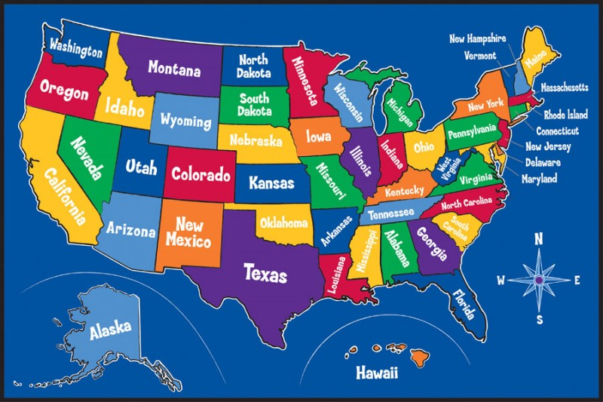

- Find South Dakota. Name the state that is north of South Dakota.
___________________________ (North Dakota)
- Which state is west of Nevada? ___________________________ (California)
- Which state is just east of Wisconsin? _______________________ (Michigan)
- What state is south of both Georgia and Alabama? ______________ (Florida)
- Which state is north of Oregon and west of Idaho? ______________ (Washington)
Reflections:
n/a- lesson not implemented

Sources:
National Council for the Social Studies. (2004) Expectations of excellence: Curriculum standards for social studies. Retrieved from: http://www.socialstudies.org/standards/execsummary
Nussbaum, G. (2009). News city pizza [online game]. Retrieved from: http://mrnussbaum.com/ newscity
Mathslice (2004). Finding Nemo game [online game]. Retrieved from: http://www.mathslice. com/findnemo.php
Pennsylvania Department of Education. (2008. Dec). Pennsylvania English Language Proficiency Standards. Retrieved from: http://www.portal.state.pa.us/portal/server.pt? open=18&objID=357587&mode=2
Pennsylvania Department of Education. (2012, May). Academic standards for geography: Pre-K to 3. Retrieved from: http://static.pdesas.org/content/documents/PreK-2_Geography_ Standards.pdf
Name: _____________________________________________

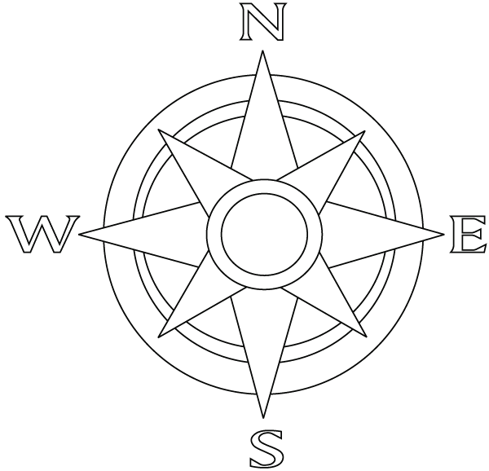

Name: __Teacher’s Copy (Key and Directions)______________

Teacher Directions:
- Move 3 squares WEST of the star and color that square red.
- Move 2 squares SOUTH of the red square and color that square blue.
- Move 6 squares EAST of the blue square and color that square green.
- Move 5 squares NORTH of the green square and color that square orange
- Move 2 squares EAST of the orange square and color that square purple.
Lesson Plan 4

Lesson Scaling Up Maps
Subject Social Studies Date Lesson Day 5; 40 minutes

Target Grade/Age Level: Grade 2

Pennsylvania/National Standards:
PA Standards Mathematics:
2.3.2.B: Use tools to estimate and measure in standard units.

PA Standards Geography: 7.1.2.A: Identify how basic geographic tools are used to organize information.

PA English Language Proficiency Standard for ELLs standard:
English language learners communicate information, ideas, and concepts necessary for academic success in the content area of SOCIAL STUDIES.

NCSS Theme: People, Places, and Environments
The study of people, places, and human-environment interactions assists students as they create their spatial views and geographic perspectives of the world beyond their personal locations. Students need the knowledge, skills, and understanding to answer questions such as: Where are things located? Why are they located where they are? What do we mean by “region”? How do landforms change? What implications do these changes have for people? In schools, this theme typically appears in units and courses dealing with area studies and geography.

Common Core State Standards: Mathematics:
CCSS.Math.Content.2.MD.A.3: Estimate lengths using units of inches, feet, centimeters, and meters.

Generalization: People can use and create tools to better understand their environment.
Discussion/Essential Questions:
- How does a map scale work and how does it help relate the map to the real world?
Key Concepts/Skills:
Mathematics concepts: measuring with standard units
Geographical concepts: map scale
Learning Objectives and Aligned Summative Assessments:
Learning Objectives | Aligned Summative Assessments
Given a map and map scale, the student will be able to use the scale to answer four questions about the map with at least 75% accuracy. (application) | Question on the summative assessment with a map and word problem. Items will be graded so that student may achieve partial credit for close answers (see items later in lesson).
Materials Needed:
- SMART® Board
- SMART® Board file: Using Scale
- One scale practice handout (two sides) per student
- Scissors for each student or group of students to cut out ruler for use on handout.

Expectations for Behavior and Class Activities:
- When others are talking students will listen quietly to what they are saying.
- When students want to answer a question they quietly raise their hands and wait to be called on.
- Students will sit safely, criss-cross applesauce on carpet during SMART® Board instruction.
- Students will sit safely at desks during independent work.
- Students will actively participate in all activities giving their best efforts.
- Students will ask a peer for help before asking the teacher during independent or group work.
- Students will always give their best effort during activities, instruction and on assessments.
- Students will come to class on time and prepared with a pencil and ready to listen.

General or Specific Accommodations for Special Needs Learners:
- English Language Learners (ELL):
  - ELLs will be paired with native English speakers during small group work or provided with a peer buddy whom they can go to for assistance during independent work.
- Students with reading disabilities:
  - All written instruction will also be given verbally to provide for equal learning opportunity.
  - Written material will be read to students with reading disabilities up to three times by independent student request.
- General Accommodations:
  - All methods of assistive technology normally available to students will be available during this lesson.

Description of Learning Activities:
Introductory Activities (Anticipatory Set):
Have a student read his or her hidden object quest from the map making activity on lesson 2. The student should challenge her peers to find the mystery item in the bedroom map. Ask students how they knew how far to go in the room for the map. Ask students to imagine they were looking for an item in her real room and find out if they might be able to figure out how big the room is from the map. When they agree they cannot move on.

Modeling/Demonstration:
Use the lesson and instructional materials at http://www.candohelperpage.com/files /comprehension/mapping/mapping_110.html to teach a lesson on what a map scale is and how to use one.

Guided Practice and Feedback:
Use the Smart Board activity to try some map scale application practice. A screen shot of this activity is attached.

Hand out the map scale practice handouts. Walk the students through cutting out the ruler on the bottom of the paper. Do the first problem on each side of the handout with the students to show them how to do the activity. If students need extra practice more items can be done as a group, but once students seem proficient allow them to work independently.

Independent Practice/Exploring:
Have students work on the remainder of the handout independently. Walk around to monitor students for success with the comprehension of the map activity.

Formative Assessments:
The teacher will have the opportunity to check for students’ understanding of using scales in maps during the guided practice activities. The teacher should also use the handout as both a real-time and after class formative assessment. The teacher can circulate during independent practice to check students work as they go and provide assistance and reteaching as needed. Any student who shows a lack of success on the turned in assessment, may need reteaching which can be completed during math class or other parts of the day.

Review and Preview:
Bring the students back together and collect the rulers so that they may be used during the summative assessment.. Review the concepts learned so far in the unit (cartography, scale, cardinal directions, key, bird’s eye view). Ask the students why they think all of those items are important in maps. They should give answers around the idea that each one makes it easier for people to understand a map and link it to the real world. Have students begin to think about why people need maps that are similar to the real world. You may wish to refer to the L part of Day 1’s KWL chart to help job students’ memories. Tell students that next week they will continue using maps and start to look at some maps that are made using cameras in outer space.

Extension Activities:
Some students might need an extra challenge. Allow these students to add a scale to either their own maps created in lesson 2 or on a map you have made of the classroom. Invite them to measure the classroom and the map or items in each to develop a scale. This can be done as a group.

Ask students that finish early to add anything new they want to learn to the KWL chart from day one or to cross off things that were learned in today’s class.

Potential Areas of Difficulty with the Content and Correction Procedures:
Students who have trouble in math may struggle with the content of this lesson. Students use addition and subtraction when working with map scale problems as well as beginning level multiplication skills. If students receive extra assistance in math instruction, invite a paraprofessional to help the students in class today or ask their math teacher to review the skills required for today’s lesson in their class. If these students have time in learning support, they may have the opportunity to go over the handout there. Make modifications to assessments based on IEPs and special education professionals’ input.

Summative Assessments:
The following item will be included on the summative assessment at a 6 point total value:

Look at the following map and answer the questions below using your ruler.
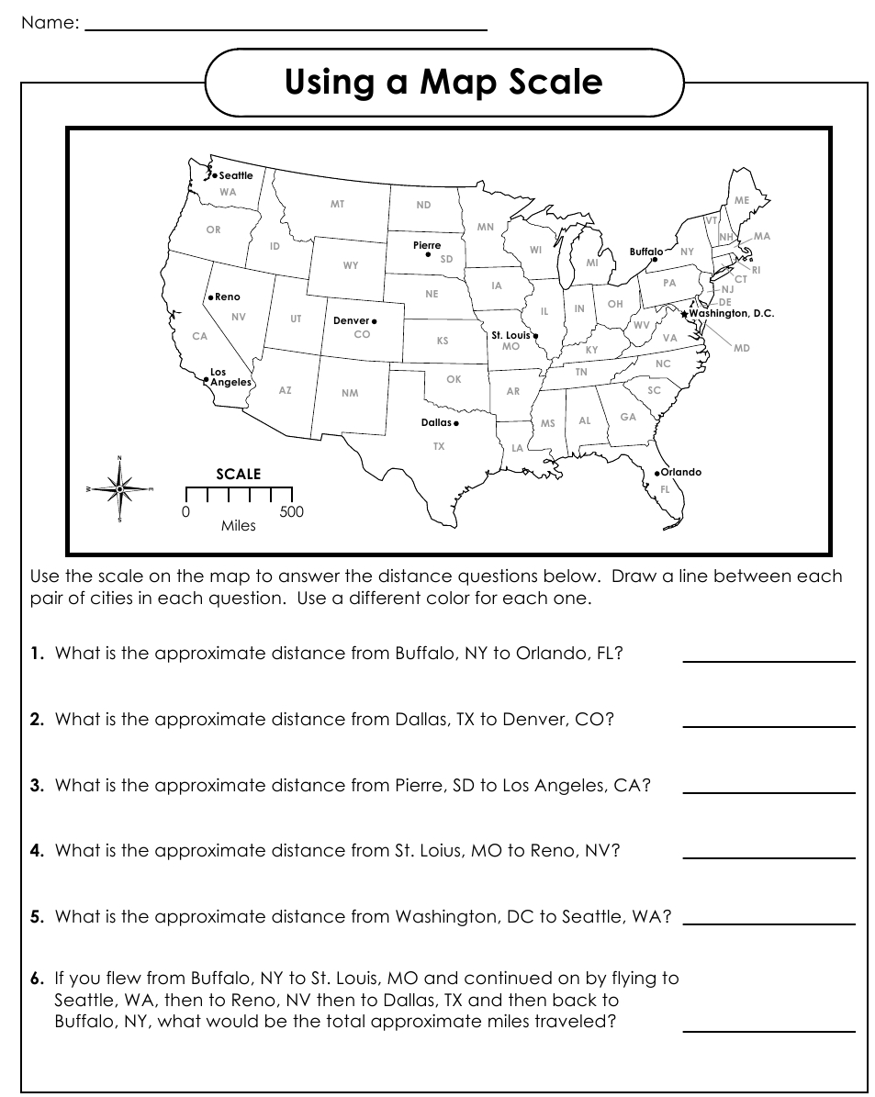

- What is the approximate distance from Denver, CO to Orlando, FL? ___________
(1400 - 1500 = 2 points; 2.75-3 inches = 1 point)
- What is the approximate distance from Seattle, WA to
Los Angeles, CA? ___________
(1000 miles = 2 points, 2 inches = 1 point)
- What is the approximate distance from Buffalo, NY to St. Louis, MO? _____________
(500-600 miles = 2 points, 1-1.25 inches = 1 point)

(Note: 75% accuracy is 4 out of 6 possible points)

Reflections:
n/a- lesson not implemented

Sources:
National Council for the Social Studies. (2004) Expectations of excellence: Curriculum standards for social studies. Retrieved from: http://www.socialstudies.org/standards/execsummary
National Governors Association Center for Best Practices, Council of Chief State School Officers (2010). Common core state standards. Washington, DC: National Governors Association Center for Best Practices, Council of Chief State School Officers. Retrieved from: http://www.corestandards.org/the-standards
Enchanted Learning. (2013). City map reading activity printout #1. Retrieved from: http://www.enchantedlearning.com/geography/mapreading/city/
Pennsylvania Department of Education. (2008. Dec). Pennsylvania English Language Proficiency Standards. Retrieved from: http://www.portal.state.pa.us/portal/server.pt? open=18&objID=357587&mode=2
Pennsylvania Department of Education. (2010, May 18). Academic standards for mathematics: Pre-K to 3. Retrieved from: http://static.pdesas.org/content/documents/Academic_Standar ds_for_Mathematics_Pre-K-3.pdf
Pennsylvania Department of Education. (2012, May). Academic standards for geography: Pre-K to 3. Retrieved from: http://static.pdesas.org/content/documents/PreK-2_Geography_ Standards.pdf
Beaudoin, R. (2012, Nov 15). Welcome to mapping skills: What is a scale? Retrieved from: http://www.candohelperpage.com/files/comprehension/mapping/mapping_110.html.
Smart Board activity

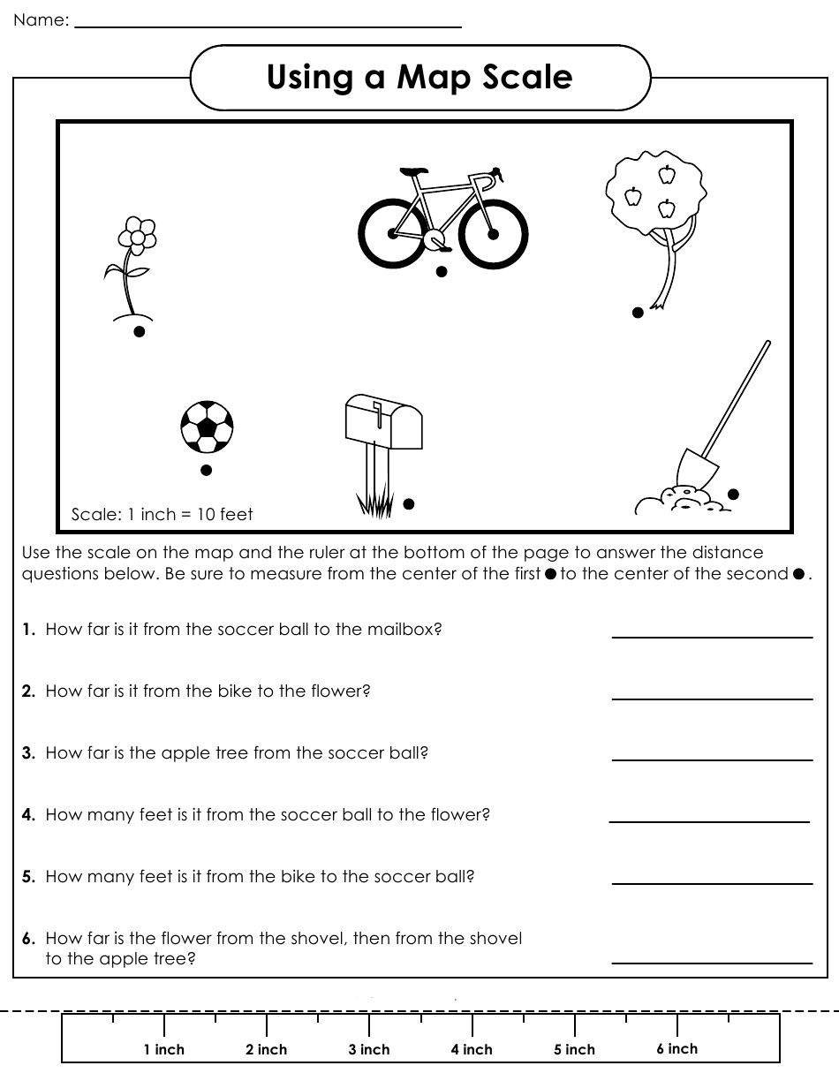
Lesson Plan 5

Lesson Exploring the 7 Wonders with Maps
Subject Social Studies Date Lesson Day 6; 45 minutes

Target Grade/Age Level: Grade 2

Pennsylvania/National Standards:

PA Standards Reading, Writing, Speaking, Listening:
1.1.2.C: Use meaning and knowledge of words (e.g., synonyms, antonyms) across content areas to develop a speaking and reading vocabulary.
1.2.2.C: Identify essential and nonessential information within and across a variety of texts.
1.2.2.E: Read, understand, and respond to essential content of text in all academic areas.
1.8.2.B: Conduct research on self-selected or assigned topics using specified sources.

PA Standards Geography:
7.1.2.A: Identify how basic geographic tools are used to organize information.
7.2.2.A: Identify the physical characteristics of places.

PA English Language Proficiency Standard for ELLs standard:
English language learners communicate information, ideas, and concepts necessary for academic success in the content area of SOCIAL STUDIES.

NCSS Theme: People, Places, and Environments
The study of people, places, and human-environment interactions assists students as they create their spatial views and geographic perspectives of the world beyond their personal locations. Students need the knowledge, skills, and understanding to answer questions such as: Where are things located? Why are they located where they are? What do we mean by “region”? How do landforms change? What implications do these changes have for people? In schools, this theme typically appears in units and courses dealing with area studies and geography.

Common Core State Standards: English/Language Arts:
CCSS.ELA-Literacy.RI.2.4: Determine the meaning of words and phrases in a text relevant to a grade 2 topic or subject area.
CCSS.ELA-Literacy.RF.2.4: Read with sufficient accuracy and fluency to support comprehension.
CCSS.ELA-Literacy.W.2.8: Recall information from experiences or gather information from provided sources to answer a question.

Generalizations: People can use and create tools to better understand their environment.
People can organize information to make finding specific information easier.
Discussion/Essential Questions:
- How can people use maps to better understand places in the world and the environment of those places?
- How do text and maps work together to describe a place?
- How can I organize information to make it easier to find specific information
Key Concepts/Skills:
Reading concepts: comprehension strategies, fluency
Geographical concepts: map skills, wonder of the modern world
Learning Objectives and Aligned Summative Assessments:
Learning Objectives | Aligned Summative Assessments
When presented with a map and a paragraph about the area shown, the student will summarize the information by filling in a graphic organizer requiring location, purpose, and people information with at least 80% accuracy as determined by a rubric. (Comprehension and Synthesis). | Students will read a paragraph about the Pyramids of Giza and look at a picture of where it is on a map. Students will fill in a graphic organizer similar to the “I Can Locate and Classify Information About a Topic” handout requesting information about the location, purpose, and people involved with at least 80% accuracy as determined by a rubric.

Materials Needed:
- Seven computers with internet access for students
- One projected computer for teacher
- One set of the following for each student:
  - Make Your Own Multiple Choice handout (Polk Brothers, 2008)
  - I Can Locate and Classify Information About a Topic Handout (Polk Brothers, 2011)
- Verbal and Visual Word Association laminates for each group (Eeds & Cockrum, 1985)

Expectations for Behavior and Class Activities:
- When others are talking students will listen quietly to what they are saying.
- When students want to answer a question they quietly raise their hands and wait to be called on.
- Students will sit safely, criss-cross applesauce on carpet during group instruction.
- Students will sit safely at desks or computers during small group and independent work.
- Students will use computers only as directed by only visiting instructed sites and being careful to not damage the technology.
- Students will actively participate in all activities giving their best efforts.
- Students will ask a peer for help before asking the teacher during independent or group work.
- Students will always give their best effort during activities, instruction and on assessments.
- Students will come to class on time and prepared with a pencil and ready to listen.

General or Specific Accommodations for Special Needs Learners:
- English Language Learners (ELL):
  - ELLs will be paired with native English speakers during small group work or provided with a peer buddy whom they can go to for assistance during independent work.
- Students with reading disabilities:
  - All written instruction will also be given verbally to provide for equal learning opportunity.
  - Students with reading disabilities will be grouped with high level readers during small group work (reading intensive).
- General Accommodations:
  - All methods of assistive technology normally available to students will be available during this lesson.

Description of Learning Activities:
Introductory Activities (Anticipatory Set):
The teacher will show images of the following 7 Wonders of the Modern World: Chichen Itza, Christ the Redeemer, Great Wall of China, Machu Picchu, Petra, Colosseum, and Taj Mahal. Example images are attached. The teacher should ask if students can recognize any of the locations. If students can identify one or all of the places, ask students to tell what they know about each place. Prompt for information about the location, history, and purpose of each place. If students cannot identify the location, tell the students the name of the location, but do not explain the other information.

Modeling/Demonstration:
The teacher will open web browser windows for http://www.mibazaar.com/new7wonders/, http://goo.gl/maps/NB4TQ and http://www.wikiforkids.ws/. She will tell the children that today they will be exploring the 7 Wonders of the Modern World using maps and non-fiction text. Have students explain what maps are and what non-fiction text is using a question and answer approach. Next, tell the students they will review how to research information and learn how to use maps to continue that research by looking at the Eiffel Tower. Remind them that the Eiffel Tower is not one of the 7 wonders of the modern world, but they will use it as an example to of how to practice summarizing information. Go to the Eiffel Tower map. As the students to explain what they see. Next, tell the students that you want to learn information about the Eiffel Tower by researching. Hang up enlarged copies of the Make Your Own Multiple Choice (MYOMC) handout and the I Can Locate and Classify Information About a Topic (ICL&C) handout.

Teacher: First, I want to guide my research, so I need to make a good question. I think I want to know what city the Eiffel tower is located in. I will write that in the Question Maker box on my handout. (write: What city is the Eiffel Tower located in? on your MYOMC handout in the Question Maker box). Now, I have a research question that is important to me that I will look for the answer to when I do my research. Next, I want to write my research topic on my other handout. (write: The Eiffel Tower on the topic line of the ICL&C handout) First, I will use my map to locate information about the location of the Eiffel Tower. I can zoom out of the map by using the minus sign and zoom in using the plus sign. (demonstrate this) I can also move around my map by clicking and dragging the map. (demonstrate this) I want to know the city the Eiffel Tower is in, so I am going to look for names near the tower. I see Champ de Mars, this might be the city name, so I am going to write it on my handout as an option. (write Champ de Mars as option a.) Champ de Mars looks like it is probably the name of the park, so I am going to zoom out until the map tells shows me what I think is a city name. (Zoom out nine times until Paris becomes clearly the closest city). Oh, it looks like Paris is the closest city that I know. I think this is probably the answer to my question, so I will write that as one option on my handout. (write on handout by letter b.) I’m going to keep zooming out to be sure. (zoom out three more times until France is written largely) Maybe the city is France, let me write that as another option. (write France as option c.). I should find one more option, so I will zoom out some more. (zoom out all the way). I remember that the countries I see are the countries in Europe. I will write Europe as my last option. (write: Europe as option d.) OK, I know that Europe is a continent and France is a country, that means those are not cities. I remember hearing about the city of Paris, so that is a city. I will circle that as the right answer. Next, I will check this using a non-fiction text.

Go to the http://www.wikiforkids.ws/ webpage and search for the Eiffel Tower. When the page comes up select the first item (Simple English Wiki). Read the introduction and history paragraphs to the students modeling fluency (tell students explicitly to listen to how you read and remind them that that is how fluent readers sound). Once you finish reading the first sentence, show the students that your answer was confirmed, so you are sure it is correct. Continue reading. Now guide students through the ICL&C handout.

Now I know some information about the Eiffel Tower from my map and from the text. Look at the ICL&C handout. I first want to find information about the location. I remember this information from my question. First, I know the Eiffel Tower is in a park called Champ de Mars. (write “in Champ de Mars park” in location column of handout) I know that it is in the city of Paris, which is in the country of France in Europe. (write “in Paris, France” and “on Europe” in the location box). Wow, I knew a lot about where to find the Eiffel Tower. The next column says, “Purpose” and I remember that a purpose is what something is used for. Let me think. I remember seeing that it was an entrance for something in my paragraph. I’m going to go back and re-read to find out what. (re read the paragraph until you finish reading Exposition Universelle.) Oh yes, it was the entrance to the fair called the Exposition Universelle. I’ll write that down. (write “entrance to Exposition Universelle fair” in the purpose box). Now I just need to know about the people that have to do with the Eiffel Tower. I remember seeing someone named Eiffel. (go to the history portion of the text and read again until you have read about Eiffel). Now I remember Gustave Eiffel was the man who built the tower. I also see that the tower was built to celebrate France’s 100th year of freedom. That is more information about the purpose. (add “to celebrate 100 years of free France” to the purpose box and “built by Gustave Eiffel” in the people box). Wow, look at all this information. Now I can easily tell others about the Eiffel Tower. (reread each box and the MC question to the class).

Guided Practice and Feedback:
Teacher: Now that I’ve shown you how to research information, let’s try it together. (erase the blow up copies of the handouts to start again) Let’s try this with Mount Rushmore. This is also not a wonder of the modern world, but we will practice using this. Let’s start by making a question. In the same way as before, walk through finding information to fill out both handouts related to Mount Rushmore. If children have trouble with anything reteach or guide the students in the skill. The question students come up with does not need to focus on the location, but it should be something that can be answered by using the map. A completed example of the Mount Rushmore activity is included in the attachments. Guide students to supply all the answers noted. When they have finished this activity and the teacher is sure they understand how to complete this activity, show the students the http://www.mibazaar.com /new7wonders/ website. Tell them to just click on the picture of the wonder to go to that, and answer any questions about using that site that the students might have. Be sure to remind students that they can use the Verbal and Visual Word Association laminates in the classroom to help them understand any words that they are unfamiliar with (this skill would have been taught in previous lessons).

Independent Practice/Exploring:
Break the students into seven groups and assign one wonder of the world to each group. Let the students research the items on the computers in their groups. You should expect a handout from each student, but it does not matter if they have the same answers. While the students are in groups they will use the mibazaar site (which uses google maps) to learn about the location of their wonder and use the wikiforkids site to read a narrative about the location. This set of information should be used to fill out both the MYOMC and ICL&C handouts as described earlier in the lesson. At the end of class, students will come together to share the information they found. If students finish early, they can be guided to complete the extension activity.

Formative Assessments:
The guided feedback portion of this lesson is completely formative assessment of how well the students can perform the skills needed for this lesson and success with the lesson’s objectives. During the independent practice, the teacher should circulate around the room to interact with students. At this time, the teacher must make sure that every student is participating in the group activities. If students or one student is struggling, the teacher should take time to reteach or facilitate comprehension of the learning activities amount the student or students. Finally, the MYOMC and ICL&C handouts should be collected at the end of the class to check each one for completion, accuracy, comprehension of the learning activity.

Review and Preview:
At the end of the class, each group should select one speaker to come in front of the class and share what the group found on the ICL&C handout(s). Students will be responsible for remembering some of the information they learned here. Particularly, students will be expected to match at least five out of seven images and hints about a wonder with the name of the wonder on the test. Tell the students to pay close attention. After the presentations, congratulate the students on the researching skills. Tell the students that tomorrow they will learn how to work in Google Earth and use latitude and longitude. Once they have a chance to locate all of the wonders using latitude, longitude and GIS mapping in Google Earth.

After Class:
After the exploration activity, make a collection of all the students MC questions and hand these out to the class for personal fun. On the summative assessment, allow students who finish early to work on these questions (with no answers) to earn some extra credit.
Grade all the ICL&C handouts against the attached keys. Make a copy of each handout either using the key or copying an exemplary students work and hand this out to the students. Include a picture of each wonder on this handout. This packet should be used to study for the summative assessment at home, but other exposures will be present in later lessons by which the students may rehearse this information in preparation for the summative assessment.

Extension Activities:
Gifted students and groups that finish early can be encouraged to explore the other wonders of the modern world. Tell the students they do not need to fill out the handout if they do not want to during this exploration, but have extra copies available if they wish to do so.

Ask students that finish early to add anything new they want to learn to the KWL chart from day one or to cross off things that were learned in today’s class.

Potential Areas of Difficulty with the Content and Correction Procedures:
Lower level reading students might have some trouble with vocabulary in the wiki readings. Verbal and Visual Word Association laminates will be available for their use during the independent exploration of this lesson. These laminates would be explicitly instructed on how to use them in previous reading lessons and would be used routinely in lower level reading groups as an assistive tool. If a teacher sees a student using this laminate, they should be immediately praised for using the learning strategy and assistance should be provided as needed.
ELL students might not know all the words for the readings on the wiki. Each wiki reading is available in multiple languages. As ELL students are provided with iPads in this class, those students will be able to read the selection in their native language using the translate function on the left side of the wiki on their iPad. Answers should be recorded in English to facilitate language learning, but this could be heavily assisted by group members.

Summative Assessments:
The following items will be included on the summative assessment at a 10 point total value for the matching item and a 10 point value for the summarization item:

Read the non-fiction text and look at the map below. Fill out the chart to research information about the Great Pyramid of Giza.

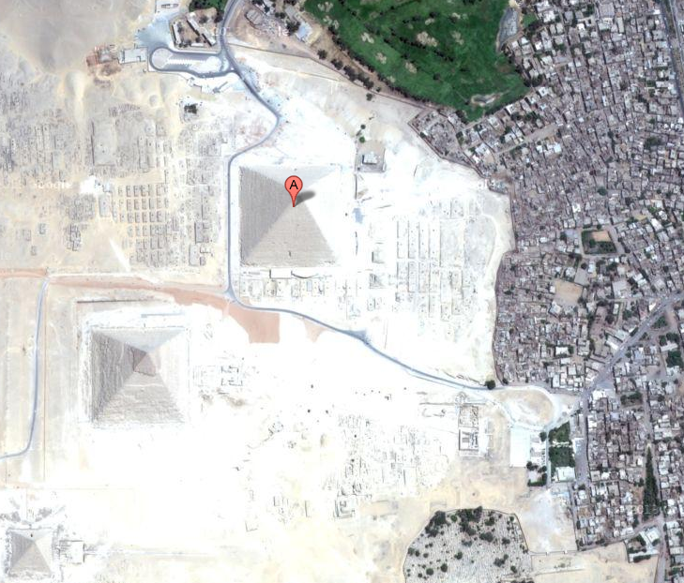 | The Great Pyramid of Giza is a huge pyramid built by the Ancient Egyptians. It stands near Cairo, Egypt and is one of the seven wonders of the ancient world. It was the tallest building in the world for over 3 thousand years. Archaeologists think the pyramid was built as a tomb or grave site for Khufu, an Egyptian pharaoh.  The great pyramid of Giza was made from limestone and granite. The pharaoh's body was placed in the heart of the pyramid, but when the archaeologists looked for the body it was missing.

Location  (where is it?) | Purpose  (what was it used for?) | People  (who’s there?, who made it?)

Rubric:
Location | Purpose | People
- Egypt (2 points)  - Cario (2 points)  - Dessert (1 bonus point, 10 points max) | - Tomb or grave site  (2 points) | - Khufu (2 points) or just pharaoh (1 point)  - Built by ancient Egyptians  (2 points)
Maximum of 10 points (if at 10 and get bonus, no additional points)

Reflections: n/a- lesson not implemented

Sources:
Ajmani, V. (2009, Aug 3). MIBAZAAR: The new 7 wonders of the world. Retrieved from: http://www.mibazaar.com/new7wonders/
Eeds, M., & Cockrum, W. A. (1985). Teaching word meanings by expanding schemata vs. dictionary work vs. reading in context. Journal of Reading, 28(6), 492-497.
National Council for the Social Studies. (2004) Expectations of excellence: Curriculum standards for social studies. Retrieved from: http://www.socialstudies.org/standards/execsummary
National Governors Association Center for Best Practices, Council of Chief State School Officers (2010). Common core state standards. Washington, DC: National Governors Association Center for Best Practices, Council of Chief State School Officers. Retrieved from: http://www.corestandards.org/the-standards
Pennsylvania Department of Education. (2008. Dec). Pennsylvania English Language Proficiency Standards. Retrieved from: http://www.portal.state.pa.us/portal/server.pt? open=18&objID=357587&mode=2
Pennsylvania Department of Education. (2011, Jun 14). Academic standards for reading, writing, speaking, and listening: Pre-K to 3. Retrieved from: http://static.pdesas.org/content/docu ments/Academic_Standards_for_Reading_Writing_Speaking_and_Listening_Pre-K-3.pdf
Pennsylvania Department of Education. (2012, May). Academic standards for geography: Pre-K to 3. Retrieved from: http://static.pdesas.org/content/documents/PreK-2_Geography_ Standards.pdf
Polk Brothers (2008). Make your own multiple choice question. Retrieved from: http://teacher.depaul.edu/bilingual/Make%20Your%20Own%20Multiple%20Choice%20Question.pdf
Polk Brothers (2011). I can locate and classify information about a topic. Retrieved from: http:// teacher.depaul.edu/files/documents/Icanlocateandclassifyinformationaboutatopic.pdf

Example Images of 7 Wonders of the Modern World:
Chichen Itza:
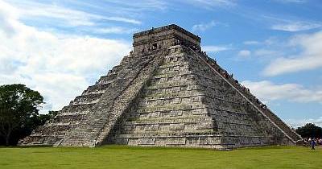
From: http://www.chichenitza.com/images/chichenitza.jpg

Christ the Redeemer:
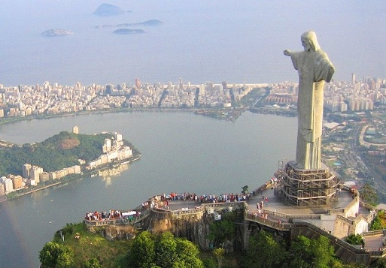
From: http://3.bp.blogspot.com/_J3etfOCrPwI/TTb3taJkGbI/AAAAAAAAETk/vHZJWjoDeJ M/s1600/brazil_christ-the-redeemer_01.jpg

Great Wall of China:
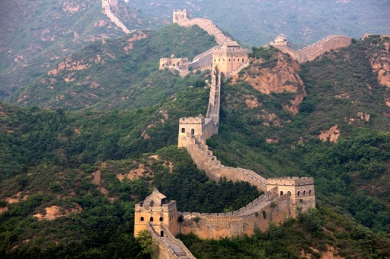
From: http://1.bp.blogspot.com/-VmEJqGsRKl8/Ta2n1S9gLeI/AAAAAAAAMns/sW0ipRGr BVg/s1600/great-wall-of-china.jpg

Machu Pichu:
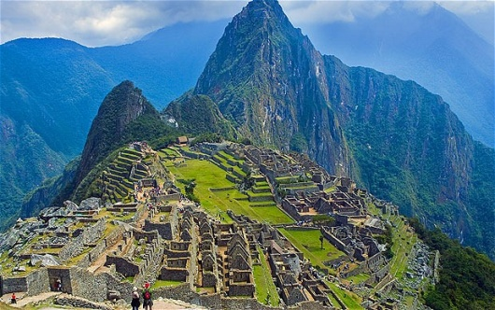
From: http://i.telegraph.co.uk/multimedia/archive/02354/MachuPicchu_2354046b.jpg

Petra:
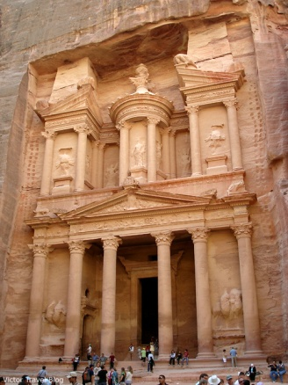
From: http://victortravelblogdotcom.files.wordpress.com/2013/01/petra-jordan-1.jpg?w=780

Colosseum:
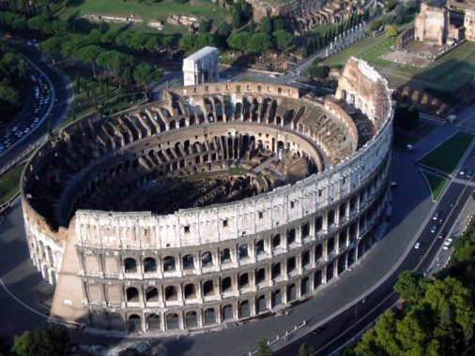
From: http://0.tqn.com/d/architecture/1/0/E/l/Colloseumaerial.jpg

Taj Mahal:

From: http://3.bp.blogspot.com/_dHj0_yTcK4Q/TGdhaOJtKRI/AAAAAAAAD7k/GQ9RbaCb HhE/s1600/AGR+Agra+-+Taj+Mahal+panorama+with+watercourse+and+indian+visitors+after +sunrise+3008x2000.jpg

Name: _______________________________________________________
Name: _______________________________________________________
People
Purpose
Location

Write on me with DRY ERASE MARKERS ONLY!
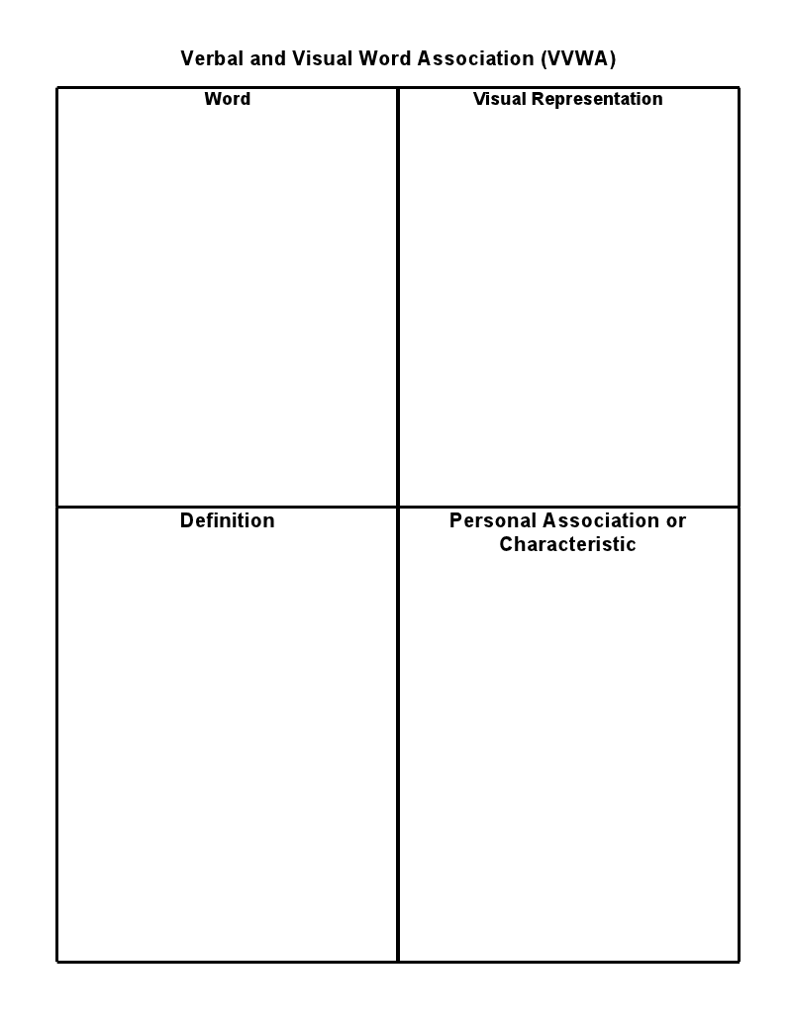
Laminated
Lesson Plan 6

Lesson Latitude and Longitude with Google Earth
Subject Social Studies Date Lesson Day 7; 40 minutes

Target Grade/Age Level: Grade 2

Pennsylvania/National Standards:

PA Standards Geography:
7.1.2.A: Identify how basic geographic tools are used to organize information.
PA English Language Proficiency Standard for ELLs standard:
English language learners communicate information, ideas, and concepts necessary for academic success in the content area of SOCIAL STUDIES.
NCSS Theme: People, Places, and Environments
The study of people, places, and human-environment interactions assists students as they create their spatial views and geographic perspectives of the world beyond their personal locations. Students need the knowledge, skills, and understanding to answer questions such as: Where are things located? Why are they located where they are? What do we mean by “region”? How do landforms change? What implications do these changes have for people? In schools, this theme typically appears in units and courses dealing with area studies and geography.

Generalization: People can use and create tools to better understand their environment.
Discussion/Essential Questions:
- How does a map describe and organize information about different places?
- How do latitude and longitude help people to understand the world?
Key Concepts/Skills:
Geographical concepts: latitude, longitude, satellite
Learning Objectives and Aligned Summative Assessments:
Learning Objectives | Aligned Summative Assessments
When presented with a fill in the blank item with a word bank, the student will write in the correct term on questions related to latitude, longitude and satellite maps with 100% accuracy. (Knowledge)  When presented with latitude and longitude coordinates and a GPS tracker, students will navigate to five given locations within 25 minutes. (Application) | Test item on summative assessment which asks the student to fill in blanks near a sentence describing a term using a word bank.  During lesson 8, students will complete geocaching task using GPS trackers. This task will rely heavily on synthesis of previously learned skills and application on latitude and longitude and cardinal direction skills.

Materials Needed:
- 1 computer with Google Earth installed for each student
- 1 on the run handout (attached)
- 1 projected computer for teacher with Google Earth installed

Expectations for Behavior and Class Activities:
- When others are talking students will listen quietly to what they are saying.
- When students want to answer a question they quietly raise their hands and wait to be called on.
- Students will sit safely, criss-cross applesauce on carpet during group instruction.
- Students will sit safely at desks or computers during small group and independent work.
- Students will use computers only as directed by only visiting instructed sites and being careful to not damage the technology.
- Students will actively participate in all activities giving their best efforts.
- Students will ask a peer for help before asking the teacher during independent or group work.
- Students will always give their best effort during activities, instruction and on assessments.
- Students will come to class on time and prepared with a pencil and ready to listen.

General or Specific Accommodations for Special Needs Learners:
- English Language Learners (ELL):
  - ELLs will be paired with a native English speaking peer buddy whom they can go to for assistance during independent work.
  - Handouts will be provided to students in their native language whenever possible.
- Students with reading disabilities:
  - All written instruction will also be given verbally to provide for equal learning opportunity.
  - Written material will be read to students with reading disabilities up to three times by independent student request.
- General Accommodations:
  - All methods of assistive technology normally available to students will be available during this lesson.

Description of Learning Activities:
Introductory Activities (Anticipatory Set):
Open Google Earth on the projected computer and load grid lines (view grid). These lines are latitude and longitude. Ask students to describe what they see as you rotate the planet and zoom in on different areas of the planet. Students should note that they make a grid, that they go up and down, they lines have numbers, the lines get more frequent when you zoom in and similar observations. Ask students what they think the lines might be for and when they answer that it could be for finding things, move on.

Modeling/Demonstration:
Show students that the lines are called longitude if they run north and south (up and down generally) and latitude if they run east and west (left and right generally). Go on to say that latitude tells you how north or south you are while longitude tells you how east or west you are. Tell the students that they can remember each because longitude lines tell you where you are aLONG the planet. Next, navigate to your school on Google Earth using the “search” box. (we will use Farmersville Elementary School for an example). Use the gridlines to show the students that it is near to the intersection of 40.665 N and 75.300 W. Look at the properties of the ‘add to place marks’ window when the tack is on the entrance and show student that the exact latitude is 40.665 N and exact longitude is 75.298 W. Explain that anyone in the world could use these coordinates to find the school. Ask the student what is different between this map and the maps of the mall and zoo they saw earlier. Students should note that these maps are photographs and not illustrations. Explain to students that maps that look like photographs are called satellite maps because they are taken by cameras on satellites in outer space. Next, find the coordinates of your local high school before class and show the class the numbers now. For example, Freedom High School is located at 40.663 N and 75.339 W. Ask the students, based on the numbers if they think that location would be near to their school are far? Then, type the coordinates into Google Earth and have it navigate to the area. Note to the students that you type the coordinates in by writing 40 (point) 663 (space) N (comma) 75 (point) 339 (space) W and that the latitude is always written first. The program will go to the high school.

Guided Practice and Feedback:
Direct the students to go to their computers and open Google Earth. Walk them through loading the grid lines onto their satellite maps and searching for the latitude and longitude for the high school just like you did. Assist the students with the technology as needed. Now write the following coordinates on the board: 48.858 N and 2.294 E. Give the students the chance to navigate to the site on their own and tell you what they find (Eiffel Tower). Do not help students unless they request assist assistance or have had three to five minutes to try the task on their own. Once you are sure students are proficient at using the latitude and longitude search tool, move on.

At this time, have students navigate to 55.751 N, 37.618 E. They will see a city. Have them zoom out to see the name of the city (Moscow). Tell them that this will be part of their quest in the next activity. Hand out the On The Run Worksheet. Read the narrative on the top. Then explain to the students that they need to use Google Earth to navigate to each set of latitude and longitude coordinates given. They might have to zoom out to find the city name, but they should write down the name of the city and circle the first letter of the city. Tell the student when they are done, they will spell the name of the city where they can find the thieves now, and they should search for that city in Google Earth and go there to show the teacher they are finished working.

Do the first city together. Guide the student to type in the coordinates and located the name of the first city (Salamanca). Circle the first letter and answer questions as needed.

Independent Practice/Exploring:
The students should be read to work on their own now. Give the students time to navigate to each coordinate set and find the city name. When students are done, you will see an image of Shanghai on their screens. Collect the worksheet as a formative assessment and allow them to spend time playing with Google Earth independently until the end of class.

Formative Assessments:
Students will work during guided practice on using Google Earth. At this time, the students will learn what latitude and longitude are and how to work with them together as a tool set. Students may struggle with the technology or concepts, so the teacher must look at their computer screens and prompt students for questions frequently to troubleshoot any problems.

The On The Run worksheet will guide students through using latitude and longitude coordinates in Google Earth. It will also look to see if students understand both how to use the coordinate and how to estimate them. The teacher should review these worksheets after class to see if additional instruction on latitude and longitude is necessary.

Review and Preview:
Bring the students back together. Ask the students to give thumbs up, down or sideways to indicate their level of comfort using Google Earth today. Use this as a formative assessment measure related to the success with the technology learning. Have students log out of their computer while verbally reviewing what latitude, longitude, and satellite maps are and which shows how north or south something is and runs east to west (right to left) and which tells how east or west a place is and runs north and south (or up and down). Also note the differences between a satellite map and an illustrated map. Tell students that tomorrow they will work with latitude and longitude more and revisit their exploration of the Seven Wonders of the Modern World using Google Earth to see more satellite images, or pictures from outer space.

Extension Activities:
Google Earth has a lot of capabilities; so many students may wish to spend their extra time playing with the program in general. If students are looking for an additional challenge, give them a quest to create their own hidden location in the same style of the handout. You may use any student created quests as extra credit assignments or enrichment activities for other students once you have checked them.

Ask students that finish early to add anything new they want to learn to the KWL chart from day one or to cross off things that were learned in today’s class.

Potential Areas of Difficulty with the Content and Correction Procedures:

Students might need more opportunities to become familiar with using Google Earth to search for latitude and longitude coordinate. You may use the following sets of coordinates as more learning opportunities: 27.979 N, 31.134 E (Great Pyramid of Giza); 34.134 N, 118.321 W (Hollywood Sign); 40.578 N, 75.534 W (Dorney Park)

Summative Assessments:
The following items will be included on the summative assessment at a 3 point value for each question. See Lesson 8 for performance assessment:

Fill in the blanks below using the words in the word box.
Latitude Longitude Satellite

Lines of ______________ usually run left and right (always east and west) on a map and tell how north or south a location is. (latitude)

________________ lines usually run up and down (always north and south) on a map and tell how east or west a location is. (longitude)

A _______________ map shows the map as photographs from outer space. (satellite)

Reflections:
n/a- lesson not implemented

Sources:
Google Inc. (2013). Google Earth (Version 7.0.3.8542) [Software]. Available from http://www. google.com/earth/download/ge/agree.html
National Council for the Social Studies. (2004) Expectations of excellence: Curriculum standards for social studies. Retrieved from: http://www.socialstudies.org/standards/execsummary
Pennsylvania Department of Education. (2012, May). Academic standards for geography: Pre-K to 3. Retrieved from: http://static.pdesas.org/content/documents/PreK-2_Geography_ Standards.pdf

ON THE RUN!
Name: ______________________________________________
Dear Detective,
The Waterford brothers are at it again! They stole the crown jewels of England! Now they are on the run! Please help us catch them. Our decoders found out the numbers below are the latitude and longitude of each city the thieves have hid out in. Use the first letter in the name of each city to find out where they are now! The latitude and longitude of that city will give us that access code to their safe and get back the crown jewels!
Thank you!

Latitude | Longitude | City Name
40.970 N | 5.663W
40.273 N | 76.884 W
34.928 S | 138.559 E
38.952 S | 68.064 W
44.519 N | 88.019 W
44.648 N | 63.575 W
5.555 N | 0.196 W
33.720 N | 73.073 E

Mystery City: ___ ___ ___ ___ ___ ___ ___ ___

Latitude: _______________ Longitude: _______________________
ON THE RUN!
Name: __Key_________________________________________
Dear Detective,
The Waterford brothers are at it again! They stole the crown jewels of England! Now they are on the run! Please help us catch them. Our decoders found out the numbers below are the latitude and longitude of each city the thieves have hid out in. Use the first letter in the name of each city to find out where they are now! The latitude and longitude of that city will give us that access code to their safe and get back the crown jewels!
Thank you!

Latitude | Longitude | City Name
40.970 N | 5.663W | S alamanca, Spain
40.273 N | 76.884 W | H arrisburg, PA, USA
34.928 S | 138.559 E | A delaide, Australia
38.952 S | 68.064 W | N euquén, Argentina
44.519 N | 88.019 W | G reen Bay, WI, USA
44.648 N | 63.575 W | H alifax, NS, Canada
5.555 N | 0.196 W | A ccra, Ghana
33.720 N | 73.073 E | I slamabad, Pakistan

Mystery City: S H A N G H A I .

Latitude: ___31.230 N______ Longitude: ___121.473 E___________
Lesson Plan 7

Lesson Finding the Wonders!
Subject Social Studies Date Lesson Day 8, 30 minutes

Target Grade/Age Level: Grade 2

Pennsylvania/National Standards:

PA Standards Geography:
7.1.2.A: Identify how basic geographic tools are used to organize information.
7.1.71B: Describe regions in geographic reference using physical features.

PA English Language Proficiency Standard for ELLs standard:
English language learners communicate information, ideas, and concepts necessary for academic success in the content area of SOCIAL STUDIES.

NCSS Theme: People, Places, and Environments
The study of people, places, and human-environment interactions assists students as they create their spatial views and geographic perspectives of the world beyond their personal locations. Students need the knowledge, skills, and understanding to answer questions such as: Where are things located? Why are they located where they are? What do we mean by “region”? How do landforms change? What implications do these changes have for people? In schools, this theme typically appears in units and courses dealing with area studies and geography.

Generalization: People can use and create tools to better understand their environment.
Discussion/Essential Questions:
- How does a map describe and organize information about different places?
- How do latitude and longitude help people to understand the world?
Key Concepts/Skills:
Geographical concepts: prime meridian, equator, hemispheres
Learning Objectives and Aligned Summative Assessments:
Learning Objectives | Aligned Summative Assessments
When presented with the latitude and longitude coordinates of a place on Earth, the student will be able to deduce which hemispheres that location lies in with 100% accuracy. (Analysis)  When presented with a fill in the blank item with a word bank, the student will write in the correct term on questions related to the prime meridian, hemispheres, and the equator with 100% accuracy. (Knowledge) | Test item on summative assessment where students are given 4 sets of latitude and longitude coordinates and must circle the hemispheres where each point is located.  Test item on summative assessment which asks the student to fill in blanks near a sentence describing a term using a word bank.
Materials Needed:
- 1 computer with Google Earth installed for each student
- 1 Finding the Wonders handout per student
- 1 projected computer for teacher with Google Earth installed

Expectations for Behavior and Class Activities:
- When others are talking students will listen quietly to what they are saying.
- When students want to answer a question they quietly raise their hands and wait to be called on.
- Students will sit safely, criss-cross applesauce on carpet during group instruction.
- Students will sit safely at desks or computers during small group and independent work.
- Students will use computers only as directed by only visiting instructed sites and being careful to not damage the technology.
- Students will actively participate in all activities giving their best efforts.
- Students will ask a peer for help before asking the teacher during independent or group work.
- Students will always give their best effort during activities, instruction and on assessments.
- Students will come to class on time and prepared with a pencil and ready to listen.

General or Specific Accommodations for Special Needs Learners:
- English Language Learners (ELL):
  - ELLs will be paired with a native English speaking peer buddy whom they can go to for assistance during independent work.
  - Handouts will be provided to students in their native language whenever possible.
- Students with reading disabilities:
  - All written instruction will also be given verbally to provide for equal learning opportunity.
  - Written material will be read to students with reading disabilities up to three times by independent student request.
- General Accommodations:
  - All methods of assistive technology normally available to students will be available during this lesson.

Description of Learning Activities:
Introductory Activities (Anticipatory Set):
The teacher will review the cardinal directions with students focusing on what parts of the planet we consider to be in the North, South, East, and West. Next, the teacher should show pictures of each hemisphere (see suggested items attached). The teacher should have students recognize countries in each (special focus on countries students in the class might come from). Tell the students that today they will learn more about how the map of the whole planet is organized.

Lectured Instruction:
Explain to students that the Equator is located at 0° latitude and that it splits the northern and southern hemisphere. Use Google Earth to show the equator and rotate the planet so that students can see the split. Also rotate the planet to show only the northern and southern hemispheres at a time. Highlight that when the northern hemisphere is shown, then all the longitude points are northern coordinate and the opposite for the southern hemisphere. Repeat this with the prime meridian and latitude coordinates. For this, show that on one side of the earth it is at 0° longitude and on the other it is at 180°. Repeat the procedures that you did for latitude, but for longitude and the eastern and western hemisphere. Discuss how you can use latitude and longitude coordinates to find out what hemispheres different places are located and move on. Also tell students that places along the equator get the most sun light and are the hottest places while places along the prime meridian are not different because the prime meridian is determined by man and not nature.

Modeling/Demonstration:
Tell the class that now they will search for key locations on the planet using Google Earth and discover which hemispheres they lie in using latitude and longitude. Ask them to also use that information to consider how close they are to the equator what that might mean for their temperature. First, search for the great pyramid of Giza. The coordinates will be 29.97 N and 31.13 E. Tell the students they can easily use the letters in the coordinates to determine the hemisphere locations. Show them that N tells that the pyramid is in the northern hemisphere and E tells that it is in the Eastern hemisphere.

Guided Practice and Feedback:
Repeat the above procedures for the Grand Canyon (36.35N, 112.66W) and Mount Fiji (17.61S, 178.01E). Allow students to come up and search for each coordinate and then ask a different student to read the GPS coordinates (latitude and longitude) while reminding students that GPS coordinates and latitude and longitude coordinates are the same. Finally choose one student to give the north and south hemisphere and another to provide east and west. Provide feedback as needed until students seem competent at the hemisphere identification task.

Independent Practice/Exploring:
Hand out the Finding the Wonders handouts and explain the instructions. Answer any questions the student might have and allow them to begin the task. Walk around during this practice to provide formative assessment where needed.

Formative Assessments:
Formative assessment will be provided on the handout submitted from independent work both while students are completing the assignment and as needed after the submission. Guided practice will also serve as a formative assessment measure. Today’s lesson also reinforces elements from the previous lessons and acts as a formative assessment for the recall of the cardinal directions, latitude and longitude concepts.

Review and Preview:
Bring the class’s attention back together as a whole, but allow students to remain at the computers. Review the answers on the worksheet (collect them also as an individual formative assessment). Make sure to tell students not to erase their original answers if they make any corrections, but to put one line through the wrong answer and write the correct answer next to the item. Collect the handouts after all answers are reviewed. If time is remaining, invite some students to come up and share their extension activities from today and yesterday that made a different latitude and longitude hunt in the style of the previous lesson’s activity. When only 3 minutes are remaining stop the activity and ask the students what they think knowing about latitude and longitude and hemispheres could help them do. This should be used as a question to help students think about the essential understanding of: People can use and create tools to better understand their environment.

Finally, tell kids to remember outside clothes because tomorrow they will work on using all they know about maps to find treasures outside.

Extension Activities:
Give students a quest to create their own hidden location activity (latitude and longitude hunt) in the same style of the previous lesson’s activity. You may use any student created quests as extra credit assignments or enrichment activities for other students once you have checked them and/or include them in today’s closing activity.

Ask students that finish early to add anything new they want to learn to the KWL chart from day one or to cross off things that were learned in today’s class.

Additionally, there is a challenge question on the Finding the Wonders handout.

Potential Areas of Difficulty with the Content and Correction Procedures:
Students might need more opportunities to practice with the hemispheres. If so select some landmarks that would be meaningful to the target class to search for and notate latitude, longitude, and hemispheres for those locations until the students are ready to move on.

Summative Assessments:
The following items will be included on the summative assessment:

Circle the two hemispheres each of the following latitude and longitude coordinates are located in. (1 point for each hemisphere)

48.25° N, 23.15° W Northern Southern
(Northern, Western) Eastern Western

48.25° S, 98.78° W Northern Southern
(Southern, Western) Eastern Western

68.95° S, 32.15° E Northern Southern
(Southern, Eastern) Eastern Western

12.54°N, 26.78° W Northern Southern
(Northern, Western) Eastern Western

Fill in the blanks below using the words in the word box. (3 points each)
Prime Meridian Equator Hemisphere

When geographers split the planet in half, they call each side a _________________. Bethlehem, PA is located in the northern and western one. (hemisphere)

The ________________ is located at 0° latitude and divides the Earth into the northern and southern hemispheres. (equator)

The ________________ is located at 0° and 180° longitude and divides the Earth into the eastern and western hemispheres. (prime meridian)

Reflections:
n/a- lesson not implemented

Sources:
Google Inc. (2013). Google Earth (Version 7.0.3.8542) [Software]. Available from http://www. google.com/earth/download/ge/agree.html
National Council for the Social Studies. (2004) Expectations of excellence: Curriculum standards for social studies. Retrieved from: http://www.socialstudies.org/standards/execsummary
Pennsylvania Department of Education. (2012, May). Academic standards for geography: Pre-K to 3. Retrieved from: http://static.pdesas.org/content/documents/PreK-2_Geography_ Standards.pdf
Suggested Hemisphere Images:

Northern Hemisphere:

1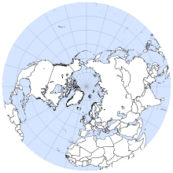 2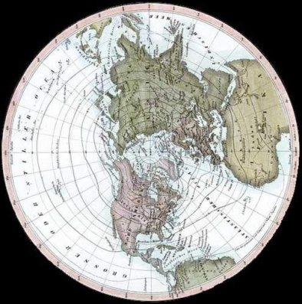 3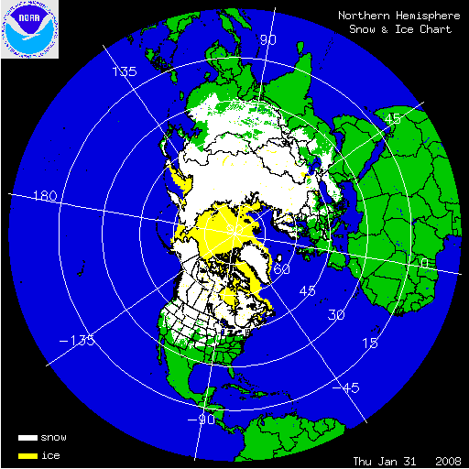

- http://upload.wikimedia.org/wikipedia/commons/thumb/5/59/Northern_Hemisphere_Azimuthal_projections.svg/220px-Northern_Hemisphere_Azimuthal_projections.svg.png
- http://www.mrinbetween.com/images/Northern-Hemisphere-forweb.jpg
- http://www.whatdoesitmean.com/nhi2.gif

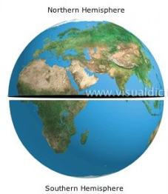
http://kashif-ali.com/wp-content/uploads/2010/03/hemispheres-227x300.jpg

Southern Hemisphere:
1 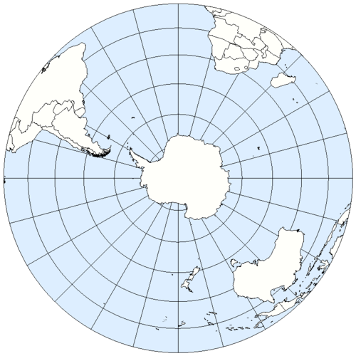 2 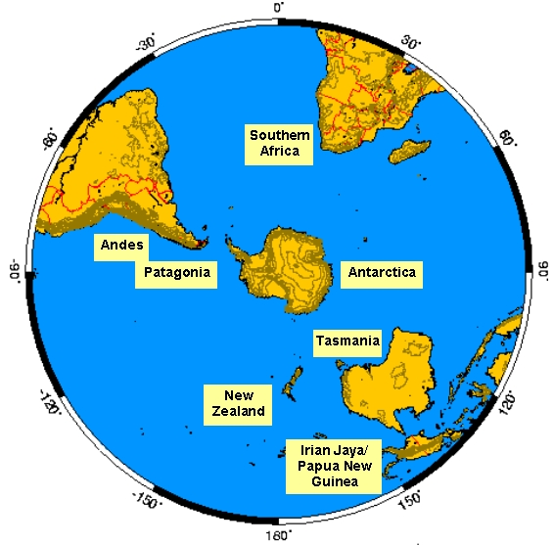

- http://www.zonu.com/images/500X0/2010-01-22-11730/Mapa-Politico-del-Hemisferio-Sur-2005.png
- http://withfriendship.com/images/g/33558/Southern-Hemisphere-image.jpg

Eastern Hemisphere:

1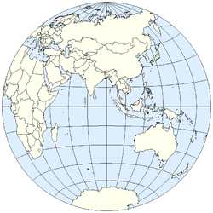 2 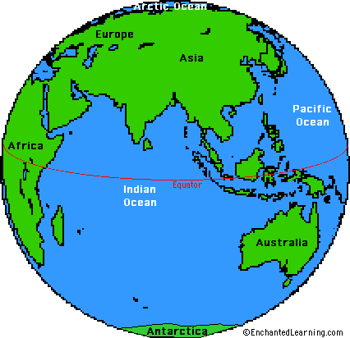

- http://upload.wikimedia.org/wikipedia/commons/thumb/e/ef/Eastern_Hemisphere_LamAz.png/250px-Eastern_Hemisphere_LamAz.png
- http://www.enchantedlearning.com/crafts/globe/earthcoloreh.GIF

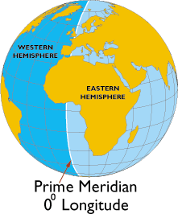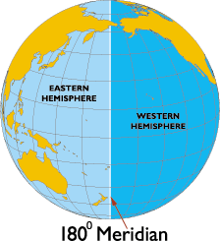
http://www.worldatlas.com/aatlas/infopage/meridian.gif
http://www.worldatlas.com/aatlas/infopage/meridianb.gif

Western Hemisphere:

1 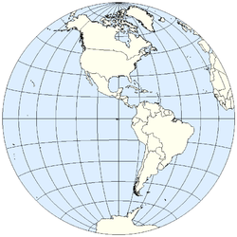 2 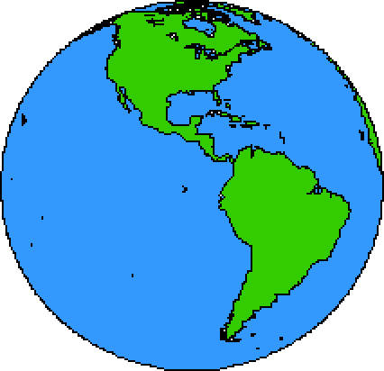

- http://upload.wikimedia.org/wikipedia/commons/thumb/6/6c/Western_Hemisphere_LamAz.png/250px-Western_Hemisphere_LamAz.png
- http://www.enchantedlearning.com/crafts/earthday/earthcolorwh.GIF

Finding the Wonders!

Name: ________________________________________

Directions: Search for each of the Seven Wonders of the Modern World listed below on Google Earth. Write down their latitude and longitude coordinates and circle the hemispheres that they are located in. Remember, each location is in two hemispheres either northern or southern AND either eastern or western.

Taj Mahal  Latitude:__________  Longitude:___________  Hemispheres:  Northern Southern  Eastern Western | Christ the Redeemer Statue  Latitude:__________  Longitude:___________  Hemispheres:  Northern Southern  Eastern Western
Petra  Latitude:__________  Longitude:___________  Hemispheres:  Northern Southern  Eastern Western | Great Wall of China  Latitude:__________  Longitude:___________  Hemispheres:  Northern Southern  Eastern Western
Colosseum  Latitude:__________  Longitude:___________  Hemispheres:  Northern Southern  Eastern Western | Macchu Picchu  Latitude:__________  Longitude:___________  Hemispheres:  Northern Southern  Eastern Western
Chichen Itza

Latitude:__________
Longitude:___________
Hemispheres:
Northern Southern
Eastern Western

Challenge Quest:
The equator is located at 0° Latitude. Order the 7 Wonders from closest to farthest from the Equator.
1. 5.
2. 6.
3. 7.
4.
Finding the Wonders!

Name: ___KEY__________________________________

Directions: Search for each of the Seven Wonders of the Modern World listed below on Google Earth. Write down their latitude and longitude coordinates and circle the hemispheres that they are located in. Remember, each location is in two hemispheres either northern or southern AND either eastern or western.

Taj Mahal  Latitude:__27.17 N__  Longitude:_78.04 E____  Hemispheres:  Northern Southern  Eastern Western | Christ the Redeemer Statue  Latitude:_22.95 S__  Longitude:_43.21 W____  Hemispheres:  Northern Southern  Eastern Western
Petra  Latitude:_39.60 N__  Longitude:_3.11 E____  Hemispheres:  Northern Southern  Eastern Western | Great Wall of China  Latitude:_40.42 N__  Longitude:_116.56 E__  Hemispheres:  Northern Southern  Eastern Western
Colosseum  Latitude:_52.23 N__  Longitude:_6.83 E____  Hemispheres:  Northern Southern  Eastern Western | Macchu Picchu  Latitude:_13.16 S__  Longitude:_72.54 W___  Hemispheres:  Northern Southern  Eastern Western
Chichen Itza

Latitude:_20.67 N__
Longitude:_88.57 W___
Hemispheres:
Northern Southern
Eastern Western

Challenge Quest:
The equator is located at 0° Latitude. Order the 7 Wonders from closest to farthest from the Equator.
1. Macchu Picchu 5. Petra
2. Chichen Itza 6. Great Wall of China
3. Christ the Redeemer Statue 7. Colosseum
4. Taj Mahal

Lesson Plan 8

Lesson Geocaching
Subject Social Studies Date Lesson Day 9; 1 hour

Target Grade/Age Level: Grade 2

Pennsylvania/National Standards:

PA Standards Mathematics:
2.3.2.B: Use tools to estimate and measure in standard units.

PA Standards Geography: 7.1.2.A: Identify how basic geographic tools are used to organize information.

PA English Language Proficiency Standard for ELLs standard:
English language learners communicate information, ideas, and concepts necessary for academic success in the content area of SOCIAL STUDIES.

NCSS Theme: People, Places, and Environments
The study of people, places, and human-environment interactions assists students as they create their spatial views and geographic perspectives of the world beyond their personal locations. Students need the knowledge, skills, and understanding to answer questions such as: Where are things located? Why are they located where they are? What do we mean by “region”? How do landforms change? What implications do these changes have for people? In schools, this theme typically appears in units and courses dealing with area studies and geography.

Common Core State Standards: Mathematics:
CCSS.Math.Content.2.MD.A.3: Estimate lengths using units of inches, feet, centimeters, and meters.

Generalization: People can use and create tools to better understand their environment.
Discussion/Essential Questions:
- How can I apply latitude, longitude, cardinal directions, and maps to understand my environment?
- What things do people use and create to better understand their environment?
Key Concepts/Skills:
Geographical concepts: GPS tracking, geocaching
Learning Objectives and Aligned Summative Assessments:
Learning Objectives | Aligned Summative Assessments
When presented with latitude and longitude coordinates and a GPS tracker, students will navigate to five given locations within 25 minutes. (Application) | Students will complete geocaching task using GPS trackers. This task will rely heavily on synthesis of previously learned skills and application on latitude and longitude and cardinal direction skills.

Materials Needed:
- 10 eTrex GPS units loaded with preplanted geocaches
- 6 planted geocaches (see Description of Learning Activities)
- Projected computer screen
- 10 Geocaching Worksheets
- 10 Clipboards (to hold worksheets)

Expectations for Behavior and Class Activities:
- When others are talking students will listen quietly to what they are saying.
- When students want to answer a question they quietly raise their hands and wait to be called on.
- Students will sit safely, criss-cross applesauce on carpet during whole group instruction.
- Students will use technology in a safe and careful manner.
- Students will work nicely in small groups by being kind and respectful to their peers.
- Students will ask a peer for help before asking the teacher during small group work.
- Students will always give their best effort during activities, instruction and on assessments.
- Students will come to class on time and prepared with a pencil and ready to listen.

General or Specific Accommodations for Special Needs Learners:
- English Language Learners (ELL):
  - ELLs will be paired with native English speakers during small group work.
- Students with reading disabilities:
  - All written instruction will also be given verbally to provide for equal learning opportunity.
  - Students with reading disabilities will be grouped with high level readers during small group work (reading intensive).
- General Accommodations:
  - All methods of assistive technology normally available to students will be available during this lesson.

Description of Learning Activities:
Before Class:
Hide 6 geocaches outside on the school property (directions available at http://www.geocaching.com/about/hiding.aspx). In each cache (Tupperware container) place the clues included in the Cache Clues attachment. Add the 6 geocaches to the student’s GPS units (directions at http://www.youtube.com/watch?feature=player_detailpage&v=6cy7DP0lA-M).
Introductory Activities (Anticipatory Set):
Tell the students that today they will put together everything that they know about maps and mapping tools to find hidden treasures. Explain that although this is part of their unit test, the activity is also going to be fun. Show the students the video at http://www.youtube.com/watch?feature=player_detailpage&v=-4VFeYZTTYs to show them what geocaching is and ask the kids if they are excited.

Activity A:

Modeling/Demonstration:
Break the students into 10 groups and hand out the GPS units. Walk the students through how to use their gps units. The directions at http://www.youtube.com/watch?feature=player_detailpage&v=C8UKJtZIAWE may be used with discretion (some parts should be skipped as they are irrelevant to the students) or the teacher can walk the student through using the unit by modeling each item. Using a document camera would help students see the teacher during this kind of instruction.

Now guide the students to load the first, example geocache on their GPS units.

Guided Practice and Feedback:
Once all groups have the first unit loaded, bring the students outside. Navigate to the unit using a think out loud (I see that I am at x latitude and x longitude and need to go to x and x. That means I need to move north. I will look at my compass for north and head that way. The unit says that now I’m only 50 feet away rather than 70, so I must be getting closer.) When you are about 50 feet from the cache, tell the students to lead. Give feedback as necessary.

Hand out the geocaching worksheets (1 per group). Tell the students that they should find their caches in the order noted on their handouts. Explain that each geocache will have a word or phrase for each team (A, B, C, D, E, F, G, H, I, J) to write down. They should only write down the word or phrase that is next to their letter. Show the example clue from the example geocache and ask each team to identify which clue they would write down. Have them write that down in the practice item on their team’s sheet. Check to make sure they all did that correctly and move on.

Independent Practice/Exploring:
First send groups A, B, C, D, and E out to geocache. This group can be sent out with a paraprofessional or parent volunteer to supervise the children. The volunteer or para should be familiar with the geocaching task and able to provide feedback as needed on how to use the technology, but not how to apply the latitude and longitude as well as cardinal direction skills. Teachers can help with comprehension of distance measurement as this lesson only reinforces this concept which students would be learning primarily in mathematics class. After 10 minutes send out groups F, G, H, I and J. It is advisable that the first group of students include gifted students and those who are unlikely to need further assistance. The second group should focus on students that may need extra help. During the 10 minute delayed start additional practice using the GPS unit should be provided to prepare them for the activity.

Formative Assessments:
The teacher should be careful to formatively assess using thumbs up and thumbs down, question and answer, observation, and other techniques that tend to work well with the given student population during the initial geocache find. At this time, students must all be evaluated for understanding of the task and technology. Only after it is clear that all students can achieve success with the geocaching task should the teacher move on to the independent activity.

Review and Preview:
Bring the class back together and debrief. Talk about what they found easy and hard during the geocaching task and exploration activity. Bring student discussion to understanding that the students used mapping tools, or geographic tools, to help them find things in the world. State the generalization: People can use and create tools to better understand their environment. Ask the students how today’s activity or previous days’ activities showed this. Finally, have students give a thumbs up or down to indicate if they agree or disagree with this generalization.

Remind students that they have their geography test coming up and that they should study by using all of the formative assessment items that you have handed back.

Extension Activities:
Have some plastic Easter eggs available for students to hide. When they hide the eggs, show the student how to set a way point at that location on their GPS device. Have the students trade devices and locate each other’s geocache eggs.

Ask students that finish early to add anything new they want to learn to the KWL chart from day one or to cross off things that were learned in today’s class.

Potential Areas of Difficulty with the Content and Correction Procedures:
Students might have trouble combining what they have learned so far and synthesizing the information for use with the GPS system. If students need more practice before this higher level thinking task can be achieved guide students through one of the five geocache finds indented for the summative assessment.

Summative Assessments:
The independent practice portion of this lesson will be used as a formative assessment where students will be graded with either a pass or fail. Student groups who return the geocaching handout completed correctly within 25 minutes of beginning the activity will receive a pass and those that do not will receive a fail. If a student group returns the handout with a word or phrase that is correct to the geocache for an item, but incorrect to their group, that group will be given the opportunity to return to that cache (without the GPS tracker) to find what the right word or phrase was and correct the handout. In this case, the group will still receive a pass. This activity is worth 30 points on their full summative assessment.

Reflections:
n/a- lesson not implemented

Sources:
DAVEA2332. (2012, Jan 10). Waypointing and geocaching using the garmin etrex venture HC. Retrieved from: http://www.youtube.com/watch?feature=player_detailpage&v=6cy7D P0lA-M
GoGeocaching. (2010, Mar 17). What is geocaching? Retrieved from: http://www.youtube.com/ watch?feature=player_detailpage&v=-4VFeYZTTYs
Groundspeak, Inc. (2013, April). Hiding your first geocache. Retrieved from http://www.geo caching.com/about/hiding.aspx.
Lewis, B. (2011, Nov 8). Using the GPS unit. Retrieved from: http://www.youtube.com/watch ?feature=player_detailpage&v=C8UKJtZIAWE
Lockyer, S. (2013, Apr 10). A geocaching treasure hunt helped my students learn about the landscape. Retrieved from: http://www.guardian.co.uk/teacher-network/teacher-blog/2013/apr/04/geocaching-geography-history-teaching-landscapes.
National Council for the Social Studies. (2004) Expectations of excellence: Curriculum standards for social studies. Retrieved from: http://www.socialstudies.org/standards/execsummary
Pennsylvania Department of Education. (2008. Dec). Pennsylvania English Language Proficiency Standards. Retrieved from: http://www.portal.state.pa.us/portal/server.pt? open=18&objID=357587&mode=2
Pennsylvania Department of Education. (2010, May 18). Academic standards for mathematics: Pre-K to 3. Retrieved from: http://static.pdesas.org/content/documents/Academic_Standar ds_for_Mathematics_Pre-K-3.pdf
Pennsylvania Department of Education. (2012, May). Academic standards for geography: Pre-K to 3. Retrieved from: http://static.pdesas.org/content/documents/PreK-2_Geography_ Standards.pdf

Geocache Items (to be placed inside the appropriate Geocaches
example
A: latitude | F: east
B: north | G: satellite map
C: compass | H: map key
D: longitude | I: equator
E: south | J: west

Cache 001
A: The United States | F: On October 5, 1947,
B: erupted | G: sent two mice
C: the Civil War | H: Titanic
D: Queens, NYC. | I: in 1786
E: William | J: the Wester

Cache 002
A: Constitution | F: Harry Truman
B: In 1980, | G: In 1958,
C: to 1865 | H: in April 1912.
D: in Flushing, | I: by the Constitution
E: after | J: discovered

Cache 003
A: was signed | F: gave the first
B: in Washington state. | G: into space.
C: from 1861 | H: in the Atlantic Ocean
D: World’s Fair | I: of Confederation
E: Pennsylvania | J: Lewis

Cache 004
A: by 38 people | F: presidential speech
B: Mount Saint Helens | G: the United States
C: The Amerian | H: The RMS
D: took place | I: were replaced
E: Penn. | J: United States.

Cache 005
A: in 1786. | F: on television
B: like a volcano | G: called Laska and Benji
C: was fought | H: sank
D: The 1964/1965 | I: The Articles
E: was named | J: and Clark

Group A: Names: ____________________________________________

EXAMPLE | Word/Phrase: | Location:
Cache 001 | Word/Phrase: | Location:
Cache 002 | Word/Phrase: | Location:
Cache 003 | Word/Phrase: | Location:
Cache 004 | Word/Phrase: | Location:
Cache 005 | Word/Phrase: | Location:

Put the word/phrases together to make a sentence below. Your order of items is

001 002 003 004 005

Group B: Names: _____________________________________________

EXAMPLE | Word/Phrase: | Location:
Cache 002 | Word/Phrase: | Location:
Cache 004 | Word/Phrase: | Location:
Cache 001 | Word/Phrase: | Location:
Cache 005 | Word/Phrase: | Location:
Cache 003 | Word/Phrase: | Location:

Put the word/phrases together to make a sentence below. Your order of items is

002 004 001 005 003

Group C: Names: _____________________________________________

EXAMPLE | Word/Phrase: | Location:
Cache 004 | Word/Phrase: | Location:
Cache 001 | Word/Phrase: | Location:
Cache 005 | Word/Phrase: | Location:
Cache 003 | Word/Phrase: | Location:
Cache 002 | Word/Phrase: | Location:

Put the word/phrases together to make a sentence below. Your order of items is

004 001 005 003 002

Group D: Names: _____________________________________________

EXAMPLE | Word/Phrase: | Location:
Cache 005 | Word/Phrase: | Location:
Cache 003 | Word/Phrase: | Location:
Cache 004 | Word/Phrase: | Location:
Cache 002 | Word/Phrase: | Location:
Cache 001 | Word/Phrase: | Location:

Put the word/phrases together to make a sentence below. Your order of items is

005 003 004 002 001

Group E: Names: _____________________________________________

EXAMPLE | Word/Phrase: | Location:
Cache 003 | Word/Phrase: | Location:
Cache 005 | Word/Phrase: | Location:
Cache 002 | Word/Phrase: | Location:
Cache 001 | Word/Phrase: | Location:
Cache 004 | Word/Phrase: | Location:

Put the word/phrases together to make a sentence below. Your order of items is

003 005 002 001 004

Group F: Names: _____________________________________________

EXAMPLE | Word/Phrase: | Location:
Cache 001 | Word/Phrase: | Location:
Cache 002 | Word/Phrase: | Location:
Cache 003 | Word/Phrase: | Location:
Cache 004 | Word/Phrase: | Location:
Cache 005 | Word/Phrase: | Location:

Put the word/phrases together to make a sentence below. Your order of items is

001 002 003 004 005

Group G: Names: _____________________________________________

EXAMPLE | Word/Phrase: | Location:
Cache 002 | Word/Phrase: | Location:
Cache 004 | Word/Phrase: | Location:
Cache 001 | Word/Phrase: | Location:
Cache 005 | Word/Phrase: | Location:
Cache 003 | Word/Phrase: | Location:

Put the word/phrases together to make a sentence below. Your order of items is

002 004 001 005 003

Group H: Names: _____________________________________________

EXAMPLE | Word/Phrase: | Location:
Cache 004 | Word/Phrase: | Location:
Cache 001 | Word/Phrase: | Location:
Cache 005 | Word/Phrase: | Location:
Cache 003 | Word/Phrase: | Location:
Cache 002 | Word/Phrase: | Location:

Put the word/phrases together to make a sentence below. Your order of items is

004 001 005 003 002

Group I: Names: _____________________________________________

EXAMPLE | Word/Phrase: | Location:
Cache 005 | Word/Phrase: | Location:
Cache 003 | Word/Phrase: | Location:
Cache 004 | Word/Phrase: | Location:
Cache 002 | Word/Phrase: | Location:
Cache 00 | Word/Phrase: | Location:

Put the word/phrases together to make a sentence below. Your order of items is

005 003 004 002 001

Group J: Names: _____________________________________________

EXAMPLE | Word/Phrase: | Location:
Cache 003 | Word/Phrase: | Location:
Cache 005 | Word/Phrase: | Location:
Cache 002 | Word/Phrase: | Location:
Cache 001 | Word/Phrase: | Location:
Cache 004 | Word/Phrase: | Location:

Put the word/phrases together to make a sentence below. Your order of items is

003 005 002 001 004

Answers per group:
A: The United States Constitution was signed by 38 people in 1786.
B: In 1980, Mount Saint Helens erupted like a volcano in Washington state.
C: The American Civil War was fought from 1861 to 1865.
D: The 1964/1965 World’s Fair took place in Flushing, Queens, NYC.
E: Pennsylvania was named after William Penn.
F: On October 5, 1947, Harry Truman gave the first presidential speech on television.
G: In 1958, the United States sent two mice called Laska and Benji into space.
H: The RMS Titanic sank in the Atlantic Ocean in April 1912.
I: The Articles of Confederation were replaced by the Constitution in 1786.
J: Lewis and Clark discovered the Western United States.

Summative Assessment
Unit Test: Maps

Name: ______________________ Date: _________________

Fill in the blanks below using the words in the word box. (3 points each)
Equator Hemisphere Key
Latitude Longitude Prime Meridian
Satellite Symbol

- A _______________ is a collection of pictures and what they mean. It is used to help a person understand a map.

- Maps can use a _______________ to show, or represent, a different item or place on the map rather than drawing every detail.

- Lines of _______________ usually run left and right (always east and west) on a map and tell how north or south a location is.

- _______________ lines usually run up and down (always north and south) on a map and tell how east or west a location is.

- A _______________ map shows the map as photographs from outer space.

- When geographers split the planet in half, they call each side a _______________ Bethlehem, PA is located in the northern and western one.

- The _______________ is located at 0° latitude and divides the Earth into the northern and southern hemispheres.

- The _______________ is located at 0° and 180° longitude and divides the Earth into the eastern and western hemispheres.
Circle the two hemispheres each of the following latitude and longitude coordinates are located in.

- 48.25° N, 23.15° W Northern Southern
Eastern Western

10. 48.25° S, 98.78° W Northern Southern
Eastern Western

11. 68.95° S, 32.15° E Northern Southern
Eastern Western

12. 12.54°N, 26.78° W Northern Southern
Eastern Western

13. Look at the following map.
- Place an X on the restrooms.
- Circle (O) the fishing pier.
- Square ( ) the school house.
- Put a triangle ( ) on the campground.

Look at the map below. Read each item and give the best answer based on the map.

- Find South Dakota. Name the state that is north of South Dakota.
___________________________
- Which state is west of Nevada?
___________________________
- Which state is just east of Wisconsin?
____________________________
- What state is south of both Georgia and Alabama? ____________________________
- Which state is north of Oregon and west of Idaho? ____________________________

Look at the following map and answer the questions below using your ruler.

- What is the approximate distance from Denver, CO to Orlando, FL? _____________________

- What is the approximate distance from Seattle, WA to Los Angeles, CA? _____________________

- What is the approximate distance from Buffalo, NY to St. Louis, MO? _____________________

- Read the non-fiction text and look at the map below. Fill out the chart to research information about the Great Pyramid of Giza.

The Great Pyramid of Giza is a huge pyramid built by the Ancient Egyptians. It stands near Cairo, Egypt and is one of the seven wonders of the ancient world. It was the tallest building in the world for over 3 thousand years. Archaeologists think the pyramid was built as a tomb or grave site for Khufu, an Egyptian pharaoh.
The great pyramid of Giza was made from limestone and granite. The pharaoh's body was placed in the heart of the pyramid, but when the archaeologists looked for the body it was missing.

Location  (where is it?) | Purpose  (what was it used for?) | People  (who’s there?, who made it?)

Score on test ______ / 70 points
Performance Assessment Score: _____ / 30 points

Unit Score: ______/ 100 points

_____________________________________ ______________
Parent/Guardian Signature Date
Unit Test: Mapping (KEY)

Name: ______________________ Date: _________________
(1 Point for name, 1 point for date)

Fill in the blanks below using the words in the word box. (3 points each)
Equator Hemisphere Key
Latitude Longitude Prime Meridian
Satellite Symbol

- A _______________ is a collection of pictures and what they mean. It is used to help a person understand a map. (key)

- Maps can use a _______________ to show, or represent, a different item or place on the map rather than drawing every detail. (symbol)

- Lines of _______________ usually run left and right (always east and west) on a map and tell how north or south a location is. (latitude)

- _______________ lines usually run up and down (always north and south) on a map and tell how east or west a location is. (longitude)

- A _______________ map shows the map as photographs from outer space. (satellite)

- When geographers split the planet in half, they call each side a _______________ Bethlehem, PA is located in the northern and western one. (hemisphere)

- The _______________ is located at 0° latitude and divides the Earth into the northern and southern hemispheres. (equator)

- The _______________ is located at 0° and 180° longitude and divides the Earth into the eastern and western hemispheres. (prime meridian)

Circle the two hemispheres each of the following latitude and longitude coordinates are located in. (1 point for each hemisphere)

- 48.25° N, 23.15° W Northern Southern
(Northern, Western) Eastern Western

10. 48.25° S, 98.78° W Northern Southern
(Southern, Western) Eastern Western

11. 68.95° S, 32.15° E Northern Southern
(Southern, Eastern) Eastern Western

12. 12.54°N, 26.78° W Northern Southern
(Northern, Western) Eastern Western

13. Look at the following map.
- Place an X on the restrooms. (4 points, 2 per restroom)
- Circle (O) the fishing pier. (2 points)
- Square ( ) the school house(2 points)
- Put a triangle ( ) on the campground. (2 points)

Look at the map below. Read each item and give the best answer based on the map. (2 points each)

- Find South Dakota. Name the state that is north of South Dakota.
___________________________ (North Dakota)
- Which state is west of Nevada?
___________________________ (California)
- Which state is just east of Wisconsin?
____________________________ (Michigan)
- What state is south of both Georgia and Alabama? ____________________________ (Florida)
- Which state is north of Oregon and west of Idaho? ____________________________ (Washington)

Look at the following map and answer the questions below using your ruler.

- What is the approximate distance from Denver, CO to Orlando, FL? _____________________ (1400 - 1600 = 2 points; 2.75-3.25 inches = 1 point)

- What is the approximate distance from Seattle, WA to Los Angeles, CA? _____________________ (900-1100 miles = 2 points, 2 inches = 1 point)

- What is the approximate distance from Buffalo, NY to St. Louis, MO? _____________________ (700-900 miles = 2 points, 1.25-1.75 inches = 1 point)
- Read the non-fiction text and look at the map below. Fill out the chart to research information about the Great Pyramid of Giza.

The Great Pyramid of Giza is a huge pyramid built by the Ancient Egyptians. It stands near Cairo, Egypt and is one of the seven wonders of the ancient world. It was the tallest building in the world for over 3 thousand years. Archaeologists think the pyramid was built as a tomb or grave site for Khufu, an Egyptian pharaoh.
The great pyramid of Giza was made from limestone and granite. The pharaoh's body was placed in the heart of the pyramid, but when the archaeologists looked for the body it was missing.

Location  (where is it?) | Purpose  (what was it used for?) | People  (who’s there?, who made it?)

Rubric:
Location | Purpose | People
- Egypt (2 points)  - Cario (2 points)  - Dessert (1 bonus point, 10 points max) | - Tomb or grave site  (2 points) | - Khufu (2 points) or just pharaoh (1 point)  - Built by ancient Egyptians  (2 points)
Maximum of 10 points (if at 10 and get bonus, no additional points)

Grade = Test: ____ / 70 pts + Geocache = ___ / 30 pts = _____/100 pts
Evaluation
Evaluations involved in the present unit are many and include both summative and formative assessments in a variety of forms. The unit integrates real time formative assessment techniques such as thumbs up/ thumbs down responding, question and answer, and checks for understanding and permanent products such as independent and group-work based worksheets for review and catered teaching following assessment of each student. Students are summatively assessed in two major forms including both a performance assessment and written assessment. In order to provide students with opportunities for success despite diverse learning needs, assessment items include a variety of forms such as fill in the blank, multiple choice, and creative instruction-based items. With this collection of assessment tools, teachers can ensure that all students are being evaluated in a way that reflects their personal learner profile and educational needs and outcomes.
This unit has built in measures which allow for evaluation of its efficacy in both assessment items, engagement and participation review, objective criteria, and standards alignment. Assessment items should be reviewed to determine whether each element of the unit was taught in a way where all students could be successful. When most students failed to complete an item correctly, the instruction will know that the lesson teaching that element was not sufficient and should review the lesson for weaknesses and areas for improvement. Teachers should also observe students to determine whether they appeared engaged in the lesson activities. This should be done with acute discretion where participation and engagement are evaluated based on pre-determined criteria. Similarly, success with each objective should signify that students mastered the skills and concepts of each associated lesson. Furthermore, the connection between the objectives, learning material, and state and national standards is indicative of student learning outcomes relevant to those objectives. With each of the previously stated items, this unit could be effectively evaluated and improved as needed for a successful and growing unit that is useful and relevant to both the students involved in the learning and the standard which are addressed.
References
Ajmani, V. (2009, Aug 3). MIBAZAAR: The new 7 wonders of the world. Retrieved from: http://www.mibazaar.com/new7wonders/
Beaudoin, R. (2012, Nov 15). Welcome to mapping skills: What is a scale? Retrieved from: http://www.candohelperpage.com/files/comprehension/mapping/mapping_110.html.
Bria (2009, Nov 1). Teaching geography with children’s literature: Mapping penny’s world. Retrieved from: http://blog.richmond.edu/openwidelookinside/archives/1954.
Eeds, M., & Cockrum, W. A. (1985). Teaching word meanings by expanding schemata vs. dictionary work vs. reading in context. Journal of Reading, 28(6), 492-497.
Enchanted Learning. (2013). City map reading activity printout #1. Retrieved from: http://www.enchantedlearning.com/geography/mapreading/city/
Google Inc. (2013). Google Earth (Version 7.0.3.8542) [Software]. Available from http://www. google.com/earth/download/ge/agree.html
Leedy, L. (2000). Mapping penny’s world. New York, NY: Henry Holt and Compancy, LLC.
Mathslice (2004). Finding Nemo game [online game]. Retrieved from: http://www.mathslice. com/findnemo.php
National Art Education Association (1994). The national visual arts standards. Retrieved from: http://www.arteducators.org/store/NAEA_Natl_Visual_Standards1.pdf
National Council for the Social Studies. (2004) Expectations of excellence: Curriculum standards for social studies. Retrieved from: http://www.socialstudies.org/standards/execsummary
National Governors Association Center for Best Practices, Council of Chief State School Officers (2010). Common core state standards. Washington, DC: National Governors Association Center for Best Practices, Council of Chief State School Officers. Retrieved from: http://www.corestandards.org/the-standards
Nussbaum, G. (2009). News city pizza [online game]. Retrieved from: http://mrnussbaum.com/ newscity
Pennsylvania Department of Education. (2008. Dec). Pennsylvania English Language Proficiency Standards. Retrieved from: http://www.portal.state.pa.us/portal/server.pt? open=18&objID=357587&mode=2
Pennsylvania Department of Education. (2010, May 18). Academic standards for mathematics: Pre-K to 3. Retrieved from: http://static.pdesas.org/content/documents/Academic_Standar ds_for_Mathematics_Pre-K-3.pdf
Pennsylvania Department of Education. (2011, Jun 14). Academic standards for reading, writing, speaking, and listening: Pre-K to 3. Retrieved from: http://static.pdesas.org/content/docu ments/Academic_Standards_for_Reading_Writing_Speaking_and_Listening_Pre-K-3.pdf
Pennsylvania Department of Education. (2012, May). Academic standards for geography: Pre-K to 3. Retrieved from: http://static.pdesas.org/content/documents/PreK-2_Geography_ Standards.pdf
Polk Brothers (2008). Make your own multiple choice question. Retrieved from: http://teacher.depaul.edu/bilingual/Make%20Your%20Own%20Multiple%20Choice%20Question.pdf
Polk Brothers (2011). I can locate and classify information about a topic. Retrieved from: http:// teacher.depaul.edu/files/documents/Icanlocateandclassifyinformationaboutatopic.pdf

